Vocabulary Comprehension
A. Write the words in the box under the correct categories.
doctor cinema pilot post office train
spaghetti mechanic tomato bicycle plane
taxi salad chef bread shoe shop

Jobs | Foods | Transportation | Places

B. Write the words from the box under the correct pictures.
bus | waiter | hamburger | newspaper
gym | carrot | hairdresser | wine

 |  | 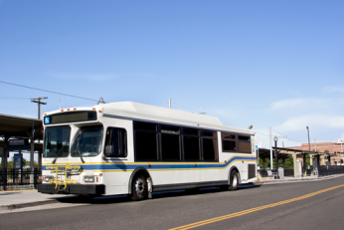 | 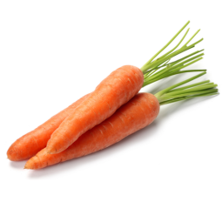
1. ________________ | 2. _______________ | 3. ________________ | 4. ______________
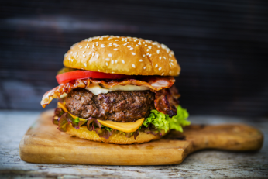 | 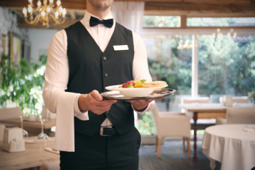 |  | 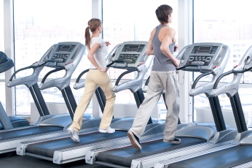
5. ________________ | 6. _______________ | 7. ________________ | 8. _______________

Grammar Practice
- Circle the correct words.
1. Nick is ( an / a ) actor.
2. You ( is / are ) my friend.
3. ( Is / Are ) Diana a nurse?
4. Jackie ( like / likes ) ice cream.
5. ( Do / Does ) you work at the post office?
6. Ben ( always drinks / drinks always ) tea at breakfast.
7. A: What’s your job? B: I’m ( businesswoman / a businesswoman ).
8. Do you ( usually work / work usually ) late?
9. That is ( him / his ) car.
10. A: Are they teachers?
B: Yes, ( they are / they’re ).

- Underline the errors and rewrite the sentences correctly.
1. He work in a restaurant.
___________________________________________________________________________
2. I like a sandwich, please.
___________________________________________________________________________
3. You doesn’t like opera.
___________________________________________________________________________
4. I could have a ticket, please?
___________________________________________________________________________
5. What time they do get up?
___________________________________________________________________________

Listening Comprehension
Listen to Nicole answer questions about her weekend. Then read the statements and circle true or false.
1. Nicole sometimes watches a film on Friday nights. true false
2. She listens to music on Saturdays. true false
3. She likes pop music. true false
4. She never listens to classical music. true false
5. She often reads the newspaper on Sundays. true false

Practice for Speaking
Fill in the blanks with the correct phrases from the box.
could I have I’d like never drink my name’s So that’s Would you like

Waiter: Hi, (1) ______________ Robert. Can I take your order?
Customer 1: Yes, (2) ________________ a hamburger, please?
Customer 2: And I’d like a chicken sandwich.
Waiter: OK. (3) _______________ something to drink?
Customer 1: Yes, (4) ______________ a beer. How about you, Nina?
Customer 2: No, I (5) ______________ beer. I’d like a glass of water, please.
Waiter: (6) _________________ a hamburger, a chicken sandwich, a beer, and a glass of water.

Reading Comprehension
Read the passage. Then read the statements and circle true or false.
Hello, I’m Derek. I’m from Toronto, but I live in London. I work in an office. I always work from Monday to Friday, but I sometimes work on Saturdays, too. I usually get up at 7:00 a.m. and drive to work. Sometimes I take the train. I start work at 9:00 a.m., and I usually finish at 6:00. After work, I often eat dinner at a restaurant with my friends. On Sundays, I usually get up late. I read the newspaper and watch TV in the morning. Sometimes I play tennis in the afternoon, and I often go to the gym. But I never work on Sundays!

1. Derek is from London. true false
2. He never works on Saturdays. true false
3. He usually drives to work. true false
4. He always eats dinner at home. true false
5. He often exercises on Sundays. true false
6. He sometimes goes to work on Sundays. true false

Writing
Introduce yourself. Answer the following questions:
What’s your name? Where are you from? Where do you live? What do you do? What do you usually do at the weekend?
_________________________________________________________________________________
_________________________________________________________________________________
_________________________________________________________________________________
__________________________________________________________________________________
_________________________________________________________________________________
_________________________________________________________________________________

