Vocabulary Comprehension
A. Match the words with the correct definitions.
1. hoovering a. a person who takes care of children
2. appraisal b. a person who takes care of a garden
3. sociable c. always thinking about how other people feel
4. nanny d. a large, expensive house
5. crowded e. the journey between your home and work
6. commute f. happy to meet and talk with other people
7. considerate g. a person that you work with
8. groundsman h. the act of cleaning a rug or carpet with a machine
9. colleague i. a review to check the progress of someone or something
10. mansion j. having too many people in one place

B. Write the words from the box under the correct pictures. Two words will not be used.
robotics chauffeur laundry penthouse flat eyeliner
caravan rubbish guinea pig cottage moisturizer

 |  | 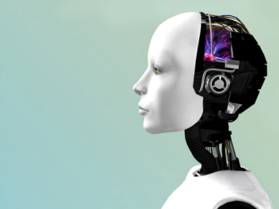
1. _________________ | 2. _________________ | 3. _________________ | 4. _________________
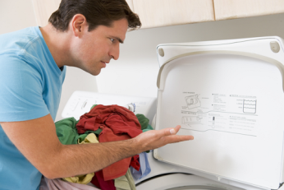
5. ________________ | 6. _________________ | 7. _________________ | 8. _________________

Grammar Practice
- Circle the correct words.
1. Try to avoid ( to talk / talking ) too loud.
2. Lisa doesn’t get along ( with / on ) her roommates.
3. What did Lucas ( say / said ) on the phone?
4. Did you hurt ( you / yourself ) when you fell on the ice?
5. In 2100, we’ll ( found / have found ) aliens on other planets.

- Fill in the blank with the given verb in the correct form.
1. __________________ you ever __________________ at this café before? (eat)
2. Stefan hopes ______________________ China next summer. (visit)
3. Who usually _______________________ the washing-up at your house? (do)
4. If you _______________________ a dog, you’d be happier. (have)
5. We have our flat ____________________ every two or three years. (paint)

C. Put the words in the correct order to make sentences.
1. use / to / didn’t / coffee / I / drink
______________________________________________________________________________.
2. asked us / lived / we / where / Sylvia
______________________________________________________________________________.
3. honest / who / like / I / people /are
______________________________________________________________________________.
4. OK / be / it / would / watched TV / we / if
______________________________________________________________________________?
5. fixed / herself / car / she / her
______________________________________________________________________________.
Listening Comprehension
Listen to the interview. Then read the statements and circle true or false.
1. Mabel works in a boutique with her friends. true false
2. She had a lot of money in the sixties. true false
3. She used to drink a lot. true false
4. She would buy tickets for every Beatles concert. true false
5. She didn’t use to wear makeup. true false

Practice for Speaking
Match each question or statement with the correct response. Three responses will not be used.
1. Have you got to know your classmates? a. Certainly.
2. Do you think I could borrow that dress? b. I’m getting used to it.
3. It’s still snowing hard. c. Thanks!
4. Who usually takes out the rubbish? d. I didn’t use to.
5. How’s your new job? e. I do.
f. In two weeks’ time.
g. Yes, I wish it would stop.
h. Yes, they’re very nice.

Reading Comprehension
Read the passage. Then read the statements and circle true or false.
In the future, the world will be very different. By 2060, population worldwide will have risen to 10.5 billion, and countries like China, India, and Brazil will have grown in importance. We’ll need 70 per cent more food to feed all these extra people, and this means food prices will be much higher than they are now.

Technology will have changed completely in fifty years’ time. We won’t use keyboards to control
computers. Instead we’ll just talk to them and tell them what to do. Robots will do most boring, low- paid jobs. People won’t work so hard and will enjoy much more free time.

Perhaps the biggest changes will be in medicine. People will live longer and get sick less. We’ll have found the cure for many diseases including, perhaps, cancer. We won’t be able to cure everything, though – for example, we won’t have found a cure for the common cold!

1. There will be fewer people in 2060. true false
2. Food will become more expensive in the future. true false
3. We’ll use different kinds of computer keyboards in the future. true false
4. People won’t have to do boring work. true false
5. In fifty years’ time, we’ll have found cures for every disease. true false

Writing
Write about how you and your life were different ten years ago. Include information such as:
What did you use to do/be ten years ago? Where were you living? What were you doing?

