Vocabulary Comprehension
- Match to make sentences.
1. A mechanic works a. watching sports.
2. A secretary works b. in my briefcase.
3. There are business papers c. picks up passengers.
4. There’s money d. a computer.
5. I can’t stand e. in a garage.
6. The supermarket is f. opposite the cinema.
7. A bus driver g. in an office.
8. I haven’t got h. in his wallet.

- Write the words and phrases from the box under the correct pictures.
hiking garlic bread torch trainers
digital camera tent mushrooms gardening

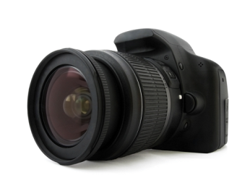 | 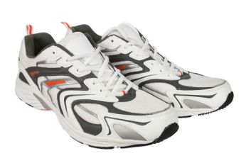 | 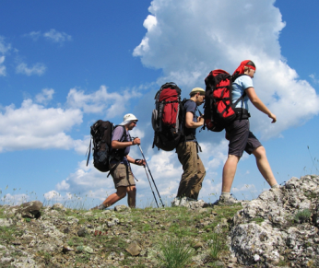 | 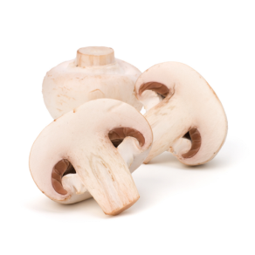
1. ________________ | 2. ________________ | 3. _______________ | 4. _______________
 | 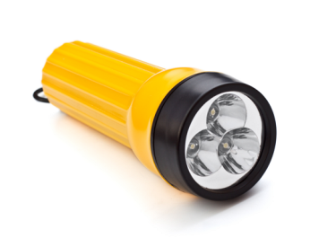 |  | 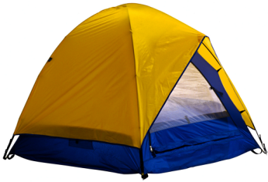
5. ________________ | 6. ________________ | 7. _______________ | 8.________________

Grammar Practice
- Circle the correct words.
1. Joseph (always is / is always ) late for class.
2. Is there ( a / an ) avocado in the refrigerator?
3. She’s ( have / got ) a new bicycle.
4. Do you like ( taking / to take ) photos?
5. There aren’t ( any / some ) nice restaurants near here.

B. Put the words in order to make sentences.
1. drink / morning / I / in / usually / the / coffee
____________________________________________________________________________.
2. got / you / have / key / a
____________________________________________________________________________?
3. there / is / bank / here / near / a
____________________________________________________________________________?
4. quite / car / driving / I / like / my
____________________________________________________________________________.

C. Underline the error and write the correction on the line.
1. We need buy some potatoes. __________________________
2. Is he eat dinner now? __________________________
3. Do you want see a movie tonight? __________________________
4. I dislike play football. __________________________
5. A: Are you staying at a hotel? __________________________
B: Yes, I do.

Listening Comprehension
Listen to the conversation and circle the correct answers.
1. Which is one of Ben’s hobbies?
a. Hiking b. Golf c. Watching TV
2. What is Ben’s favourite sport?
a. Football b. Tennis c. Swimming
3. Alice doesn’t like ________.
a. tennis b. golf c. walking
4. Alice quite likes _________.
a. watching TV b. playing football c. exercising

Practice for Speaking
Match the questions and answers.
1. What do you do? a. No, I’m British.
2. Where are you from? b. Yes, I am.
3. Are you French? c. No, I don’t.
4. Have you got a dog? d. Some batteries.
5. Do you play sports? e. I’m a teacher.
6. Is there a post office near here? f. No, I haven’t.
7. Are you working today? g. Yes, there is.
8. What do you need to buy? h. Canada.

Reading Comprehension
Read the question and answer on a travel website. Then read the statements and circle true or false.
Kenny L.:
I’m from Korea, and I’m planning to go to Los Angeles on holiday next month. I went there once when I was a kid, but I don’t remember much. This time, I want to go to the beach and see Hollywood! I’m excited because I love movies. But I need some help planning my trip.
I’m a student, so I haven’t got much money. I hate shopping, but I do love trying new food! I’m staying in the Gold Western hotel. Are there any good, cheap restaurants near there? And I don’t have a car. Do I need to rent one? Or can I walk everywhere?

Erica J.:
Hi, Kenny. I think you’ll have a great time here in Los Angeles. There are many good places to eat near the Gold Western hotel. There are Mexican, Japanese, and Korean restaurants, and they’re not expensive.
Yes, rent a car! There aren’t any beaches near your hotel, and there aren’t many places to walk in L.A.
Have a good trip!

1. Kenny visited Los Angeles as a child. true false
2. He wants to see movies on his trip. true false
3. He wants to do a lot of shopping. true false
4. There are a lot of cheap restaurants near his hotel. true false
5. He doesn’t need to rent a car. true false

Writing
Describe your hometown to a visitor. Answer the following questions.
What is your hometown? What do people like doing there? What kind of shops and restaurants are there? Where can you stay?

