Vocabulary Comprehension
A. Write the words from the box under the correct pictures.
watermelon sandals carpenter nurse
laundry retirement graduation washing-up

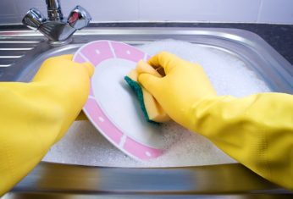 |  |  | 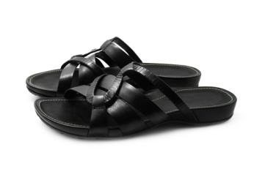
1. _________________ | 2. ________________ | 3. _________________ | 4. _________________
5. ________________ | 6. _________________ | 7. _________________ | 8. _________________

B. Fill in the blanks with the correct words from the box. Two words will not be used.
access fireworks staff accountant stamps
romantic drawing mute stressed easy-going

1. If you’re good with money and good at math, you could become a(n) ______________________.
2. This hotel has a very nice and hard-working ________________________.
3. Please put your phone on ____________________ when the movie starts.
4. Kate is really _____________________. She never gets angry or stressed.
5. My family loves watching the ____________________ on New Year’s Day.
6. That’s a beautiful ______________________. You’re a good artist!
7. I need to go to the post office to buy some _______________________.
8. Does the coffee shop have Internet ______________________?

Grammar Practice
- Circle the correct words.
1. I haven’t got ( many / much ) cousins.
2. Today ( she wears / she’s wearing ) jeans and a black sweater.
3. You ( don’t have / haven’t ) to go to school today.
4. The shop is ( at / on ) North Elm Street.
5. Victor is the ( most rich / richest ) person in his family.
6. The meeting ( began / begun ) at 9:15 this morning.
7. How ( much / many ) time do we have?
8. What will you do if ( you’ll / you ) miss the bus?

- Underline the error and write the correction on the line.
1. Do you make sometimes breakfast? ____________________________
2. My parents wasn’t angry last night. ____________________________
3. What is your math teacher look like? ____________________________
4. Go past the park and turning right. ____________________________
5. Ginny didn’t watched the football match yesterday. ____________________________
6. I usually don’t drink many wine. ____________________________
7. Tom was late, so he has to run to school. ____________________________
8. We stay with our friends this week. ____________________________

Listening Comprehension
Listen to the conversation. Then read the statements and circle true or false.
1. Martin’s parents weren’t strict. true false
2. Jenny thinks parents are stricter with boys. true false
3. Jenny and Martin had to do a lot of homework. true false
4. Jenny had to look after the lawn. true false
5. Martin’s sister made lunches for his family. true false

Practice for Speaking
cross the street get to on your left past the shopping centre first left

Man: Excuse me, ma’am. How do I (1) _______________________ Murray Park?
Woman: Oh, it’s not far. First, (2) ________________________. Then go (3) ___________________ and take the (4) ______________________.
Man: Is that West 12th Street?
Woman: Yes. Keep going, and Murray Park will be (5) _______________________.

Reading Comprehension
Read the email. Then circle the correct answers.
Hi Clara,

What are you doing these days? Are you enjoying your summer? I love the summer holidays because I don’t have to go to class or study. I’ve got a lot of free time. These days, I’m not feeling stressed. I have a job at the university book shop, and I work on Mondays, Wednesdays, and Fridays. It’s the best job I’ve ever had! I don’t have to start early in the morning. I usually start at 12:00 p.m. I’m meeting a lot of interesting people, and I’m reading a lot of good books.

Are you planning to visit me next month? We can go to the beach. It’s the best time of year here. I went swimming at the beach last weekend, and it was a lot of fun. Write soon!

Kevin

1. Kevin is very busy nowadays. true false
2. He has to go to work every morning. true false
3. He is reading many books. true false
4. If Clara visits him, they’ll go to the beach. true false
5. He had a good time at the beach last weekend. true false

Writing
Write about what you did last weekend. Answer the following questions:
When did you get up? Did you have to do any housework or homework? What was the most interesting thing you did?

