Page | Activity | Answers
p.2 | Think Ahead | 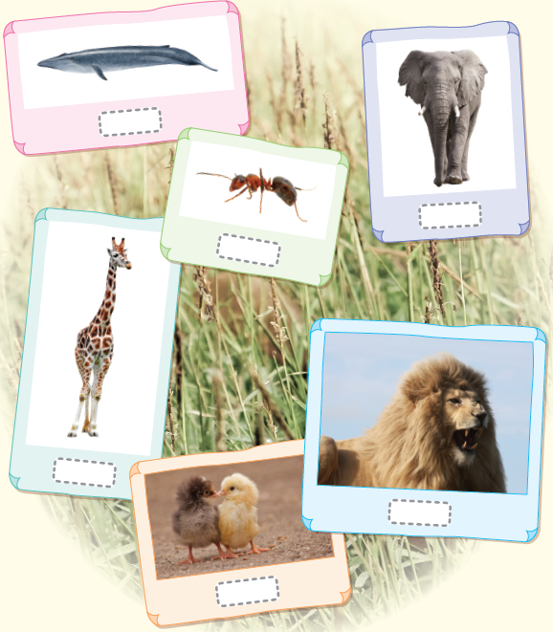  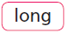  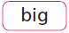  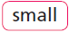  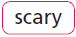  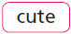
p.3 | Sound Patterns | 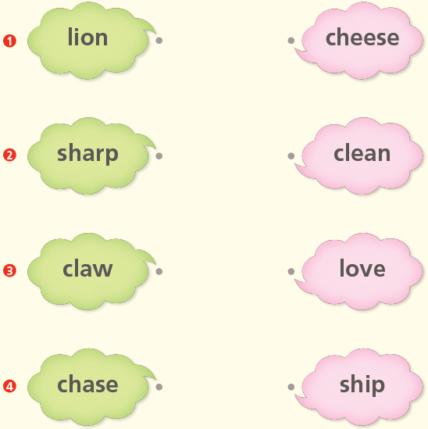
pp.4~5 | Words to Know | A.  1) chase  2) sharp  3) teeth  4) nail
B.
1) marry
2) eat
3) big
4) sharp
pp.6~7 | Meet the Characters | A.  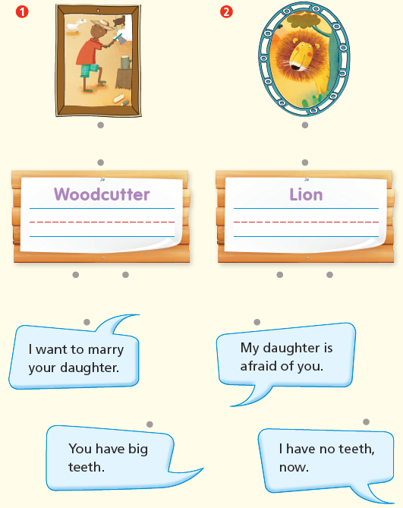
B.
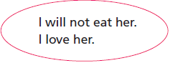
1)

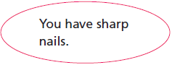
2)

pp.8~11 | Comprehension | A.  1) T  2) F  3) T  4) T
B.
1) The girl
2) He wants to marry the girl.
3) His teeth and claws
4) Can I marry your daughter now?
C.
1) teeth, idea
2) nails, sad
D.
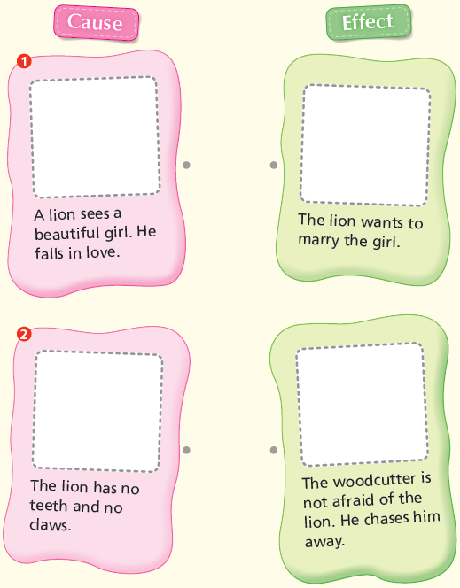

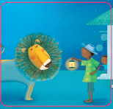
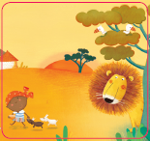

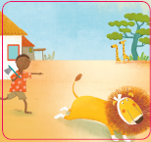
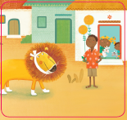

pp.12~13 | Review Quiz | A.  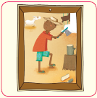  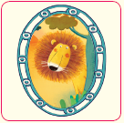  1) 2)
B.
1) teeth
2) sharp
3) nails
4) chases
 |  | C.
D.
1) a
2) a

E.
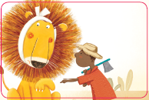
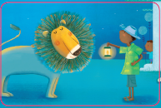
1) 2)

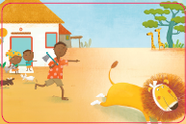
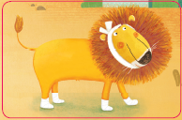
3) 4)

p.15 | Book Report | <Lesson>  Love

