Page | Activity | Answers
pp.2~3 | Think Ahead | A.  1) The title of this book is The Gift of the Magi.  2) The author of this book is O. Henry.  3) combs, jewels, surprised  4) I think the woman will be happy about the man’s gift.
B. <Sample Answer>
1) The most memorable gift that I have ever received was a letter from my friend.
2) It was special because it was a meaningful gift.
 |  | C. Drawing may vary.
pp.4~5 | Words to Learn | A.  1) item  2) wig  3) chain  4) unusual  5) expression  6) elegant
B.
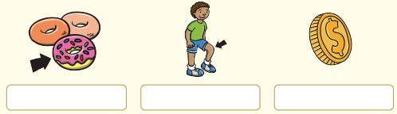

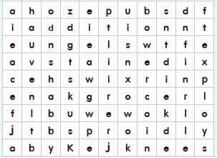

p.6 | Sentence Practice | A.  1) Don’t feel bad about looking.  2) It took Della months to save her little fortune.  3) Della wanted to give him a beautiful Christmas gift.  4) She pushed the small chain into his hand.  5) They were silver with little colored jewels.  6) I sold my watch to pay for the combs.
P.7 | Story Map | A.  Story Character(s): Della, Jim  Setting(s): in Jim and Della’s house  First:  ⓑ Della decided to sell her hair to get money to buy Jim a gift.  Second:  ⓒ Della sold her hair to a local wig maker and bought a watch  chain for Jim.  Then:  ⓓ Della told Jim that she sold her hair to buy him a gift and  showed him the watch chain.  Last:  ⓐ Jim told Della that he sold his watch to buy Della a gift and  showed her a set of silver combs.
pp.8~9 | Comprehension | A.  1) T  2) F  3) F  4) F
B.
1) a
2) b
3) b
4) a
P.10 | Review Quiz | A.  1) shabby  2) knees  3) stained  4) addition  5) grocer
B.
1) elegant
2) chain
3) expression
4) unusual
5) item
P.11 | Book Report | d. Della only had $1.87 to buy a gift for Jim.  h. Jim and Della were a poor couple whose only items of value were Della’s thick and dark hair and Jim’s gold watch.  b. She sold her hair for $20 and bought a watch chain for $21.  c. Satisfied with the perfect gift for Jim, Della went home to prepare dinner.  e. At 7 o’clock, Jim came home and gave Della a look that she couldn’t understand.  f. Della said that she sold her hair to buy his gift and showed him the watch chain.  g. Jim said that he sold his watch to buy her gift and showed her a set of combs.  a. Though they were crying, they were both very happy.

