Page | Activity | Answers
pp.2~3 | Think Ahead | A.  1) The title of this book is The Happy Prince.  2) The author of this book is Oscar Wilde.  3) statue, sword, swallow  4) I think the prince and the swallow will be good friends.
B. <Sample Answer>
1) I helped my friend.
2) I felt happy and I was so proud of myself.
 |  | C. Drawing may vary.
pp.4~5 | Words to Learn | A.  1) beak  2) gem  3) perfect  4) statue  5) swallow  6) survive
B.
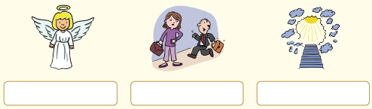

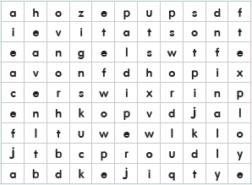

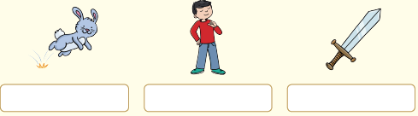

p.6 | Sentence Practice | A.  1) They put me here on top of this hill.  2) The swallow feels sorry for the prince.  3) Doing kind makes us feel good.  4) Shall I take him a red gem?  5) He decides to stay one more night.  6) Then he kisses the prince on the cheek and dies.
P.7 | Story Map | A.  Story Character(s): Prince, Swallow  Setting(s): on a hill over the city.  Problem 1: ⓒ The prince saw a poor woman who had no food for her sick boy.  Solution 1: ⓑ The prince asked the swallow to bring a red gem to the poor woman.  Problem 2: ⓐ The prince saw a young man who tried to work but cannot.  Solution 2: ⓔ The prince asked the swallow to bring a blue gem from his eyes to the young man.  Problem 3: ⓓ The prince saw a poor little girl who couldn’t sell her wet matches.  Solution 3: ⓕ The prince asked the swallow to bring the  other blue gem from his eyes to the little match girl.
pp.8~9 | Comprehension | A.  1) F  2) F  3) T  4) T
B.
1) a
2) a
3) b
4) a
P.10 | Review Quiz | A.  1) perfect  2) gems  3) statue  4) beak  5) survive
B.
1) sword
2) Finally
3) hop
4) angel
5) heaven
P.11 | Book Report | b. There was a statue of the Happy Prince covered with gold and fine gems.  c. A swallow lands on the statue and discovered the prince is sad.  g. The prince explained that he had never experienced sorrow when alive, but he watched people suffering in poverty since he became a statue after death.  e. Then the prince asked the swallow to take his gems and gold and bring them to the poor people of the city.  a. Staying with the prince, the swallow helped the poor people in the city.  d. Winter came and the swallow froze to death and it broke the prince’s heart.  f. An angel selected the dead swallow and the prince’s broken heart as the two most precious things in the city and took them to heaven.

