Page | Activity | Answers
p.2 | Think Ahead | A.  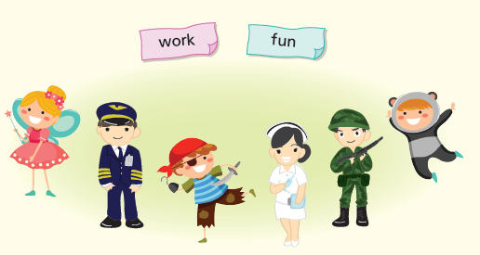
 |  | B. Draw your own answer.
p.3 | Sentence Patterns | A.  1) You  2) are good for  3) the princess  B.  “You are good for the princess.”
pp.4~5 | Words to Know | A.  1) skin 2) violin 3) handsome  4) gate 5) burn 6) castle  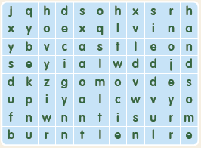
B.
1) to go
2) to sit
3) to meet
4) to marry
pp.6~7 | Meet the Characters | 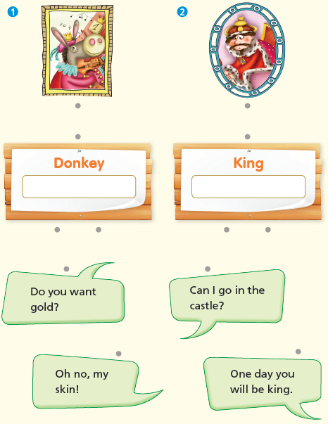  A.
B.
1) know
2) handsome
pp.8~11 | Comprehension | A.  1) F  2) T  3) F  4) T
B.
1) He can play the violin.
2) The king
3) He was inside the donkey skin.
4) Yes
C.
1) donkey, castle
2) skin, burn
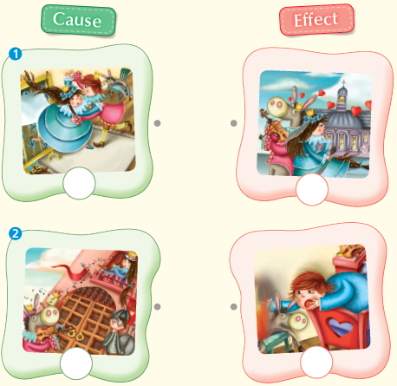
D.

pp.12~13 | Review Quiz | A.  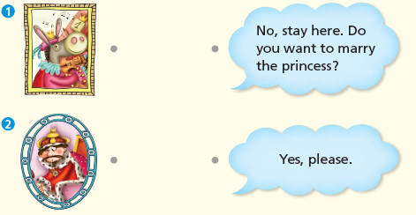
B.
1) violin
2) castle
3) gate
4) handsome
5) burning
C.
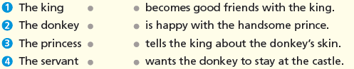

D.
1) a
2) b

E.
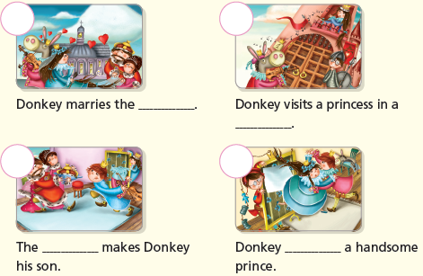

p.15 | Book Report | <Summary>  castle, princess, skin, handsome, burns  <Lesson>  afraid

