Page | Activity | Answers
p.2 | Think Ahead | A. <Sample Answer>  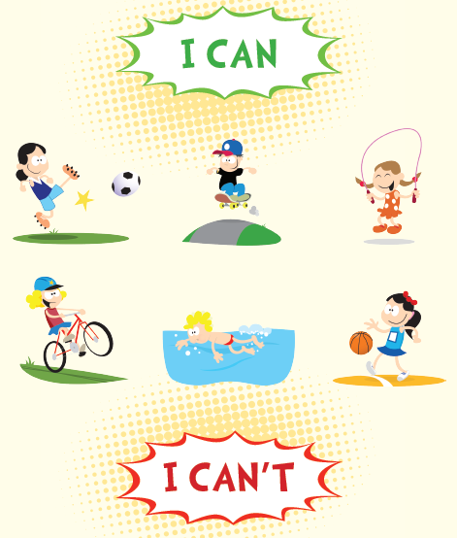
p.3 | Sentence Patterns | A.  1) The man who can  2) pull the sword from the stone  3) will become King of England  B.  “The man who can pull the sword form the stone will become King of England.”
pp.4~5 | Words to Know | A.  1) sword 2) pull 3) magic  4) fight 5) stone 6) wise  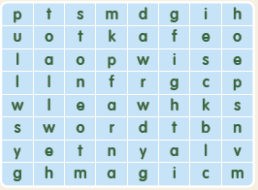
B.
1) knows
2) puts
3) forgets
4) becomes
pp.6~7 | Meet the Characters | 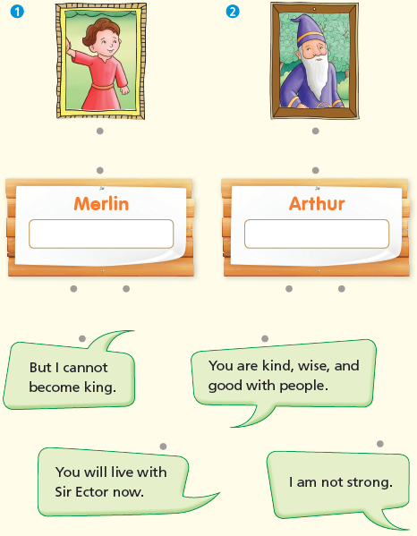  A.
B.
1) son
2) sword
pp.8~11 | Comprehension | A.  1) F  2) F  3) T  4) T
B.
1) The king’s friend
2) Merlin
3) Arthur
4) A sword
C.
1) nobles, stone
2) strong, good
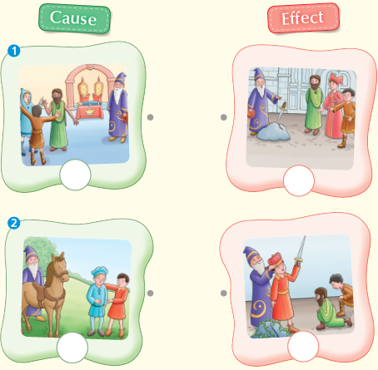
D.

pp.12~13 | Review Quiz | A.  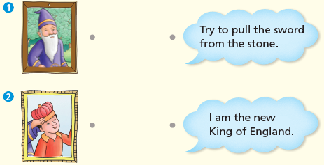
B.
1) king
2) fight
3) poor
4) stone
5) live
 |  | C.
D.
1) a
2) b

E.
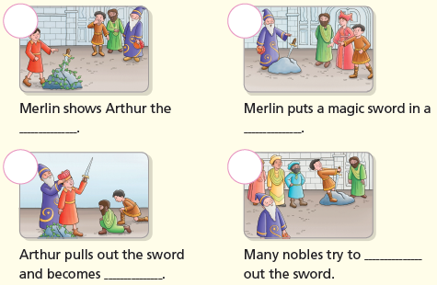

p.15 | Book Report | <Summary>  magic, stone, fight, sword, pulls  <Lesson>  happy

