Page | Activity | Answers
p.2 | Think Ahead | A. <Sample Answer>  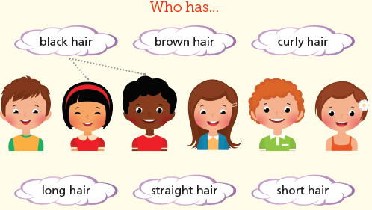
 |  | B. Draw your own answer.
p.3 | Sentence Patterns | A.  1) As Rapunzel grows older  2) her golden hair  3) gets longer and longer  B.  As Rapunzel grows older, her golden hair gets longer and longer.
pp.4~5 | Words to Know | A.  1) tears 2) tower 3) blind  4) voice 5) hair 6) grow  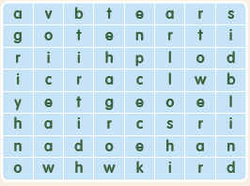
B.
1) hears
2) makes
3) finds
4) cries
pp.6~7 | Meet the Characters | 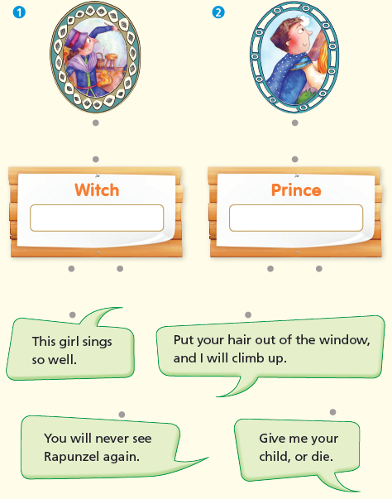  A.
B.
1) tree
2) voice
pp.8~11 | Comprehension | A.  1) F  2) F  3) T  4) T
B.
1) In a tower
2) It is long and golden.
3) In a town
4) Her mother and father
C.
1) witch, blind
2) cries, tears
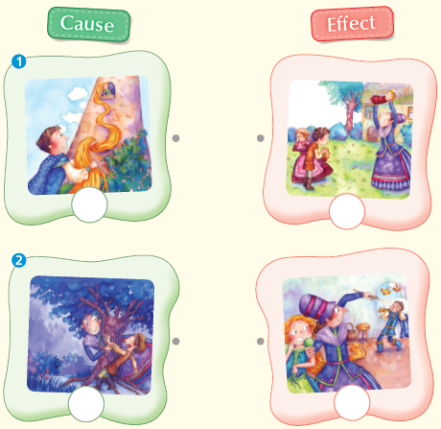
D.

pp.12~13 | Review Quiz | A.  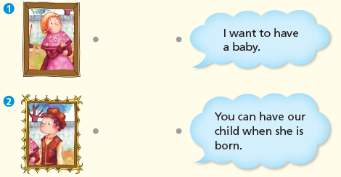
B.
1) tower
2) hair
3) voice
4) prince
5) blind
C.
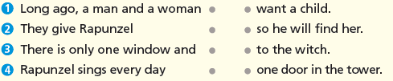

D.
1) a
2) b

E.
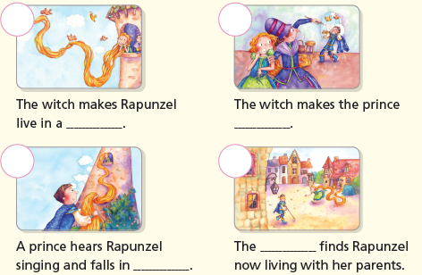

p.15 | Book Report | <Summary>  witch, tower, hair, blind, tears  <Lesson>  love

