Page | Activity | Answers
p.2 | Think Ahead | A.  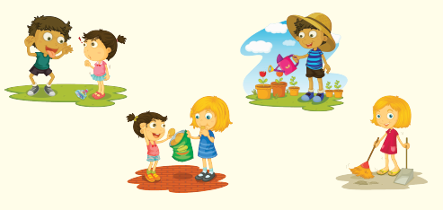
 |  | B. Draw your own answer.
p.3 | Sentence Patterns | A.  1) When you speak  2) diamonds will come  3) from your mouth  B.  “When you speak, diamonds will come from your mouth.”
pp.4~5 | Words to Know | A.  1) frog 2) rude 3) thirsty  4) diamond 5) mouth 6) fine  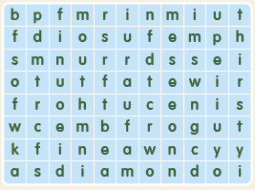
B.
1) has
2) is
3) tells
4) comes
pp.6~7 | Meet the Characters | 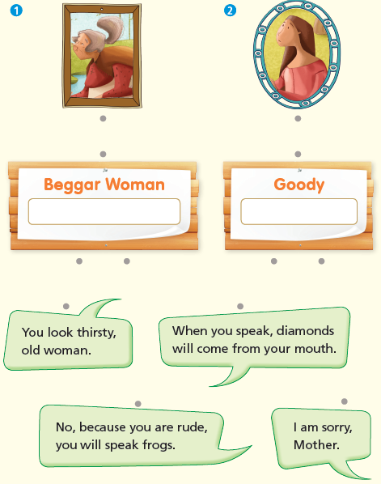  A.
B.
1) rude
2) house
pp.8~11 | Comprehension | A.  1) T  2) F  3) T  4) F
B.
1) Thirsty
2) She is kind.
3) Into the woods
4) A prince
C.
1) diamond, surprised
2) fine, thirsty
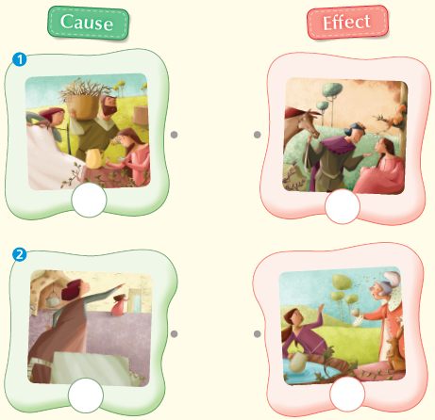
D.

pp.12~13 | Review Quiz | A.  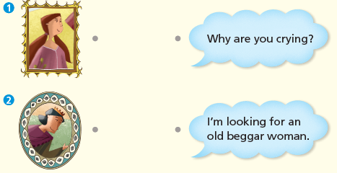
B.
1) father
2) fine
3) rude
4) mouth
5) thirsty
C.
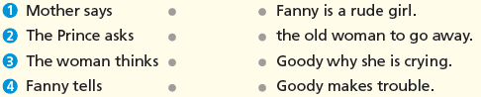

D.
1) a
2) a

E.
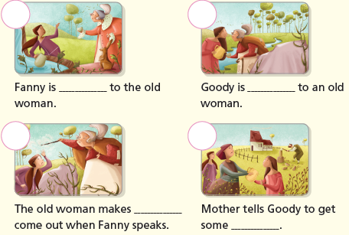

p.15 | Book Report | <Summary>  water, diamonds, rude, frogs, meets  <Lesson>  well

