Page | Activity | Answers
p.2 | Think Ahead | A.  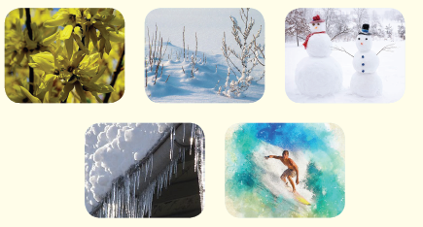
 |  | B. Draw your own answer.
p.3 | Sentence Patterns | A.  1) King Frost  2) took Eva back  3) to her home  B.  King Frost took Eva back to her home.
pp.4~5 | Words to Know | A.  1) freezing 2) rude 3) frost  4) robe 5) blizzard 6) polite  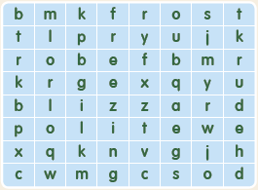
B.
1) Send
2) begged
3) wrapped
4) found
pp.6~7 | Meet the Characters | 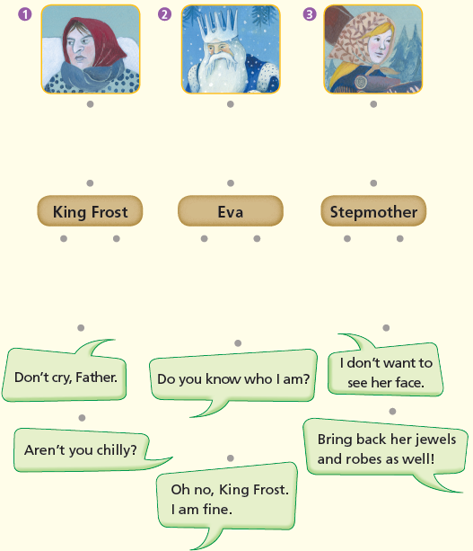  A.
B.
1) freezing
2) snow
pp.8~11 | Comprehension | A.  1) T  2) T  3) F  4) F
B.
1) Because she didn’t want him to feel bad.
2) He gave a fur robe and jewels to Eva.
3) Because she was too rude.
4) She became an icicle.
C.
1) Leave, get
2) gorgeous, colder, colder
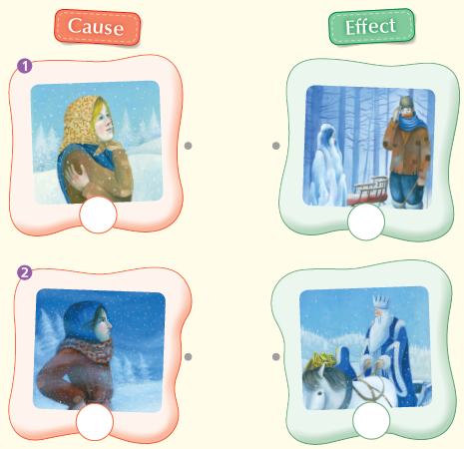
D.

pp.12~13 | Review Quiz | 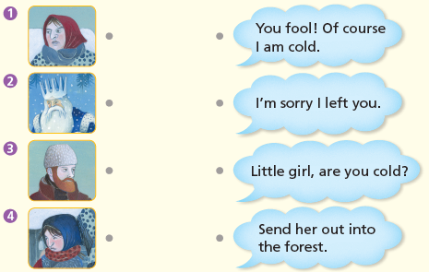  A.
B.
1) stepdaughter
2) forest
3) bad
4) sled
5) fool
6) icicle
C.
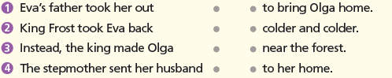

D.
1) b
2) a

E.
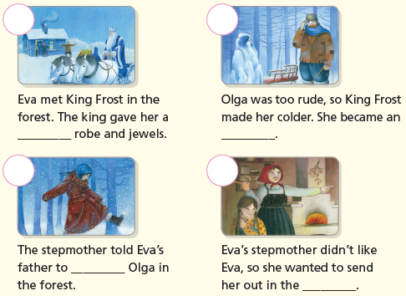

p.15 | Book Report | <Summary>  stepmother, polite, robe, rude, colder, icicle  <Lesson>  polite

