Page | Activity | Answers
p.2 | Think Ahead | A.  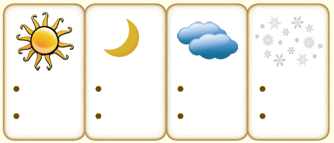
 |  | B. Draw your own answer.
p.3 | Sentence Patterns | A.  1) I  2) have brought  3) some good for you  B.  I have brought some good for you.
pp.4~5 | Words to Know | A.  1) reward 2) bright 3) greedy  4) glow 5) punish 6) bitter  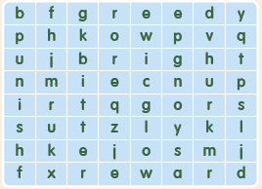
B.
1) waited
2) appeared
3) share
4) spend
pp.6~7 | Meet the Characters | 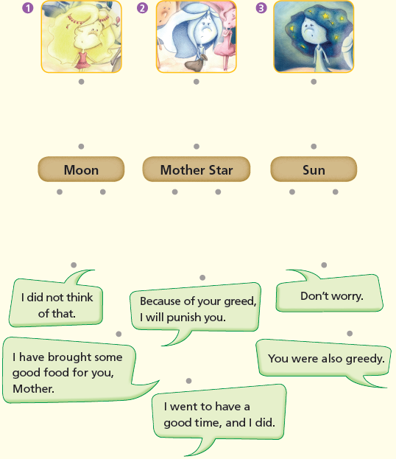  A.
B.
1) bring
2) thoughtful
pp.8~11 | Comprehension | A.  1) F  2) T  3) T  4) F
B.
1) At Aunt Thunder and Uncle Lightning’s house
2) They ate and ate.
3) Because of their greed
4) They will cover their heads.
C.
1) Bring, have
2) punish, unpleasant
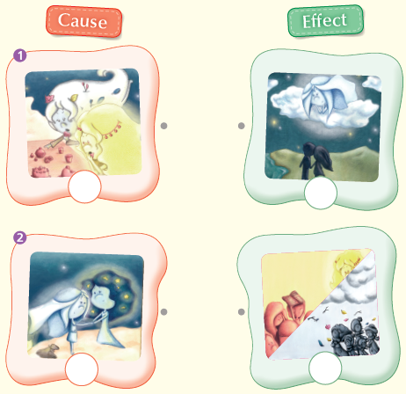
D.

pp.12~13 | Review Quiz | 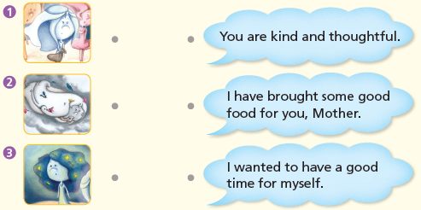  A.
B.
1) excited
2) greedy
3) share
4) nervous
5) punish
6) shines
C.
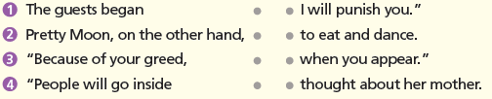

D.
1) a
2) b

E.
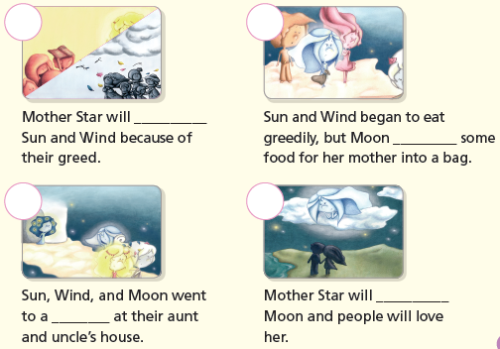

p.15 | Book Report | <Summary>  party, amazed, brought, punish, greed, reward  <Lesson>  kind

