Page | Activity | Answers
p.2 | Think Ahead | 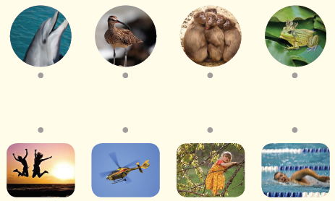  A.
 |  | B. Draw your own answer.
p.3 | Sentence Patterns | A.  1) They  2) could both  3) swim and curl up  B.  They could both swim and curl up!
pp.4~5 | Words to Know | A.  1) swim 2) confused 3) scoop  4) shell 5) prickle 6) curl  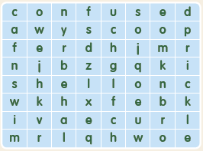
B.
1) told
2) filled
3) learn
4) call
pp.6~7 | Meet the Characters | 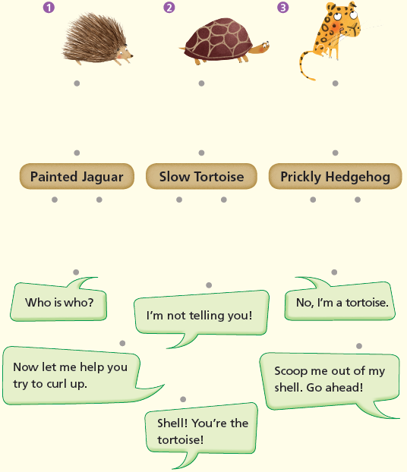  A.
B.
1) shell
2) Tortoise
pp.8~11 | Comprehension | A.  1) T  2) F  3) F  4) T
B.
1) Slow Tortoise
2) He reached out his paw to the hedgehog.
3) He taught Prickly Hedgehog how to swim.
4) Because Prickly Hedgehog and Slow Tortoise could both
swim and curl up.
C.
1) uncurl, shell
2) swim, curl
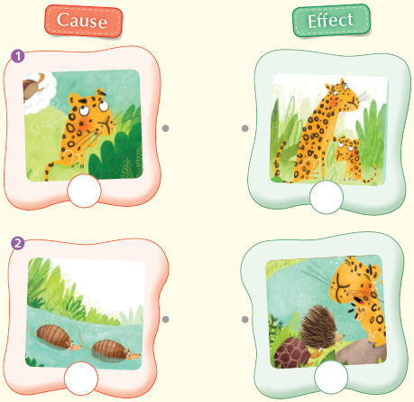
D.

pp.12~13 | Review Quiz | 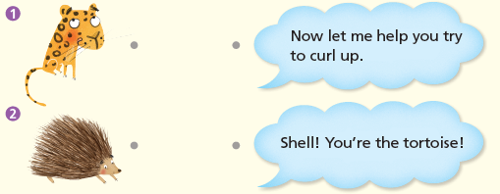  A.
B.
1) river
2) confused
3) paw
4) curl
5) taught
6) ‘armadillos’
C.
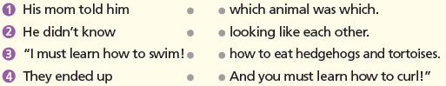

D.
1) a
2) b

E.
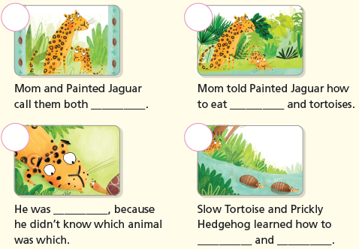

p.15 | Book Report | <Summary>  taught, confused, curl, swim, armadillo  <Lesson>  help

