Page | Activity | Answers
p.2 | Think Ahead | A.
 |  | B. Draw your own answer.
p.3 | Sentence Patterns | A.  1) The garden  2) was  3) a quiet place  B.  The garden was a quiet place.
pp.4~5 | Words to Know | A.  1) sick 2) return 3) shake  4) hole 5) bloom 6) noise  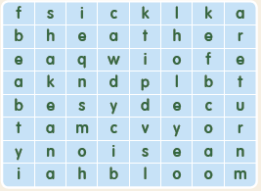
B.
1) hole
2) difficult
3) blooming
4) tractor
pp.6~7 | Meet the Characters | 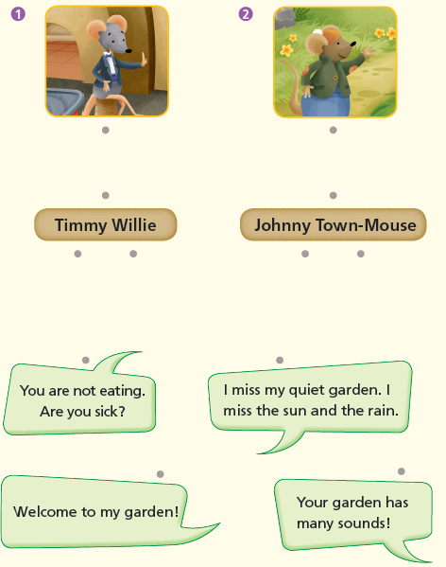  A.
B.
1) sick
2) sounds
pp.8~11 | Comprehension | A.  1) T  2) F  3) F  4) T
B.
1) He was scared.
2) He fell asleep in a box.
3) Because the city was noisy.
4) The garden has many sounds.
C.
1) hole, crawled
2) hide, returns
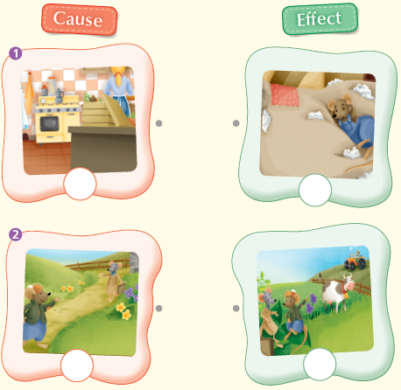
D.

pp.12~13 | Review Quiz | 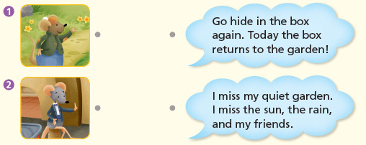  A.
B.
1) delicious
2) difficult
3) burrow
4) sick
5) returns
6) Welcome
 |  | C.
D.
1) a
2) b

E.
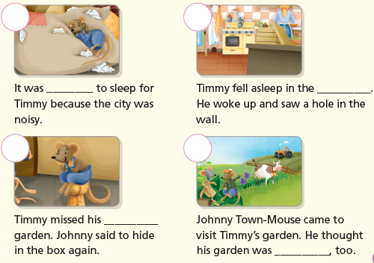

p.15 | Book Report | <Summary>  garden, shaking, sleep, quiet, noisy  <Lesson>  home

