Page | Activity | Answers
p.2 | Think Ahead | A.  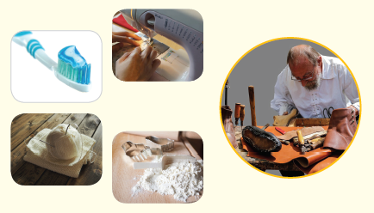
 |  | B. Draw your own answer.
p.3 | Sentence Patterns | A.  1) The shoemaker  2) wanted  3) to make shoes  B.  The shoemaker wanted to make shoes.
pp.4~5 | Words to Know | A.  1) leather 2) hurry 3) rich  4) wake 5) busy 6) coat  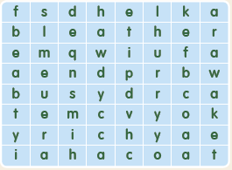
B.
1) leather
2) elves
3) coats
4) happy
pp.6~7 | Meet the Characters | 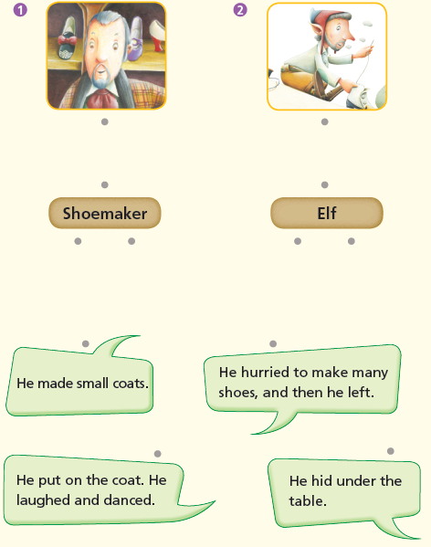  A.
B.
1) hide
2) coats
pp.8~11 | Comprehension | A.  1) F  2) F  3) T  4) F
B.
1) He cut the leather and went to bed.
2) Because the shoes were already made.
3) Elves
4) They put on the coats.
C.
1) woke, amazed
2) returned, song
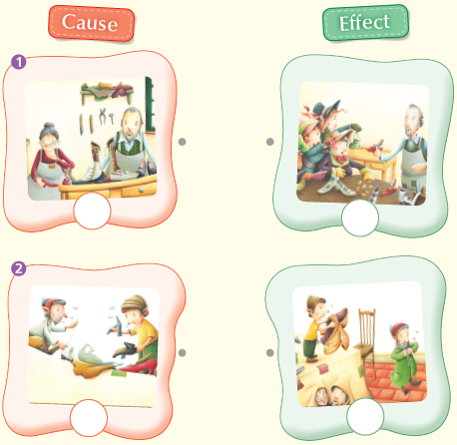
D.

pp.12~13 | Review Quiz | 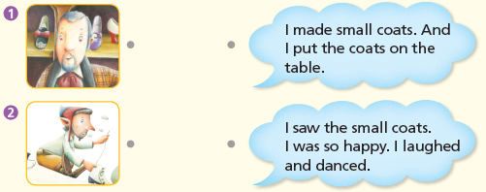  A.
B.
1) poor
2) beside
3) Elves
4) cold
5) done
6) busy
C.
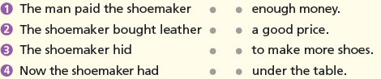

D.
1) b
2) a

E.
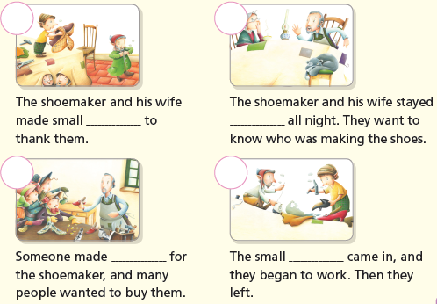

p.15 | Book Report | <Summary>  shoemaker, awake, table, sad, money  <Lesson>  Help

