Page | Activity | Answers
p.2 | Think Ahead | 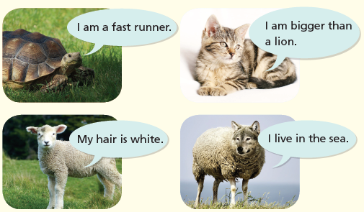  A.
 |  | B. Draw your own answer.
pp.3~4 | Words to Know | A.  1) sheep 2) liar 3) shout  4) attack 5) truth 6) trick  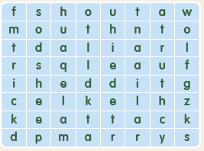
B.
1) sheep
2) pretended
3) shouted
4) liar
pp.5~6 | Comprehension | A.  1) F  2) F  3) T  4) T
B.
1) trick, attacking
2) liar, truth
p.7 | Review Quiz | 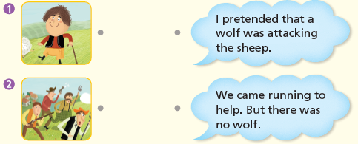  A.
B.
1) trick
2) shouted
3) no
4) wolf
5) shouts
6) truth
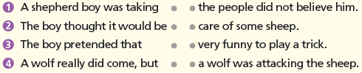
C.

p.8 | Book Report | <Summary>  shepherd, trick, many, wolf, shouted  <Lesson>  lie
p.10 | Think Ahead | A. <Sample Answer>  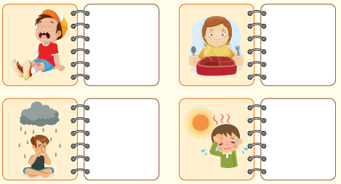  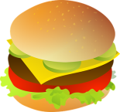  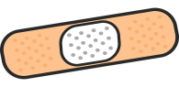
 |  | B. Draw your own answer.
pp.11~12 | Words to Know | A.  1) chew 2) rope 3) trap  4) wagon 5) snore 6) asleep  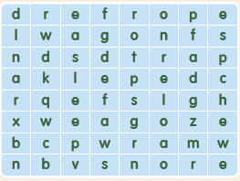
B.
1) asleep
2) paw
3) hunters
4) chewed
pp.13~14 | Comprehension | A.  1) The mouse ran up and down on top of him.  2) Because he thought what the mouse said was very funny.  3) A wagon  4) Because he did not forget his promise to the lion.
B.
1) paw, mouth
2) hunters, wagon
p.15 | Review Quiz | 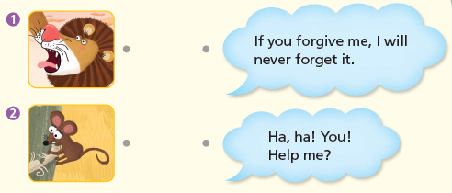  A.
B.
1) asleep
2) forgive
3) funny
4) trap
5) promise
6) great

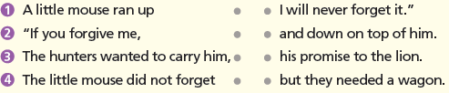
C.

p.16 | Book Report | <Summary>  woke up, funny, trap, ropes, friends  <Lesson>  kindness

