Page | Activity | Answers
p.2 | Think Ahead | 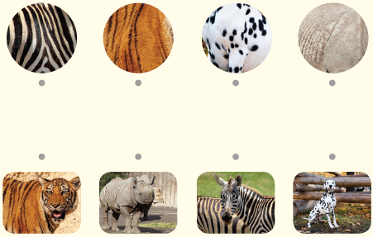  A.
 |  | B. Draw your own answer.
p.3 | Sentence Patterns | A.  1) That rhinoceros  2) always eat  3) my cake  B.  That rhinoceros always eat my cake.
pp.4~5 | Words to Know | A.  1) wrinkled 2) scratch 3) stove  4) tickle 5) crumb 6) steal  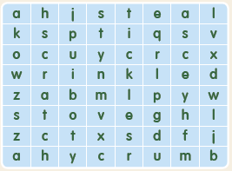
B.
1) baked
2) climbed
3) stole
4) punched
pp.6~7 | Meet the Characters | 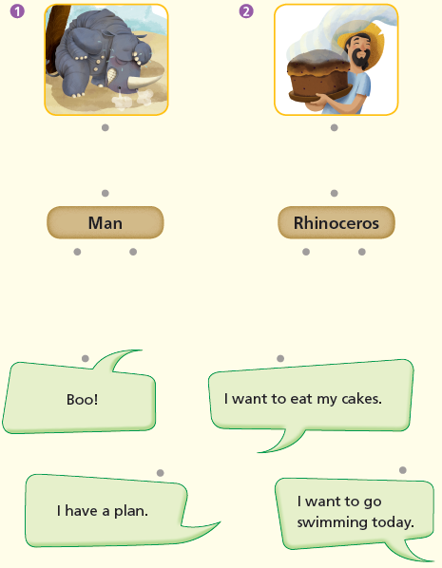  A.
B.
1) teach
2) swimming
pp.8~11 | Comprehension | A.  1) F  2) T  3) F  4) T
B.
1) He was hiding behind the tree.
2) Because he had a plan to teach the rhinoceros.
3) He scratched his skin and rolled in the sand.
4) Some crumbs were inside this skin.
C.
1) collected, mixed
2) took off, hung
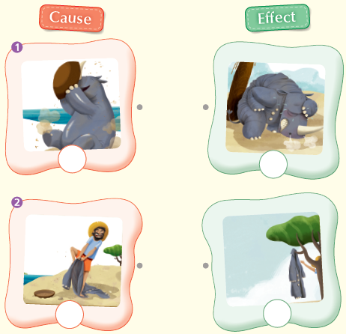
D.

pp.12~13 | Review Quiz | 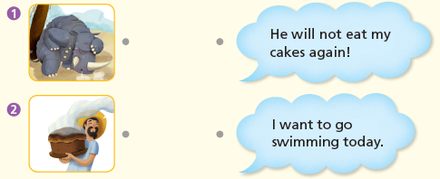  A.
B.
1) stove
2) tree
3) left
4) skin
5) wrinkled
6) scratched
C.
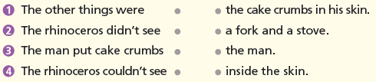

D.
1) a
2) a

E.
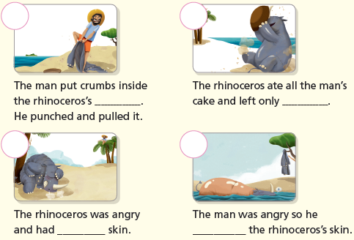

p.15 | Book Report | <Summary>  stove, baked, crumbs, stole, wrinkled, tickled  <Lesson>  Don’t be

