Page | Activity | Answers
p.2 | Think Ahead | A.  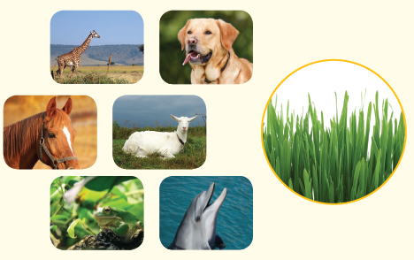
 |  | B. Draw your own answer.
p.3 | Sentence Patterns | A.  1) The first billy goat  2) crossed  3) the bridge  B.  The first billy goat crossd the bridge.
pp.4~5 | Words to Know | A.  1) hungry 2) bridge 3) troll  4) strong 5) beast 6) yell  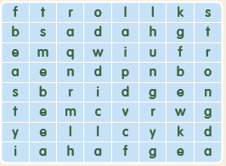
B.
1) cross
2) patient
3) beast
4) mud
pp.6~7 | Meet the Characters | 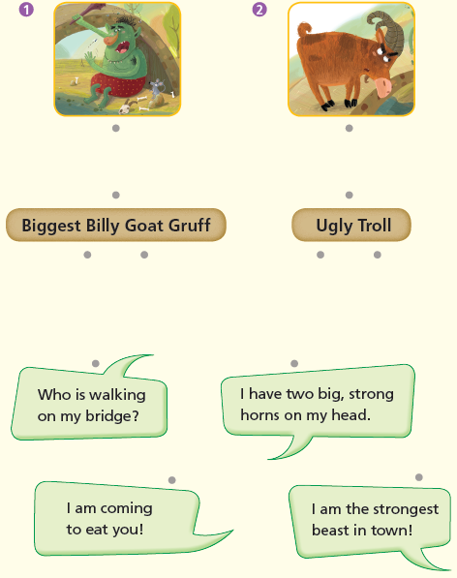  A.
B.
1) delicious
2) Fetch
pp.8~11 | Comprehension | A.  1) T  2) F  3) F  4) T
B.
1) They had to cross a bridge.
2) His eyes were very small and his nose was long.
3) Strong horns
4) He was very, very angry and very, very hungry.
C.
1) troll, ugly
2) horns, mud
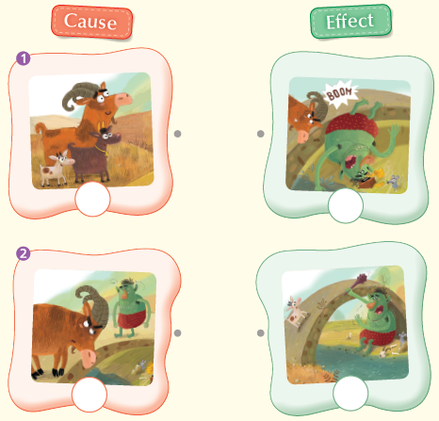
D.

pp.12~13 | Review Quiz | 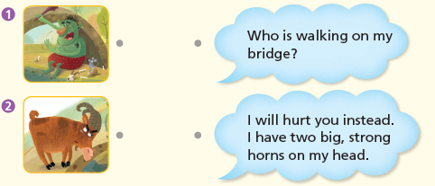  A.
B.
1) name
2) cross
3) hungry
4) delicious
5) strong
6) biggest
C.
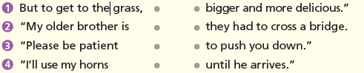

D.
1) a
2) b

E.
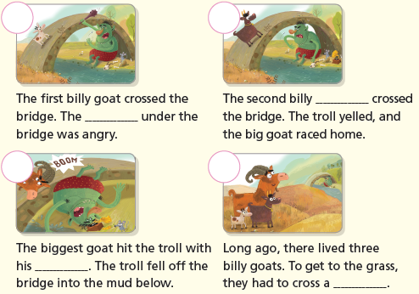

p.15 | Book Report | <Summary>  grass, cross, patient, beast, bothered  <Lesson>  greedy

