Page | Activity | Answers
p.2 | Think Ahead | 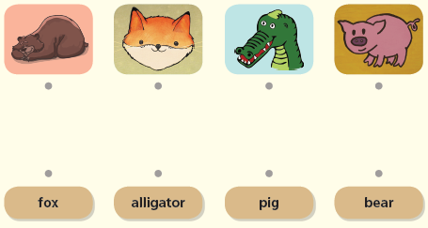  A.
 |  | B. Draw your own answer.
p.3 | Sentence Patterns | A.  1) A wolf  2) knocked  3) at the door  B.  A wolf knocked at the door.
pp.4~5 | Words to Know | A.  1) wedding 2) mouth 3) tail  4) wolf 5) knock 6) marry  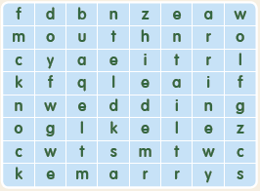
B.
1) sad
2) maid
3) marry
4) beautiful
pp.6~7 | Meet the Characters | 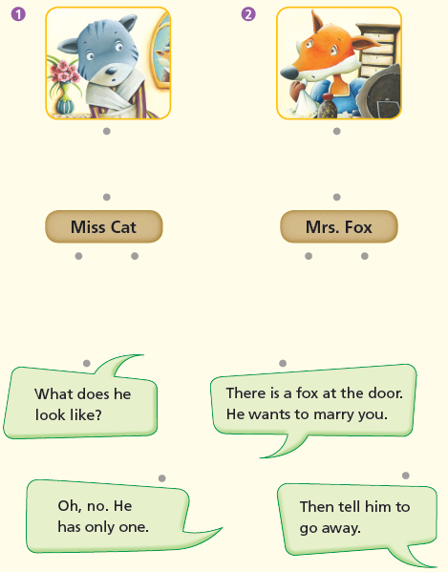  A.
B.
1) marry
2) tails
pp.8~11 | Comprehension | A.  1) F  2) T  3) F  4) F
B.
1) Miss Cat
2) He wants to marry Mrs. Fox.
3) A fox with nine beautiful tails
4) Because he was angry.
C.
1) tails, pretending
2) wedding, dead
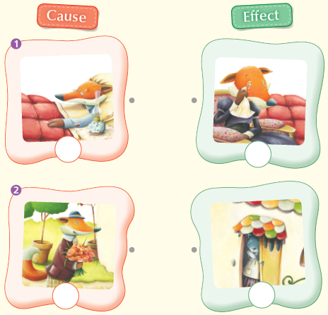
D.

pp.12~13 | Review Quiz | A.  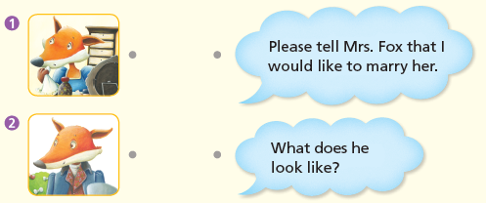
B.
1) fox
2) husband
3) maid
4) decided
5) wedding
C.
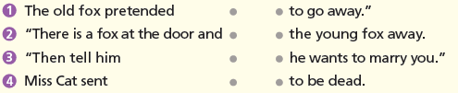

D.
1) b
2) a

E.
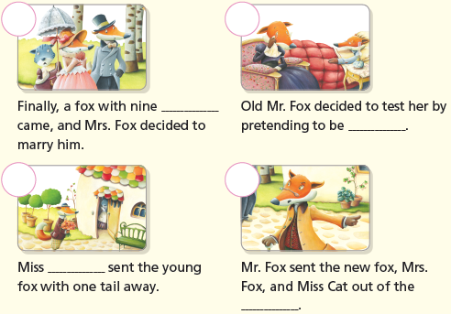

p.15 | Book Report | <Summary>  tails, dead, nine, beautiful, marry  <Lesson>  Don’t

