Page | Activity | Answers
p.2 | Think Ahead | <Sample Answer>  You should obey your teacher.  You should eat vegetables. | You should not drink coffee.  You should not stay up late.
p.3 | Sentence Patterns | A.  1) Be my friend  2) Then I will  3) get your ball  B.  “Be my friend. Then I will get your ball.”
pp.4~5 | Words to Know | A.  1) across 2) ball 3) hop  4) throw 5) both 6) magic  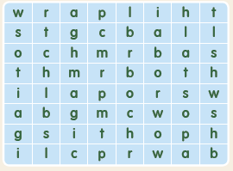
B.
1) falls
2) hops
3) hears
4) throws
pp.6~7 | Meet the Characters | 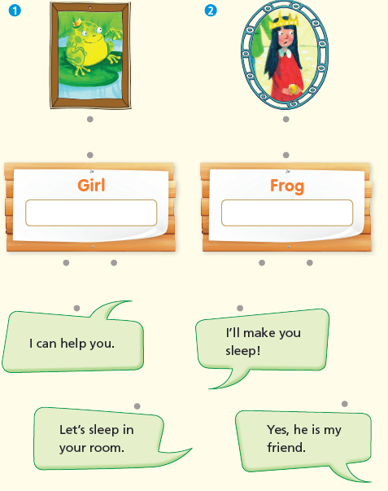  A.
B.
1) friend
2) Thank
pp.8~11 | Comprehension | A.  1) F  2) T  3) T  4) F
B.
1) The king’s daughter
2) A gold ball
3) In the girl’s room
4) A prince
C.
1) ball, hops
2) sleep, across
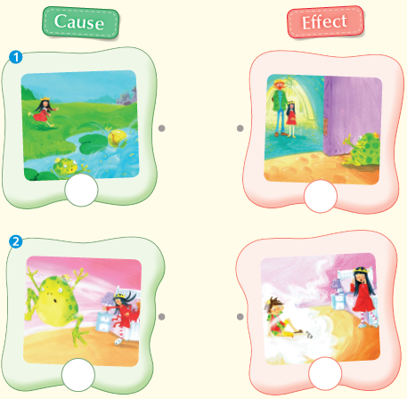
D.

pp.12~13 | Review Quiz | A.  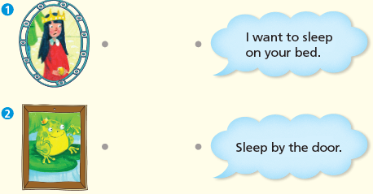
B.
1) ball
2) hops
3) throws
4) across
5) both
C.
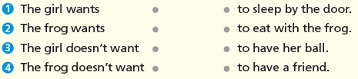

D.
1) a
2) a

E.
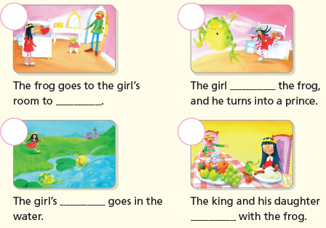

p.15 | Book Report | <Summary>  ball, hops, wants, throws, both  <Lesson>  keep

