Page | Activity | Answers
p.2 | Think Ahead | A.
 |  | B. Draw your own answer.
p.3 | Sentence Patterns | A.  1) How  2) can I  3) be a doctor  B.  “How can I be a doctor?”
pp.4~5 | Words to Know | A.  1) floor 2) dish 3) sell  4) horse 5) kitchen 6) point  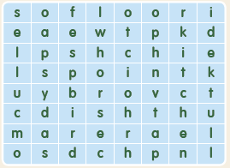
B.
1) puts
2) does
3) brings
4) points
pp.6~7 | Meet the Characters | 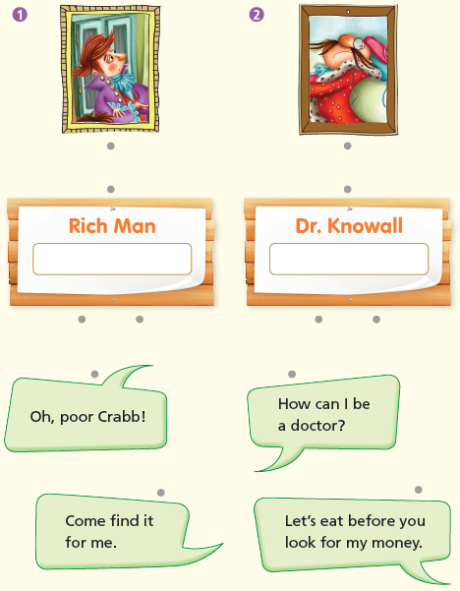  A.
B.
1) find
2) money
pp.8~11 | Comprehension | A.  1) T  2) F  3) T  4) T
B.
1) They think Dr. Knowall knows their secret.
2) No, he doesn’t.
3) The servants tell him.
4) They ask him to come to the kitchen.
C.
1) horse, book
2) rich, knows
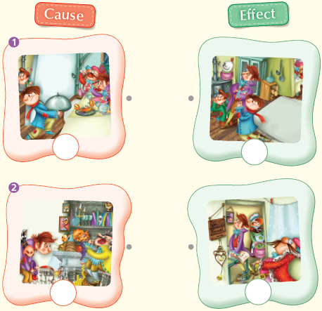
D.

pp.12~13 | Review Quiz | A.  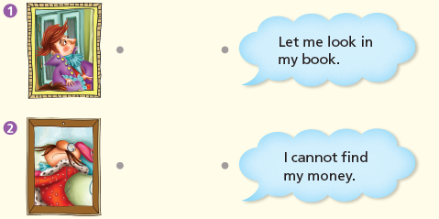
B.
1) clothes
2) dish
3) servants
4) kitchen
5) floor
C.
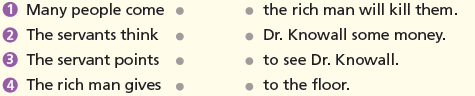

D.
1) b
2) a

E.
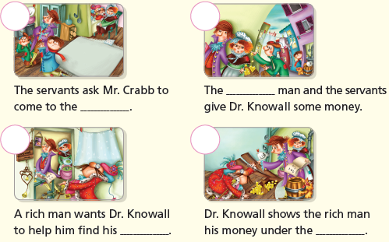

p.15 | Book Report | <Summary>  sells, find, think, point, floor  <Lesson>  right

