Page | Activity | Answers
p.2 | Think Ahead | 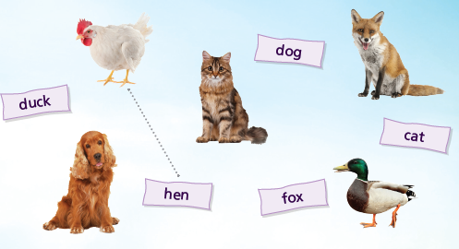  A.
 |  | B. Draw your own answer.
p.3 | Sentence Patterns | A.  1) The sky is falling!  2) I have to  3) tell the King  B.  “The sky is falling! I have to tell the King.”
pp.4~5 | Words to Know | A.  1) hit 2) nut 3) sky  4) head 5) follow 6) quickly  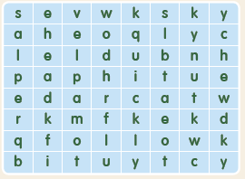
B.
1) runs
2) asks
3) looks
4) talks
pp.6~7 | Meet the Characters | 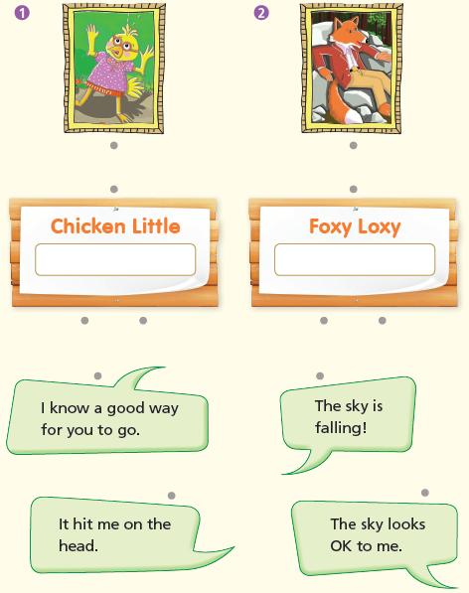  A.
B.
1) falling
2) quickly
pp.8~11 | Comprehension | A.  1) F  2) T  3) T  4) F
B.
1) Into Foxy Loxy’s home
2) Foxy Loxy
3) His son
4) They follow others without thinking.
C.
1) going, asks
2) hit, head
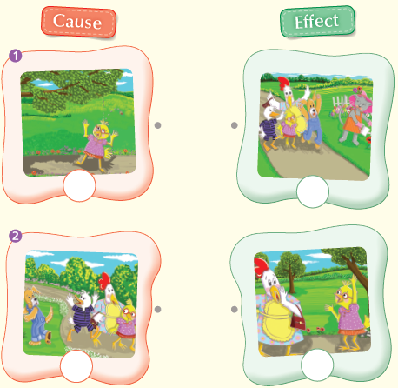
D.

pp.12~13 | Review Quiz | A.  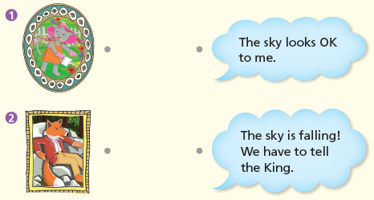
B.
1) head
2) sky
3) runs
4) follows
5) home
 |  | C.
D.
1) a
2) a

E.
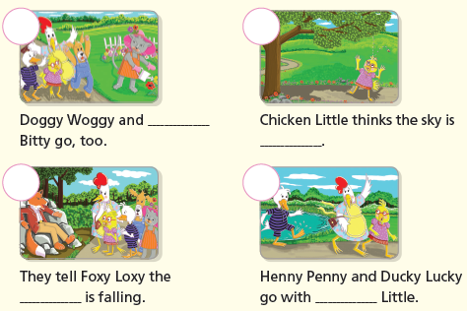

p.15 | Book Report | <Summary>  nut, sky, King, falling, None  <Lesson>  Smart

