Page | Activity | Answers
p.2 | Think Ahead | 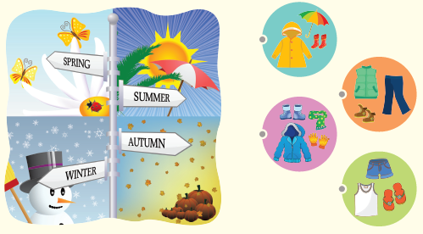  A.
 |  | B. Draw your own answer.
p.3 | Sentence Patterns | A.  1) Look!  2) The king is wearing  3) no clothes  B.  “Look! The king is wearing no clothes.”
pp.4~5 | Words to Know | A.  1) special 2) trick 3) wonderful  4) face 5) invisible 6) fool  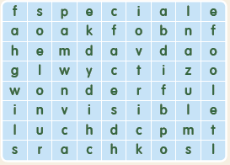
B.
1) walks
2) sends
3) smiles
4) thinks
pp.6~7 | Meet the Characters | 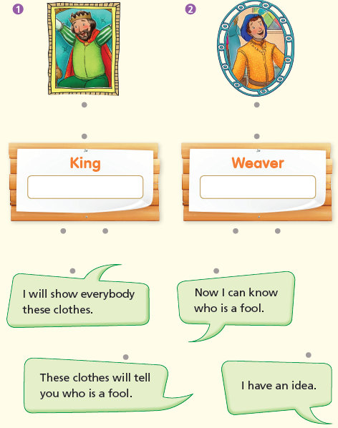  A.
B.
1) wonderful
2) fool
pp.8~11 | Comprehension | A.  1) F  2) F  3) T  4) F
B.
1) He doesn’t want to be a fool.
2) He cannot see the clothes.
3) Yes, they do.
4) Yes, they want him to be happy.
C.
1) weaver, wonderful
2) everybody, face
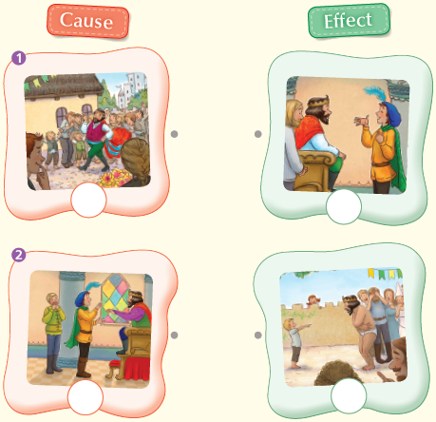
D.

pp.12~13 | Review Quiz | A.  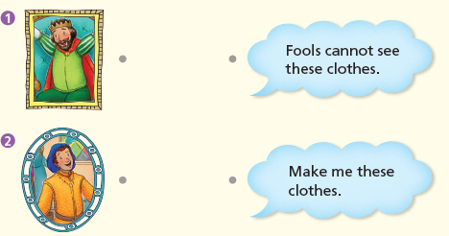
B.
1) clothes
2) tricks
3) no
4) wearing
5) king
C.
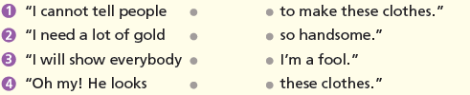

D.
1) a
2) b

E.
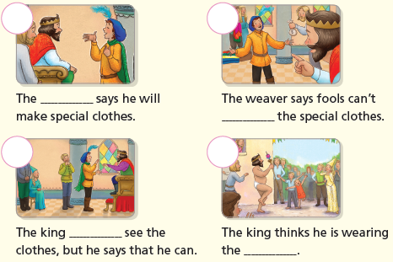

p.15 | Book Report | <Summary>  idea, clothes, fools, wonderful, face  <Lesson>  Don’t believe

