Page | Activity | Answers
p.2 | Think Ahead | A. <Sampel Answer>  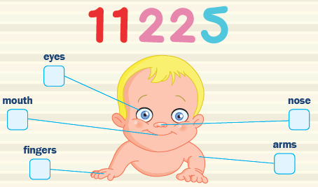
 |  | B. Write and Draw your own answer.
p.3 | Sentence Patterns | A.  1) Apple on the tree  2) I am Two-Eyes  3) Come to me  B.  “Apple on the tree, I am Two-Eyes. Come to me.”
pp.4~5 | Words to Know | A.  1) clean 2) goat 3) bleat  4) take away 5) asleep 6) awake  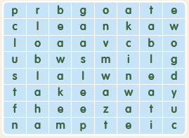
B.
1) Clean
2) Sing
3) Do
4) Come
pp.6~7 | Meet the Characters | 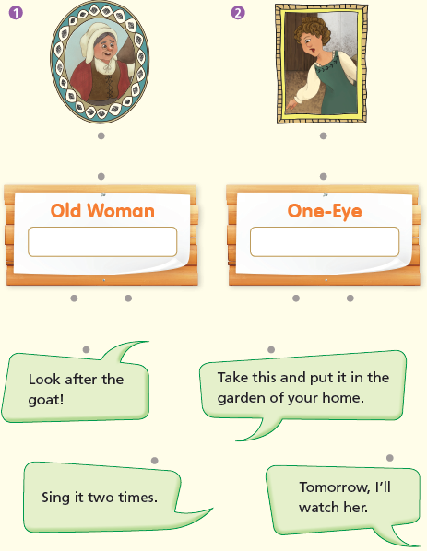  A.
B.
1) eat
2) Apple
pp.8~11 | Comprehension | A.  1) F  2) F  3) T  4) T
B.
1) Her goat
2) A tall tree
3) They are gold.
4) By singing a song
C.
1) Sing, bleat
2) awake, asleep
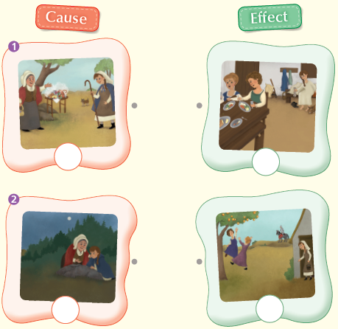
D.

pp.12~13 | Review Quiz | A.  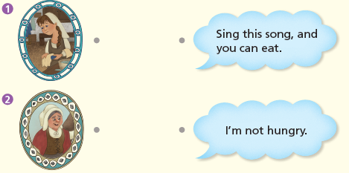
B.
1) goat
2) Bleat
3) awake
4) asleep
5) away
C.
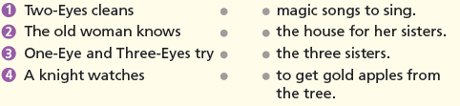

D.
1) a
2) b

E.
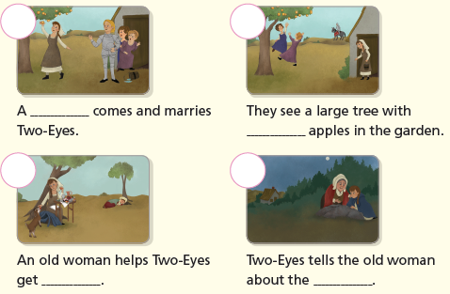

p.15 | Book Report | <Summary>  cleans, after, songs, garden, knight  <Lesson>  kind

