Page | Activity | Answers
p.2 | Think Ahead | A. <Sampel Answer>  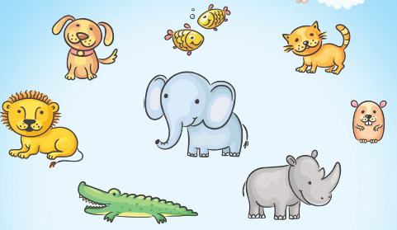
 |  | B. Draw your own answer.
p.3 | Sentence Patterns | A.  1) The girl  2) tells the king about  3) John and the dragon  B.  The girl tells the king about John and the dragon.
pp.4~5 | Words to Know | A.  1) dragon 2) wall 3) sheep  4) rock 5) kill 6) throw  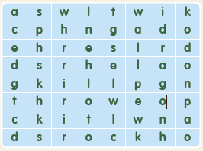
B.
1) meets
2) gets
3) lives
4) marries
pp.6~7 | Meet the Characters | 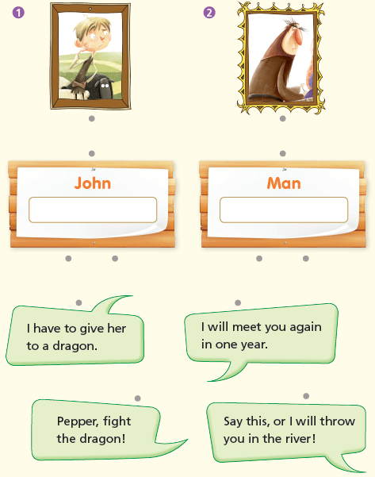  A.
B.
1) rocks
2) killing
pp.8~11 | Comprehension | A.  1) F  2) T  3) F  4) T
B.
1) He is very small.
2) He can get food.
3) To marry the girl
4) His daughter is young.
C.
1) dragon, throw
2) small, marries
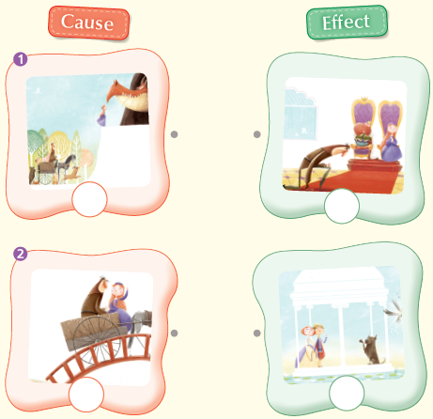
D.

pp.12~13 | Review Quiz | A.  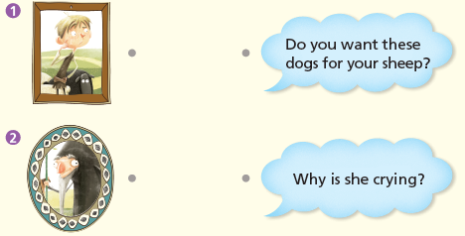
B.
1) sheep
2) dragon
3) kills
4) throw
5) wall
C.
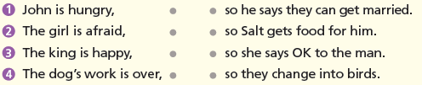

D.
1) a
2) a

E.
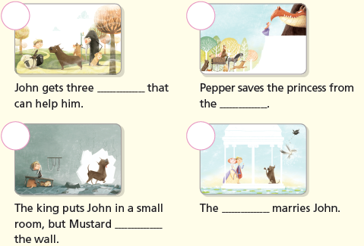

p.15 | Book Report | <Summary>  sheep, dragon, killing, wall, marries  <Lesson>  help

