Page | Activity | Answers
p.2 | Think Ahead | A. <Sample Answer>  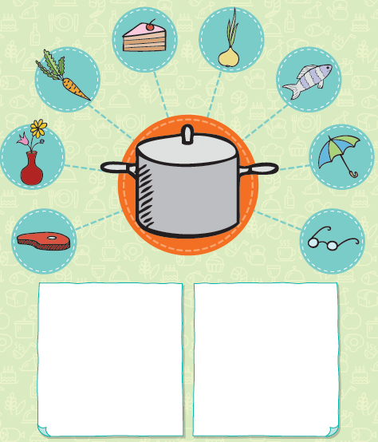
p.3 | Sentence Patterns | A.  1) Stone soup  2) is better  3) with salt and pepper  B.  “Stone soup is better with salt and pepper.”
pp.4~5 | Words to Know | A.  1) smell 2) cook 3) pot  4) stone 5) vegetables 6) meat  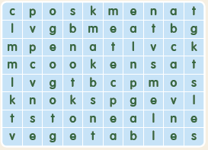
B.
1) have
2) hide
3) bring
4) love
pp.6~7 | Meet the Characters | 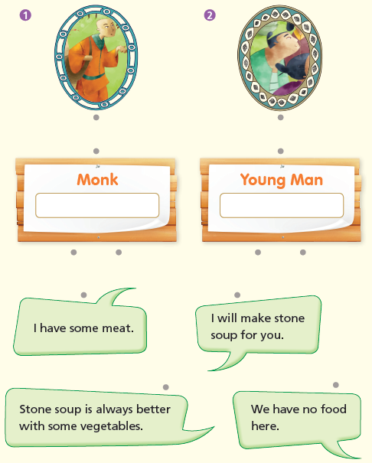  A.
B.
1) pot
2) vegetables
pp.8~11 | Comprehension | A.  1) F  2) T  3) T  4) F
B.
1) Soup
2) Some meat
3) They are dancing.
4) They have soup to eat.
C.
1) stone, vegetables
2) monk, goodbye
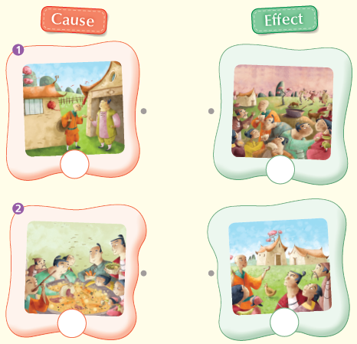
D.

pp.12~13 | Review Quiz | A.  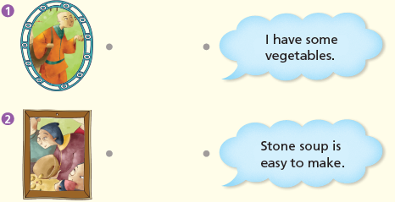
B.
1) stone
2) pot
3) cook
4) smells
5) meat
C.
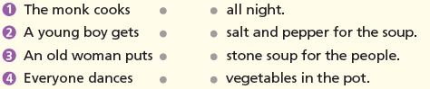

D.
1) a
2) a

E.
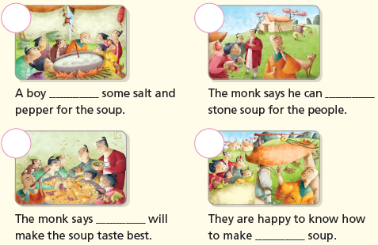

p.15 | Book Report | <Summary>  cook, pot, vegetables, smells, stone  <Lesson>  help

