Page | Activity | Answers
p.2 | Think Ahead | 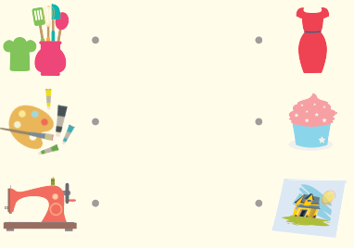  A.
 |  | B. Draw your own answer.
p.3 | Sentence Patterns | A.  1) The imp makes  2) the straw into gold  3) with the magic spinning wheel.  B.  The imp makes the straw into gold with the magic spinning wheel.
pp.4~5 | Words to Know | A.  1) wheel 2) necklace 3) magic  4) ring 5) straw 6) turn  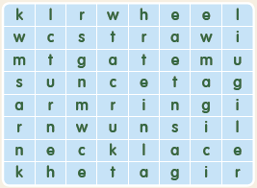
B.
1) wants
2) tries
3) appears
4) comes
pp.6~7 | Meet the Characters | 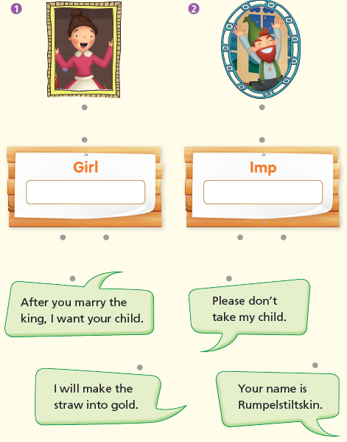  A.
B.
1) straw
2) gold
pp.8~11 | Comprehension | A.  1) T  2) T  3) F  4) T
B.
1) An imp
2) A ring
3) A baby
4) The imp wants her baby.
C.
1) daughter, turn
2) gold, straw
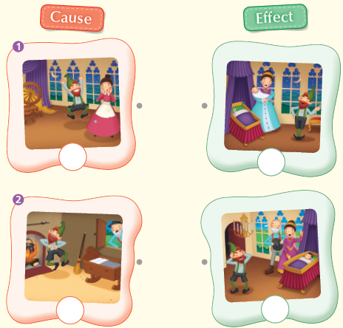
D.

pp.12~13 | Review Quiz | A.  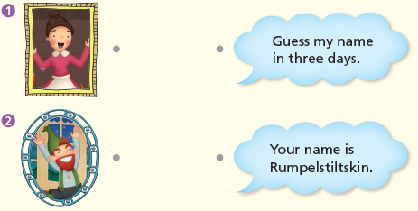
B.
1) turn into
2) straw
3) necklace
4) magic
5) ring
C.
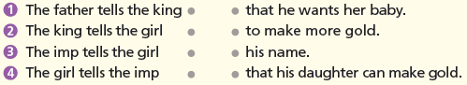

D.
1) a
2) b

E.
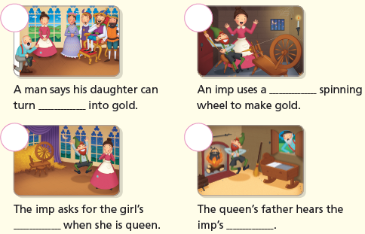

p.15 | Book Report | <Summary>  straw, spinning, necklace, queen, imp  <Lesson>  honest

