Page | Activity | Answers
p.2 | Think Ahead | 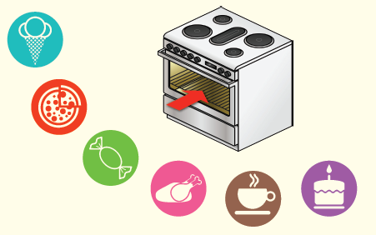  A.
 |  | B. Draw your own answer.
p.3 | Sentence Patterns | A.  1) Run, run  2) as fast as  3) you can  B.  “Run, run as fast as you can.”
pp.4~5 | Words to Know | A.  1) tail 2) nose 3) mouth  4) catch 5) oven 6) across  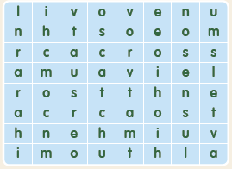
B.
1) puts
2) runs
3) comes
4) gets
pp.6~7 | Meet the Characters | 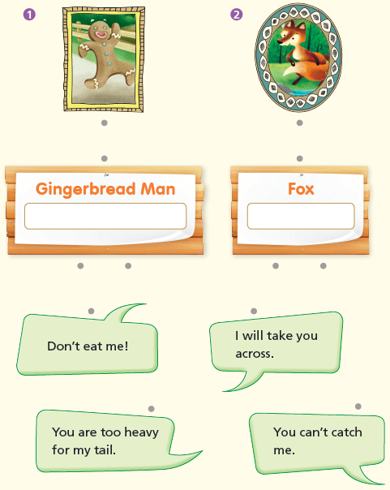  A.
B.
1) catch
2) nose
pp.8~11 | Comprehension | A.  1) F  2) F  3) F  4) T
B.
1) The gingerbread man
2) Running
3) Swimming
4) On the fox’s back
C.
1) tail, across
2) heavy, nose
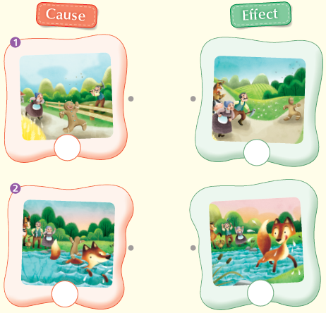
D.

pp.12~13 | Review Quiz | A.  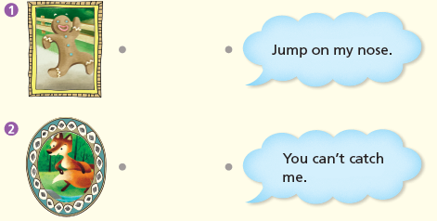
B.
1) oven
2) chases
3) comes
4) fox
5) eats
 |  | C.
D.
1) b
2) b

E.
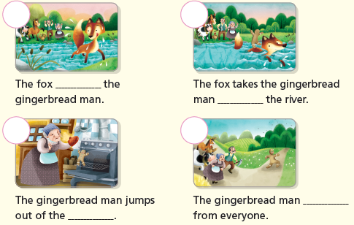

p.15 | Book Report | <Summary>  oven, chases, river, across, eats  <Lesson>  before

