Page | Activity | Answers
p.2 | Think Ahead | A. <Sample Answer>
 |  | B. Draw your own answer.
p.3 | Sentence Patterns | A.  1) Tortoise keeps on  2) walking to  3) the finishing line  B.  Tortoise keeps on walking to the finishing line.
pp.4~5 | Words to Know | A.  1) down 2) embarrassed 3) lettuce  4) win 5) race 6) finishing  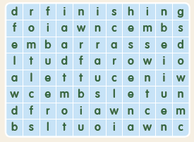
B.
1) walking
2) watching
3) finishing
4) sitting
pp.6~7 | Meet the Characters | A.  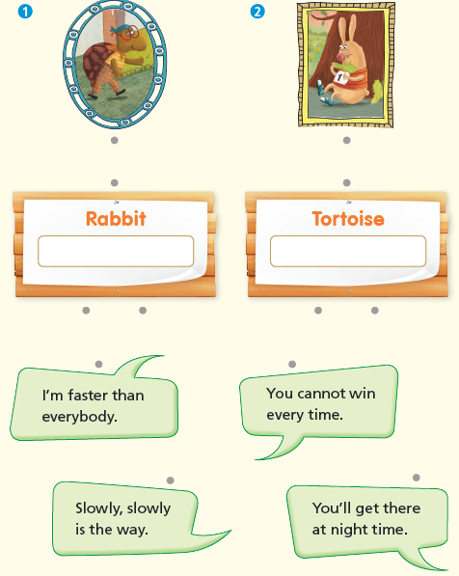
B.
1) race
2) finish
pp.8~11 | Comprehension | A.  1) F  2) T  3) T  4) F
B.
1) Rabbit and Tortoise
2) Yes
3) He walks.
4) Sitting in the sun
C.
1) race, falls
2) win, under
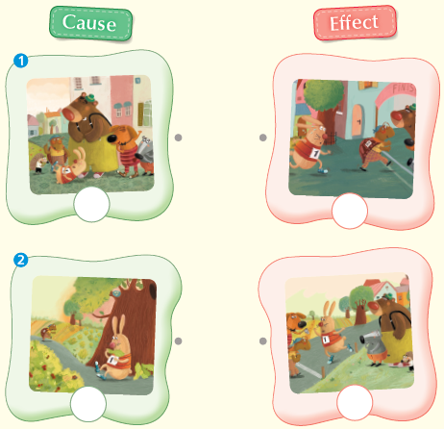
D.

pp.12~13 | Review Quiz | A.  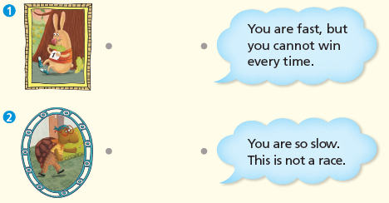
B.
1) falls
2) race
3) lettuce
4) finishing
5) wins
C.
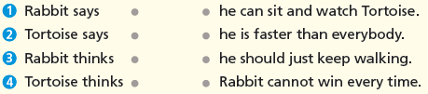

D.
1) b
2) b

E.
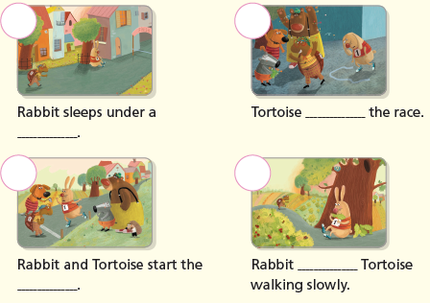

p.15 | Book Report | <Summary>  faster, race, slowly, finishing, embarrassed  <Lesson>  race

