Page | Activity | Answers
p.2 | Think Ahead | *Draw your own answer.
p.3 | Sentence Patterns | A.  1) I want  2) a golden apple  3) from the Tree of Life  B.  “I want a golden apple from the Tree of Life.”
pp.4~5 | Words to Know | A.  1) husband  2) ring  3) together  4) hear  5) snake
B.
1) brings
2) tells
3) speaks
4) gives
pp.6~7 | Meet the Characters | 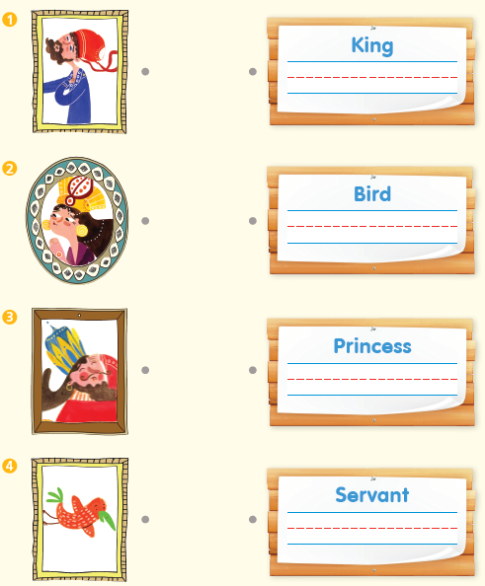  A.
B.
1) eat
2) apple
pp.8~11 | Comprehension | A.  1) F  2) F  3) T  4) T
B.
1) A snake
2) A strong man
3) The Princess
4) Birds bring it.
C.
1) ring, tells
2) servant, apple
D.
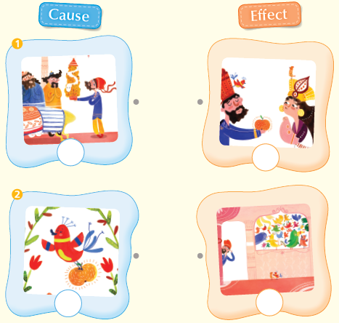

pp.12~13 | Review Quiz | A.  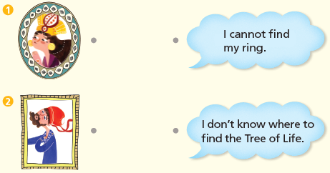
B.
1) snake
2) hears
3) ring
4) husband
5) together
C.
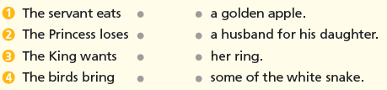

D.
1) a
2) b

E.
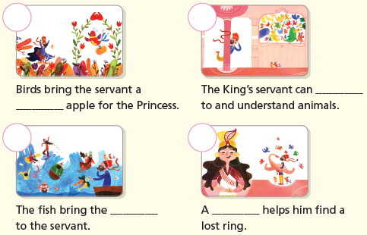

p.15 | Book Report | <Summary>  snake, ring, fish, golden, bring  <Lesson>  gifts

