Page | Activity | Answers
p.2 | Think Ahead | *Draw your own answer.
p.3 | Sentence Patterns | A.  1) Why  2) are you riding  3) the donkey  B.  “Why are you riding the donkey?”
pp.4~5 | Words to Know | A.  1) tired  2) heavy  3) unkind  4) terrible  5) shoulder
B.
1) walk
2) ride
3) meet
4) kill
pp.6~7 | Meet the Characters | 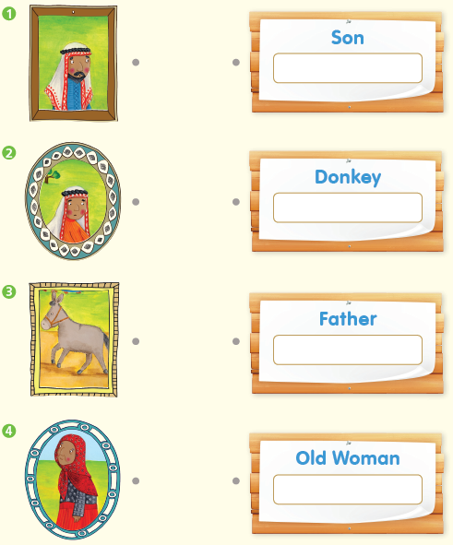  A.
B.
1) unkind
2) happy
pp.8~11 | Comprehension | A.  1) F  2) T  3) F  4) T
B.
1) The donkey
2) They laugh.
3) It runs away.
4) You can’t make everybody happy.
C.
1) tired, terrible
2) heavy, donkey
D.
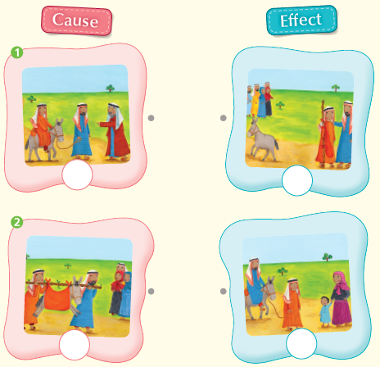

pp.12~13 | Review Quiz | A.  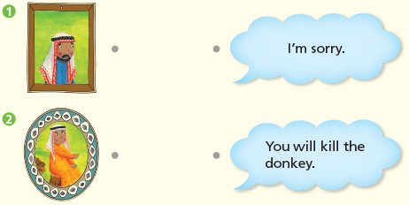
B.
1) tired
2) terrible
3) heavy
4) unkind
5) shoulders
C.
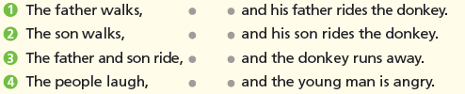

D.
1) a
2) a

E.
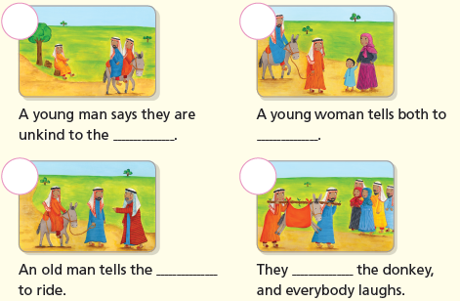

p.15 | Book Report | <Summary>  donkey, ride, unkind, carry, laughs  <Lesson>  follow

