Page | Activity | Answers
p.2 | Think Ahead | *Draw your own answer.
p.3 | Sentence Patterns | A.  1) Let’s  2) go back  3) to the tree  B.  “Let’s go back to the tree.”
pp.4~5 | Words to Know | A.  1) heart  2) smart  3) throw  4) hide  5) sick
B.
1) plays
2) sits on
3) needs
4) climbs up
pp.6~7 | Meet the Characters | 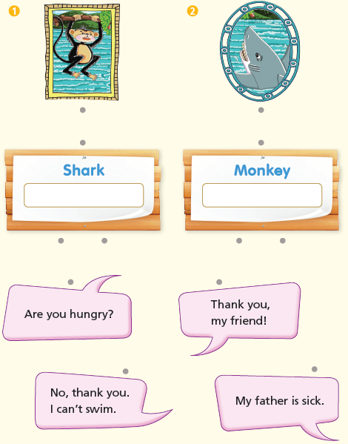  A.
B.
1) swim
2) friends
pp.8~11 | Comprehension | A.  1) T  2) T  3) F  4) F
B.
1) In a tree
2) Fruit
3) His family
4) His heart
C.
1) sisters, swim
2) smart, friends
D.
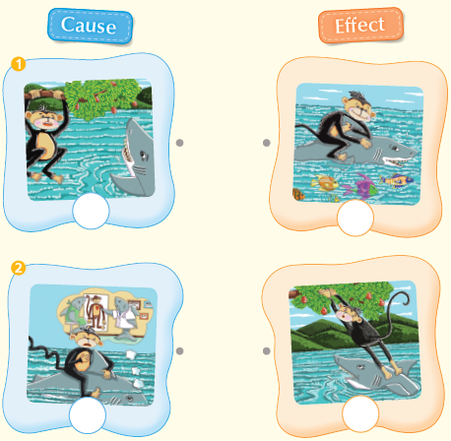

pp.12~13 | Review Quiz | A.  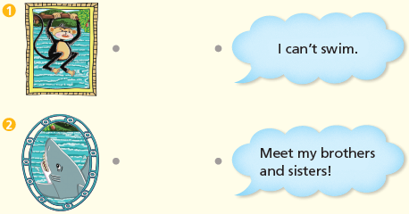
B.
1) throws
2) sick
3) heart
4) hides
5) smart
C.
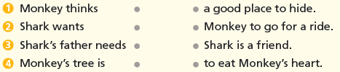

D.
1) b
2) a

E.
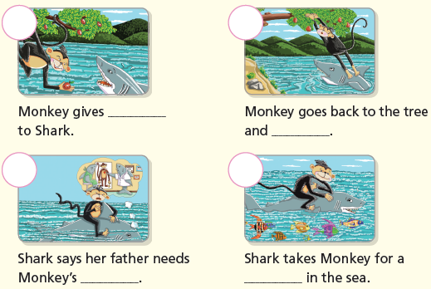

p.15 | Book Report | <Summary>  eats, fruit, needs, hides, heart  <Lesson>  friends

