Page | Activity | Answers
p.2 | Think Ahead | 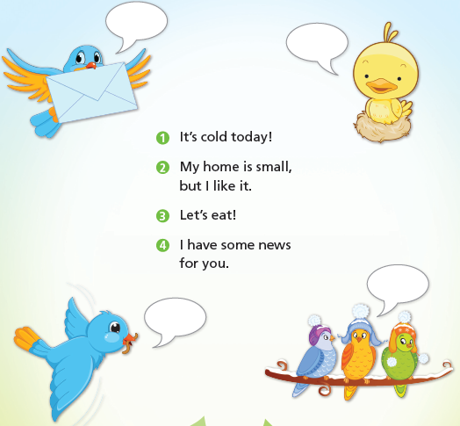
p.3 | Sentence Patterns | A.  1) No one  2) can understand  3) birds  B.  “No one can understand birds.”
pp.4~5 | Words to Know | A.  1) lost  2) storm  3) save  4) language  5) fool | B.  1) good  2) bad  3) poor  4) happy
pp.6~7 | Meet the Characters | A.  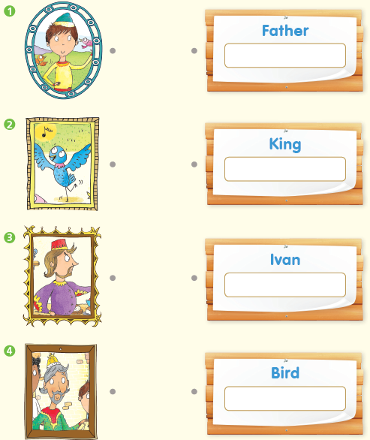
B.
1) good
2) birds
pp.8~11 | Comprehension | A.  1) F  2) T  3) T  4) F
B.
1) “You will be a prince. Your father will be your servant.”
2) Angry
3) On the window
4) His son
C.
1) boat, storm
2) castle, know
D.
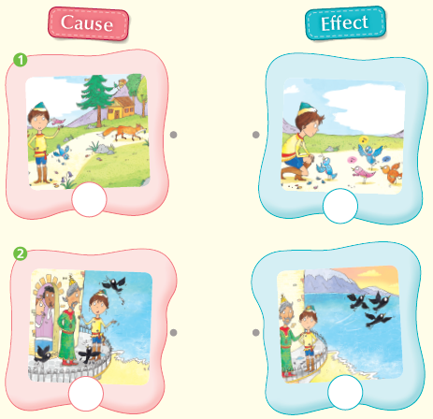

pp.12~13 | Review Quiz | A.  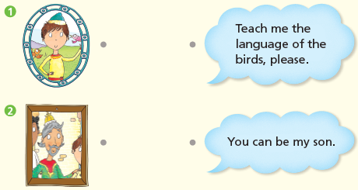
B.
1) saves
2) language
3) storm
4) fool
5) lost
C.
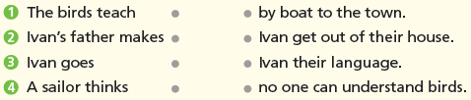

D.
1) b
2) b

E.
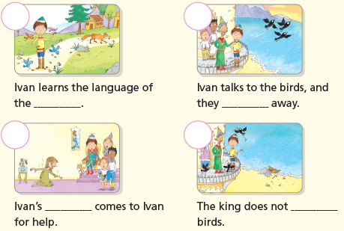

p.15 | Book Report | <Summary>  saves, language, storm, birds, happy  <Lesson>  trying

