Page | Activity | Answers
p.2 | Think Ahead | *Color the animals in a strage way.
p.3 | Sentence Patterns | A.  1) The young king  2) goes out  3) for a ride  B.  The young king goest out for a ride.
pp.4~5 | Words to Know | A.  1) grow up  2) lost  3) change  4) bottle  5) cute
B.
1) dies
2) goes
3) takes
4) has
pp.6~7 | Meet the Characters | 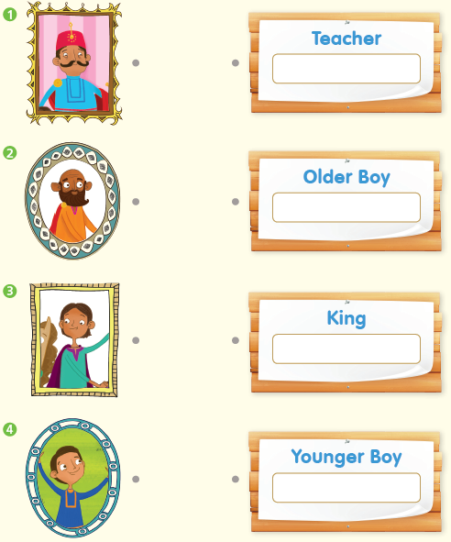  A.
B.
1) cute
2) happy
pp.8~11 | Comprehension | A.  1) T  2) T  3) F  4) T
B.
1) The older brother
2) The river
3) The teacher puts magic water on it.
4) Happy
C.
1) grow, ride
2) lost, queen
D.
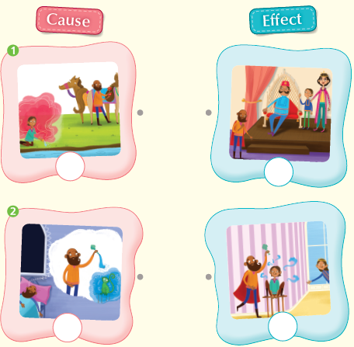

pp.12~13 | Review Quiz | A.  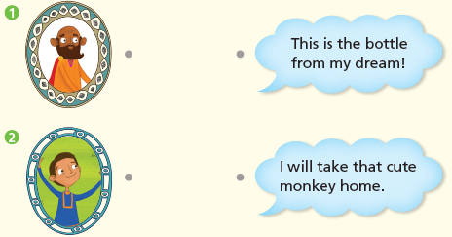
B.
1) grow up
2) lost
3) cute
4) bottle
5) changes
C.
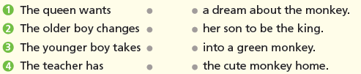

D.
1) a
2) a

E.
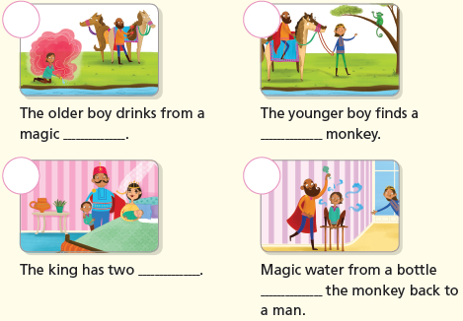

p.15 | Book Report | <Summary>  two, magic, monkey, dreams, kings  <Lesson>  love

