Page | Activity | Answers
p.2 | Think Ahead | *Draw your own answer.
p.3 | Sentence Patterns | A.  1) The four dragons  2) are angry with  3) the king  B.  The four dragons are angry with the king.
pp.4~5 | Words to Know | A.  1) sky  2) dry  3) grow  4) palace  5) rain
B.
1) sad
2) angry
3) happy
4) bad
pp.6~7 | Meet the Characters | 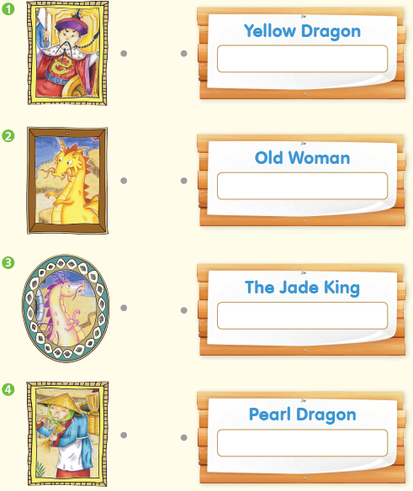  A.
B.
1) sad
2) rain
pp.8~11 | Comprehension | A.  1) F  2) T  3) F  4) F
B.
1) At the Great Palace
2) To make rain
3) In the mountains
4) Four rivers
C.
1) dry, idea
2) sky, rain
D.
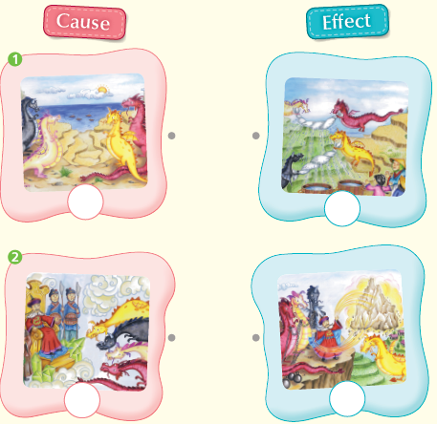

pp.12~13 | Review Quiz | A.  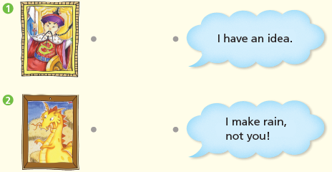
B.
1) dry
2) palace
3) sky
4) rain
5) grow
C.
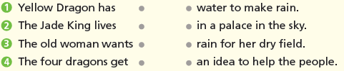

D.
1) a
2) a

E.
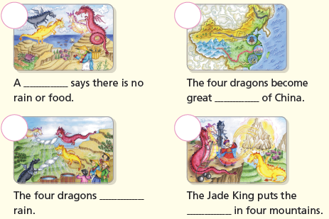

p.15 | Book Report | <Summary>  dragons, rain, make, mountains, great  <Lesson>  rivers

