Page | Activity | Answers
p.2 | Think Ahead | *Draw your own answer.
p.3 | Sentence Patterns | A.  1) Every day  2) Bearskin looks  3) more like a bear  B.  Every day Bearskin looks more like a bear.
pp.4~5 | Words to Know | A.  1) pocket  2) ring  3) nails  4) bearskin  5) coat
B.
1) has
2) looks
3) takes
4) buys
pp.6~7 | Meet the Characters | 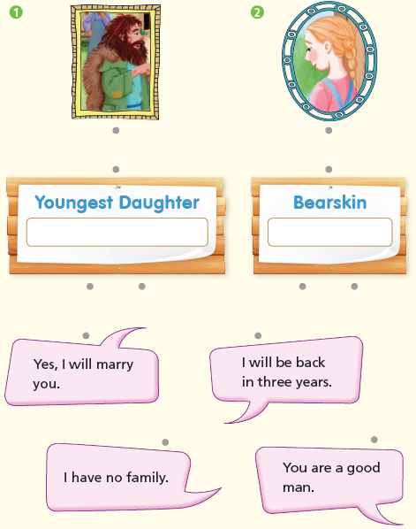  A.
B.
1) rich
2) bear
pp.8~11 | Comprehension | A.  1) T  2) T  3) T  4) F
B.
1) A coat
2) You will be rich in seven years.
3) Gold
4) Three
C.
1) poor, nails
2) clothes, handsome
D.
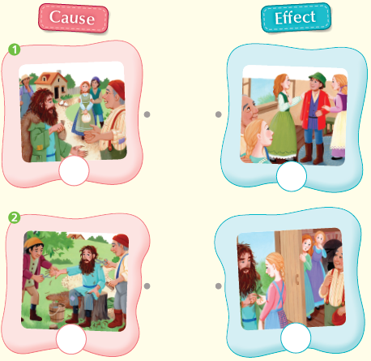

pp.12~13 | Review Quiz | A.  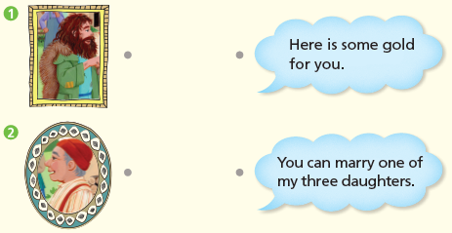
B.
1) coat
2) pockets
3) bearskin
4) nails
5) ring
C.
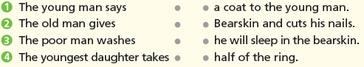

D.
1) b
2) a

E.
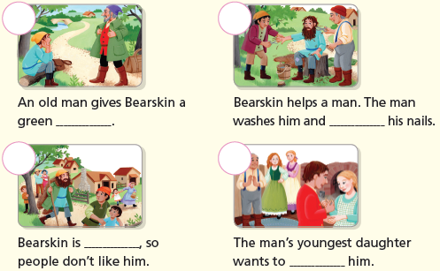

p.15 | Book Report | <Summary>  gives, gold, marry, rich, daughter  <Lesson>  look

