Page | Activity | Answers
p.2 | Think Ahead | *Draw your own answer.
p.3 | Sentence Patterns | A.  1) Come to  2) dinner  3) at my house  B.  “Come to dinner at my house, Fox.”
pp.4~5 | Words to Know | A.  1) jar  2) soup  3) dish  4) clean  5) dinner
B.
1) asks
2) looks
3) goes
4) tries
pp.6~7 | Meet the Characters | 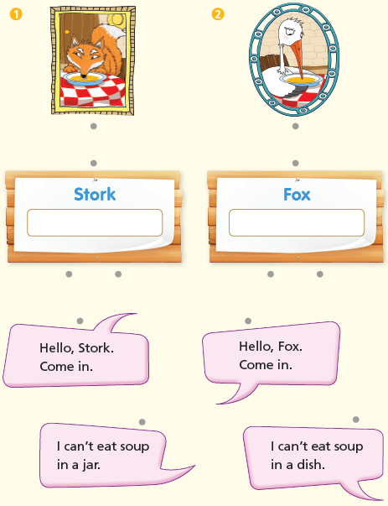  A.
B.
1) soup
2) dinner
pp.8~11 | Comprehension | A.  1) T  2) F  3) T  4) F
B.
1) Hungry
2) Come to my house.
3) Dinner
4) Soup
C.
1) jar, hungry
2) teach, nice
D.
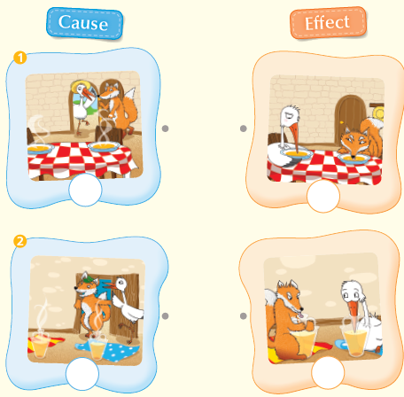

pp.12~13 | Review Quiz | A.  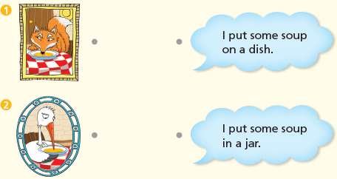
B.
1) dinner
2) soup
3) dish
4) cleans
5) jar
 |  | C.
D.
1) a
2) a

E.
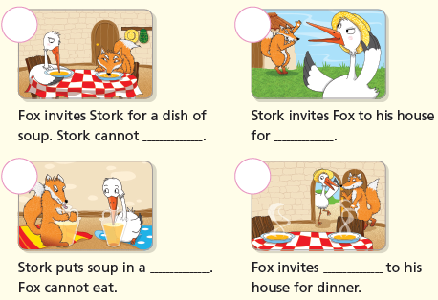

p.15 | Book Report | <Summary>  Fox, soup, cannot, house, jar  <Lesson>  bad

