Smart English
Workbook Starter
Answer Keys

Lesson 1 Toys

A. Look and Say | • Find and say.  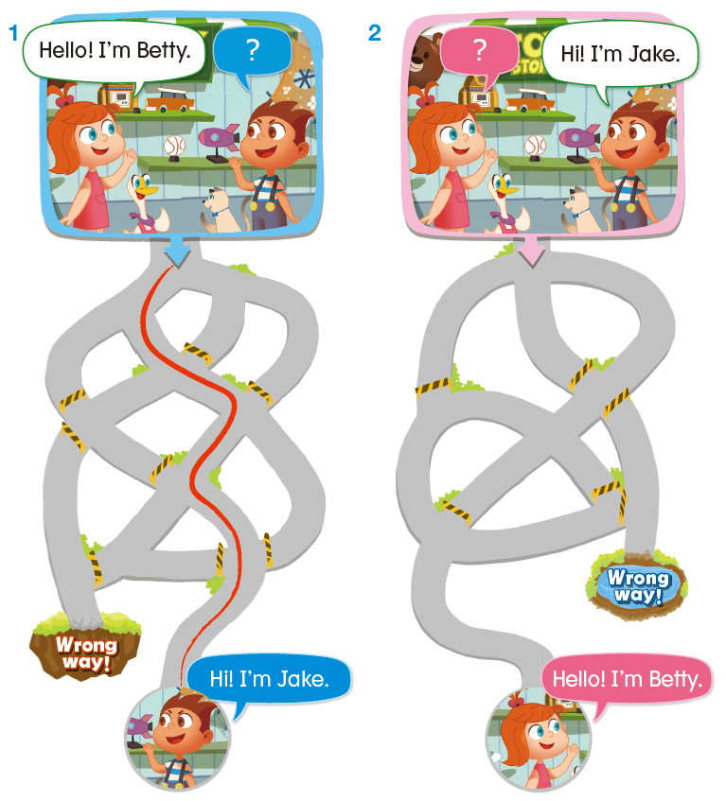
B. Look and Learn | • Match and trace.  1. c 2. a  3. d 4. b
C. Look and Practice | • Trace and find.  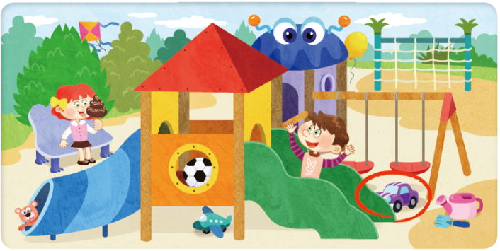
D. Look and Read | 1. Look and circle.  1. B b 2. A a  3. A a 4. B b  2. Match and trace.  1. b 2. a  3. b 4. a

Lesson 2 Classroom

B. Look and Learn | • Match and trace.  1. b – e 2. a – g  3. d – f 4. c – h
C. Look and Practice | • Match and say.  1. a 2. b  3. b 4. a
D. Look and Read | 1. Read and circle.  1. b 2. c  3. a 4. c

Lesson 3 Jump Up 1

A. Link and Say. | • Look, number, and say.  2 – 1 – 3 – 4
B. Link and Practice | • Match and say.  1. c  2. b  3. a
C. Link and Read | • Read and match.  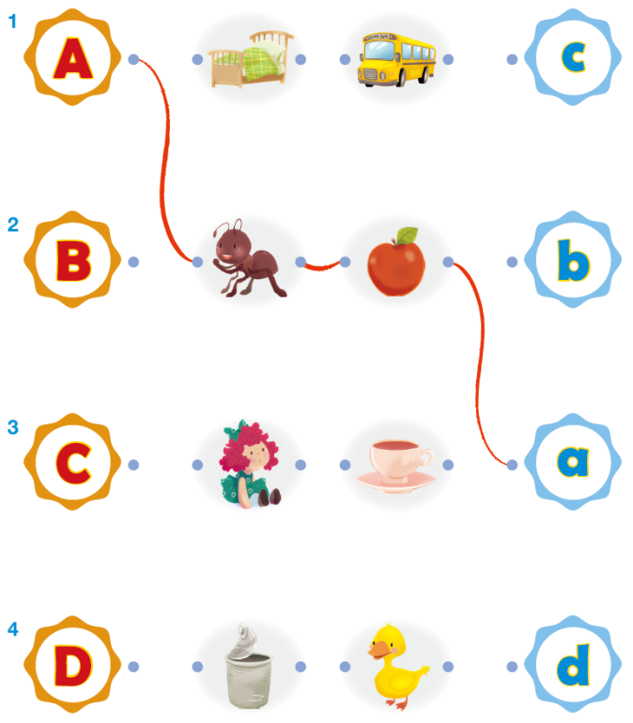
D. Link and Write | 1. Match and trace.  1. b 2. a 3. d 4. c  5. e 6. f 7. h 8. g

Lesson 4 Pets

A. Look and Say | • Find and say.  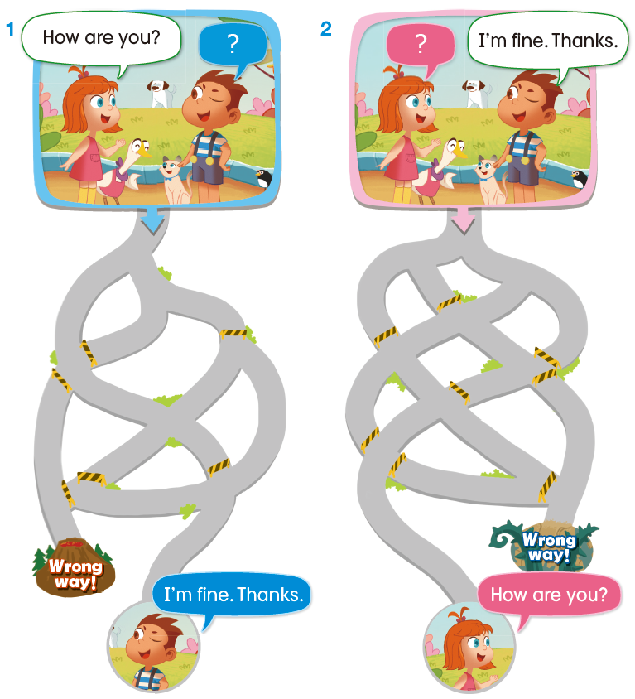
B. Look and Learn | • Match and trace.  1. b 2. a  3. d 4. c
C. Look and Practice | • Trace and find.  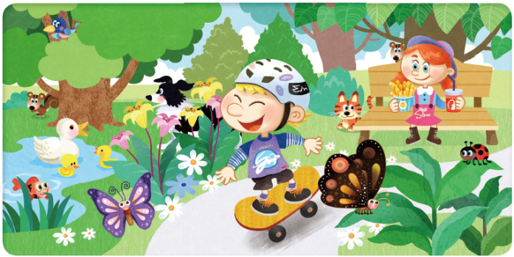
D. Look and Read | 1. Look and circle.  1. E e 2. F f  3. F f 4. E e  2. Match and trace.  1. a 2. b  3. b 4. a

Lesson 5 Farm Animals

B. Look and Learn | • Match and trace.  1. c – f 2. b – e  3. d – h 4. a – g
C. Look and Practice | • Match and say.  1. b 2. a  3. a 4. b
D. Look and Read | 1. Read and circle.  1. b 2. a  3. b 4. c

Lesson 6 Jump Up 2

A. Link and Say | • Look, number, and say.  2 – 3 – 1 – 4
B. Link and Practice | • Match and say.  1. b  2. c  3. a
C. Link and Read | • Read and match.  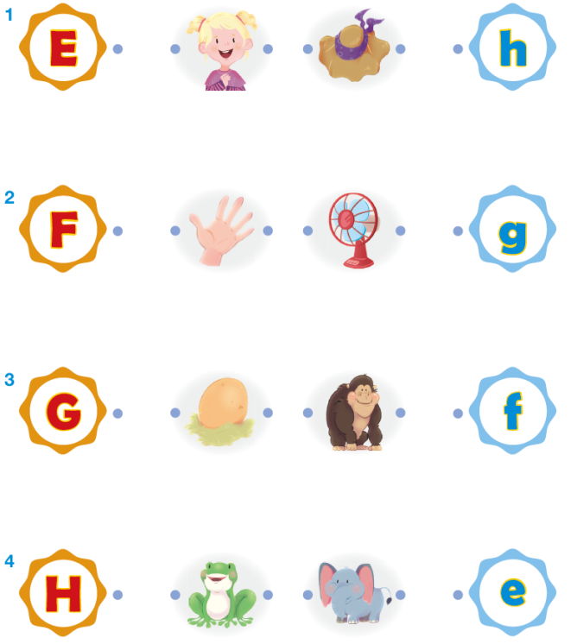
D. Link and Write | • Match and trace.  1. c 2. d 3. a 4. b  5. g 6. e 7. h 8. f

Lesson 7 Numbers

A. Look and Say | • Find and say.  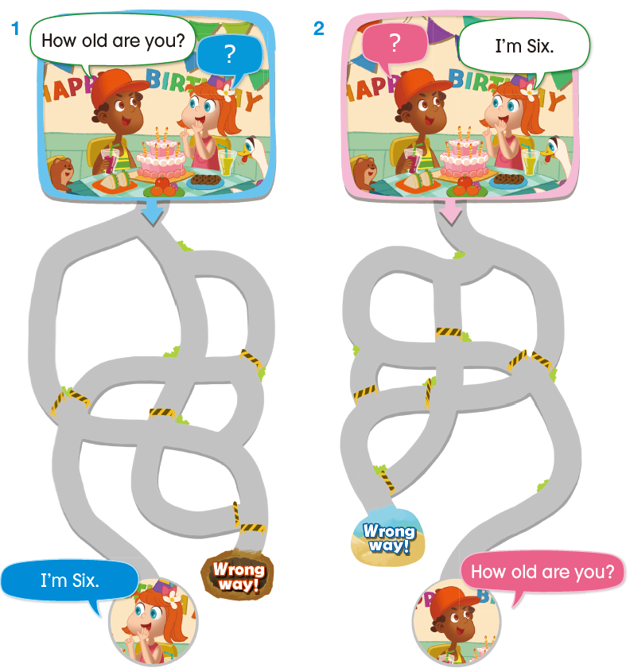
B. Look and Learn | • Color and trace.  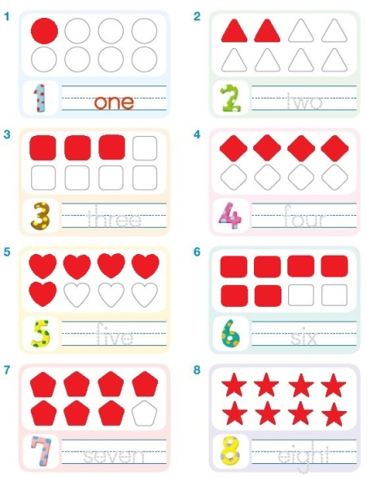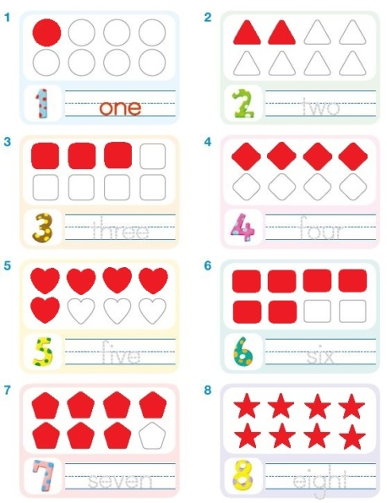
C. Look and Practice | • Match and trace.  1. b 2. a  3. d 4. c
D. Look and Read | 1. Look and circle.  1. J j 2. I i  3. J j 4. I i  2. Match and trace.  1. a 2. b  3. b 4. a

Lesson 8 Colors

B. Look and Learn | • Match, color, and trace.  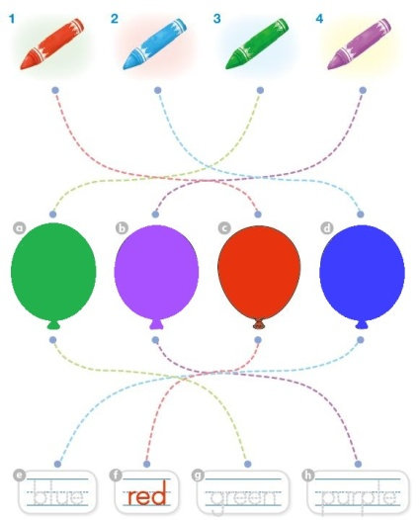
C. Look and Practice | • Color and say.  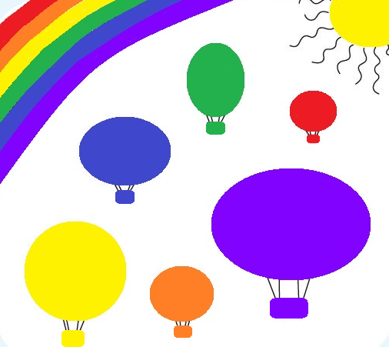
D. Look and Read | 1. Read and circle.  1. a 2. c  3. b 4. c

Lesson 9 Jump Up 3

A. Link and Say. | • Look, number, and say.  3 – 2 – 1 - 4
B. Link and Practice | • Match and say.  1. b  2. c  3. a
C. Link and Read | • Read and match.  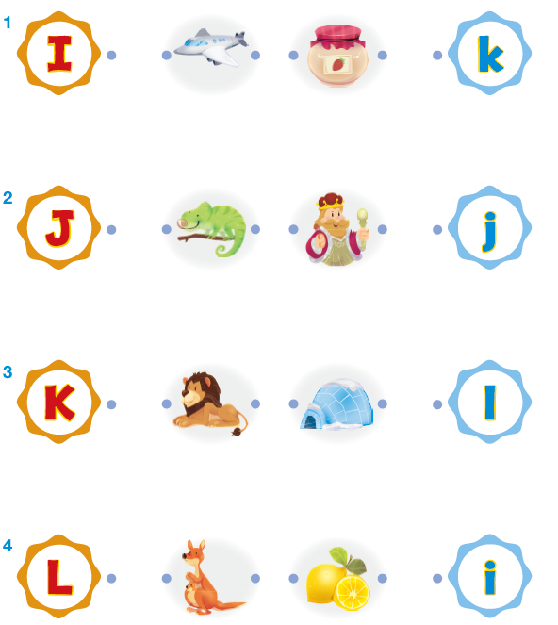

Lesson 10 Show Your Progress 1

A. Reading | 1. Read and circle.  1. b  2. a  3. c  2. Look and circle.  1. a 2. c  3. a 4. b  3. Read and match.  1. b 2. d 3. a 4. c  5. h 6. g 7. f 8. e

Lesson 11 School Things

A. Look and Say | • Find and say.  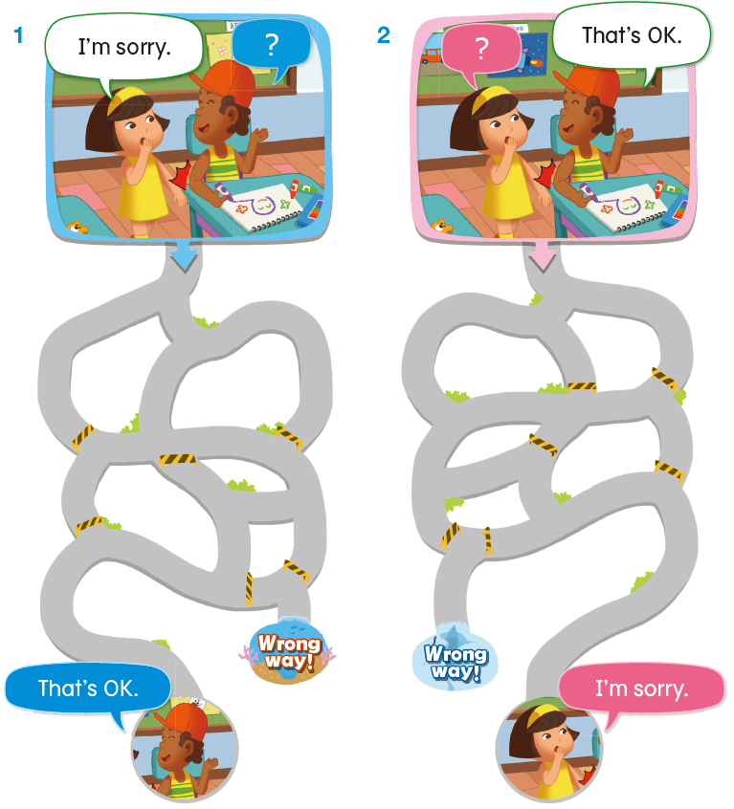
B. Look and Learn | • Match and trace.  1. d 2. c  3. a 4. b
C. Look and Practice | • Trace and find.  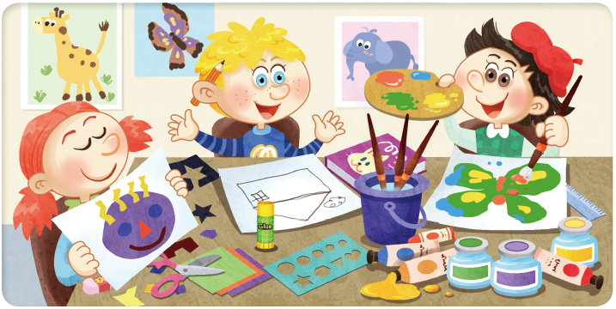
D. Look and Read | 1. Look and circle.  1. N n 2. M m  3. N n 4. M m  2. Match and trace.  1. a 2. b  3. b 4. a

Lesson 12 My Things

B. Look and Learn | • Match and trace.  1. b – h 2. c – f  3. d – e 4. a – g
C. Look and Practice | • Look, check, and say.  1. Yes, I do. 2. No, I don’t.  3. Yes, I do. 4. No, I don’t.
D. Look and Read | 1. Read and circle.  1. a 2. b  3. a 4. b

Lesson 13 Jump Up 4

A. Link and Say. | • Look, number, and say.  2 – 4 – 3 – 1
B. Link and Practice | • Match and say.  1. b  2. a  3. c
C. Link and Read | • Read and match.  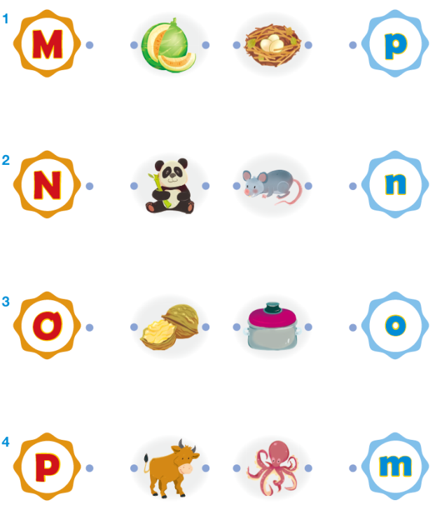
D. Link and Write | • Match and trace.  1. b 2. a 3. d 4. c  5. f 6. e 7. h 8. g

Lesson 14 Actions

A. Look and Say | • Find and say.  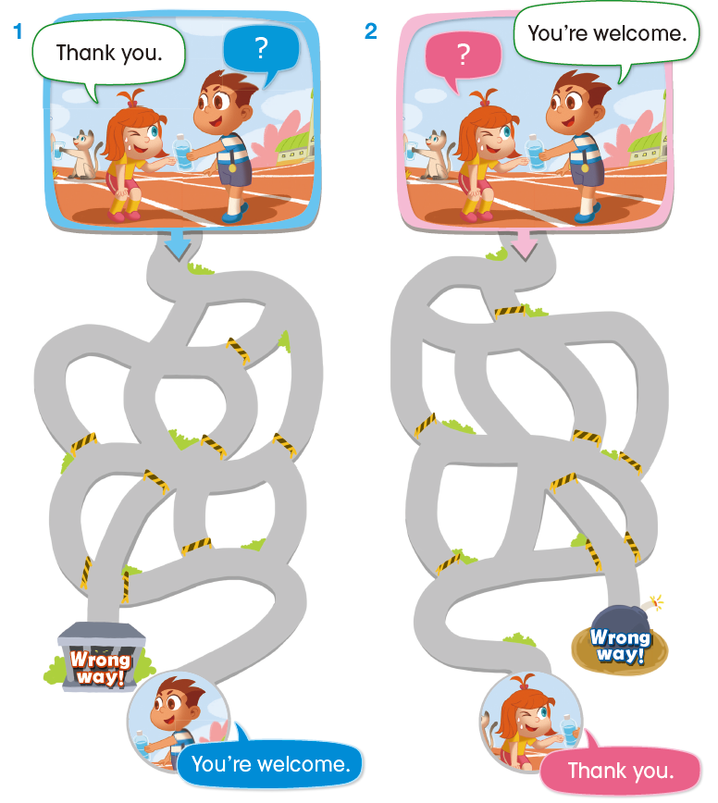
B. Look and Learn | • Match and trace.  1. d 2. a  3. b 4. c
C. Look and Practice | • Trace and find.  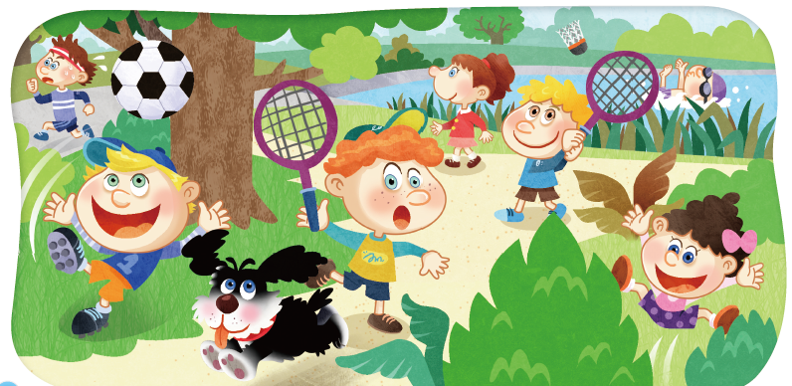
D. Look and Read | 1. Look and circle.  1. Q q 2. R r  3. R r 4. Q q  2. Match and trace.  1. a 2. b  3. a 4. b

Lesson 15 More Actions

B. Look and Learn | • Match and trace.  1. d – e 2. c – g  3. a – f 4. b – h
C. Look and Practice | • Look, check, and say.  1. No, I can’t. 2. Yes, I can.  3. Yes, I can. 4. No, I can’t.
D. Look and Read | 1. Read and circle.  1. c 2. b  3. b 4. c

Lesson 16 Jump Up 5

A. Link and Say. | • Look, number, and say.  1 – 4 – 3 – 2
B. Link and Practice | • Match and say.  1. c  2. a  3. b
C. Link and Read | • Read and match.  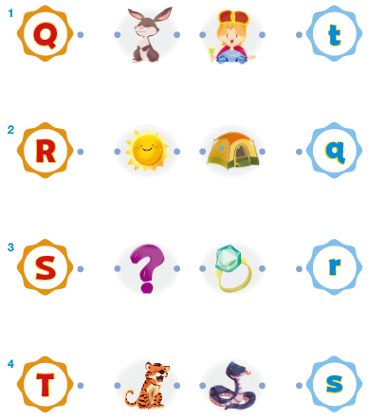
D. Link and Write | 1. Match and trace.  1. d 2. c 3. b 4. a  5. g 6. h 7. e 8. f

Lesson 17 Fruit

A. Look and Say | • Find and say.  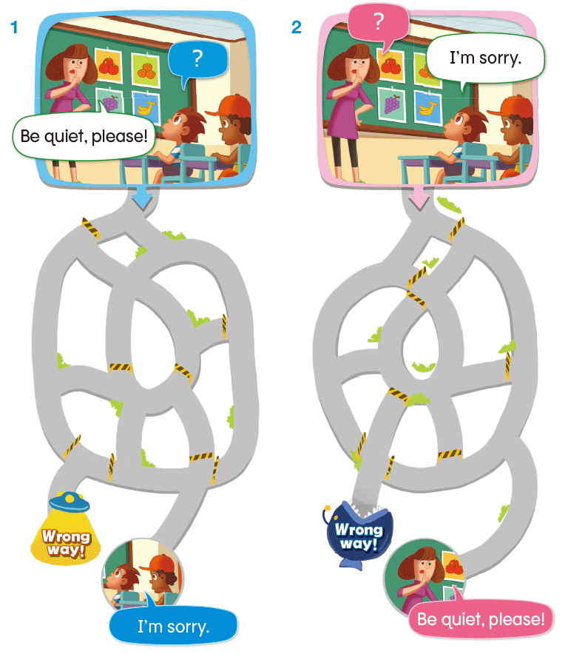
B. Look and Learn | • Match and trace.  1. d 2. c  3. b 4. a
C. Look and Practice | • Trace and find.  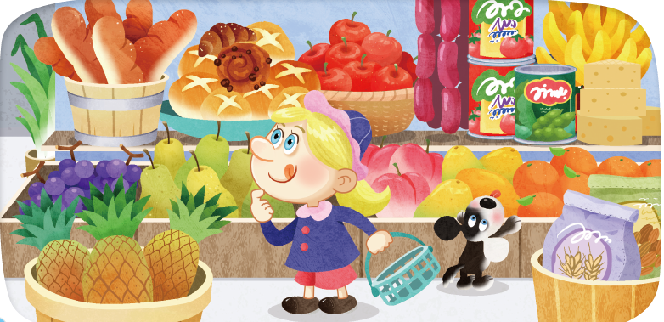
D. Look and Read | 1. Look and circle.  1. V v 2. W w  3. U u 4. V v  2. Match and trace.  1. a 2. c  3. c 4. b

Lesson 18 Food

B. Look and Learn | • Match and trace.  1. b – h 2. a – g  3. d – e 4. c – h
C. Look and Practice | • Look, check, and say.  1. Yes, I do. 2. No, I don’t.  3. No, I don’t. 4. Yes, I do.
D. Look and Read | 1. Read and circle.  1. a  2. c  3. b

Lesson 19 Jump Up 6

A. Link and Say. | • Look, number, and say.  4 – 1 – 2 – 3
B. Link and Practice | • Match and say.  1. c  2. b  3. a
C. Link and Read | • Read and match.  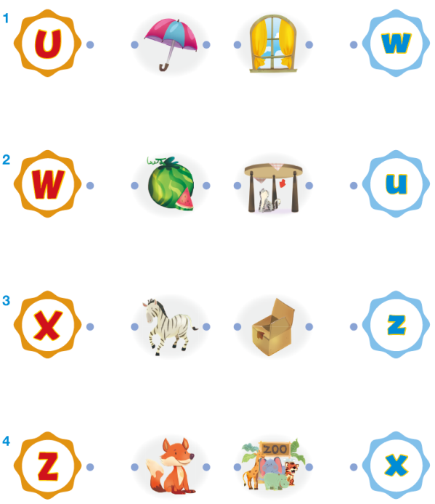
D. Link and Write | 1. Match and trace.  1. c 2. a 3. b 4. d  5. g 6. e 7. h 8. f

Lesson 20 Show Your Progress 2

A. Reading | 1. Read and circle.  1. b  2. r  3. c  2. Look and circle.  1. c 2. a  3. c 4. b  3. Read and match.  1. b 2. d 3. a 4. c  5. g 6. h 7. f 8. e

