Smart English
Student Book Starter
Answer Keys

Lesson 1 Toys

A. Look and Say | 2. Look and act out.  <Answers may vary.>  1. Hi! I’m Jake.  2. Hello! I’m Betty.
D. Look and Read | 2. Look and find.

Lesson 2 Classroom

A. Look and Say | 2. Look and act out.  <Answers may vary.>  1. I’m Ken.  2. What’s your name?
D. Look and Read | 2. Look and find.  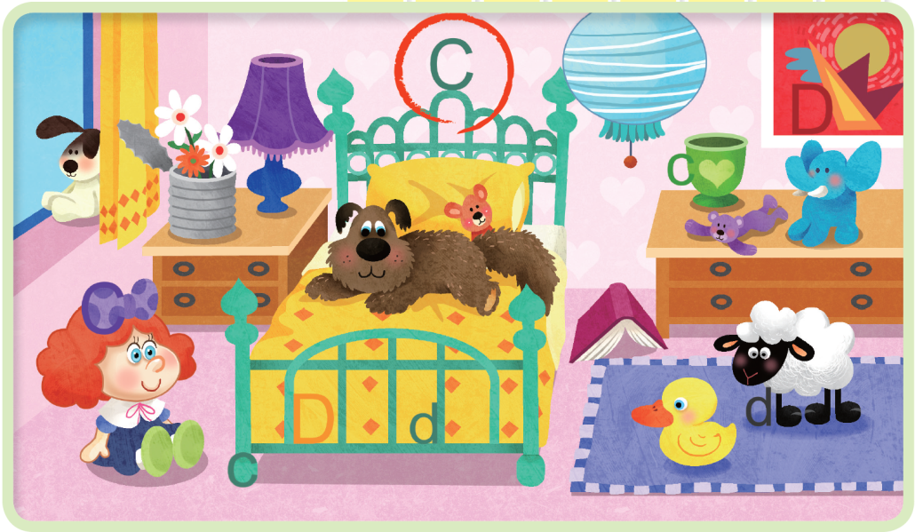

Lesson 3 Jump Up 1

B. Link and Practice | • Listen and number.  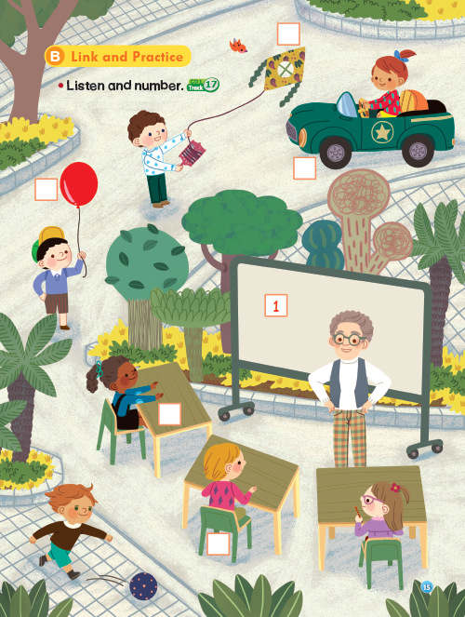  3  4  1  6  2  5
C. Link and Do | 2. Listen and number.  5-1-6-3-2-4

Lesson 4 Pets

A. Look and Say | 2. Look and act out.  1. I’m fine. Thanks.  2. How are you?
D. Look and Read | 2. Look and find.  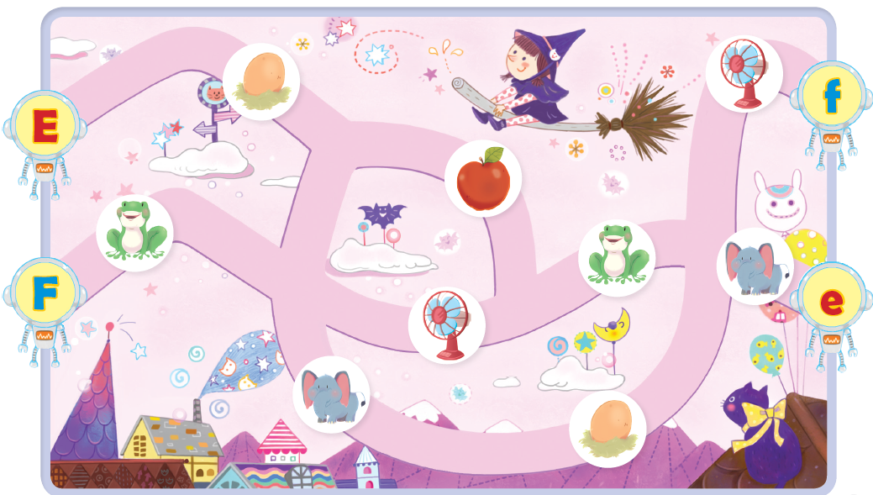

Lesson 5 Farm Animals

A. Look and Say | 2. Look and act out.  <Answers may vary.>  1. See you later!  2. Bye, Tina!
D. Look and Read | 2. Look and find.  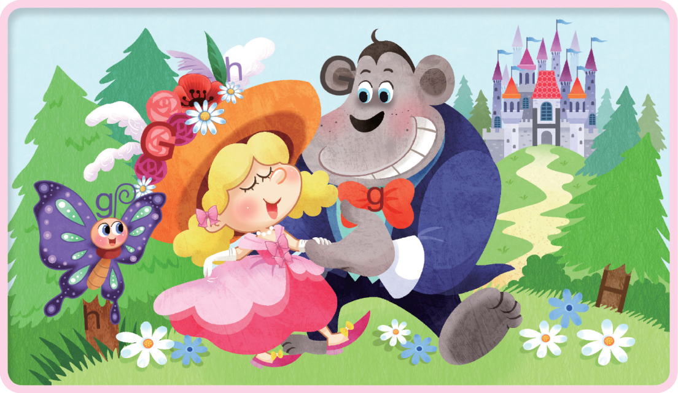
Lesson 6 Jump Up 2

B. Link and Practice | • Listen and number.  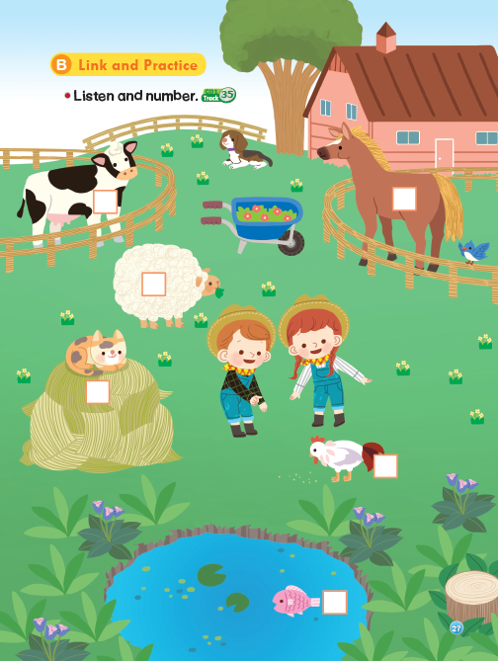  6  1  3  5  4  2
C. Link and Do | 2. Listen and number.  4-2-3-5-1-6

Lesson 7 Numbers

A. Look and Say | 2. Look and act out.  <Answers may vary.>  1. I’m six.  2. How old are you?
D. Look and Read | 2. Look and find.  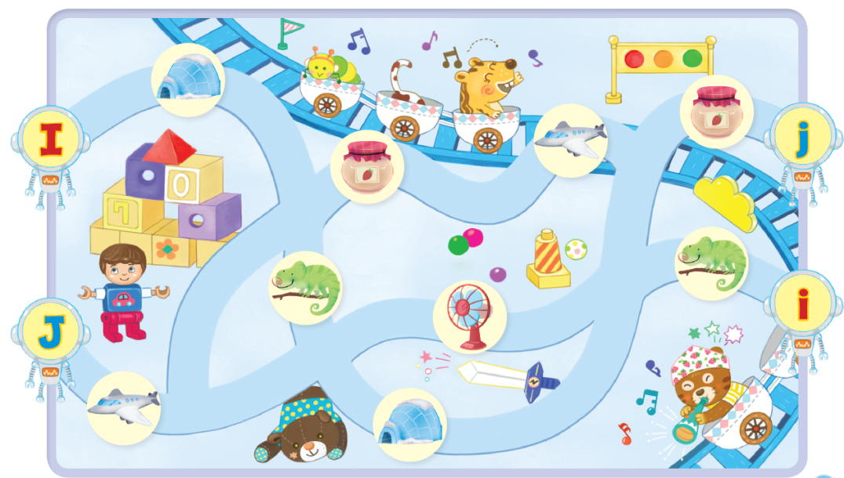

Lesson 8 Colors

A. Look and Say | 2. Look and act out.  1. Thank you.  2. Here you are.
D. Look and Read | 2. Look and find.  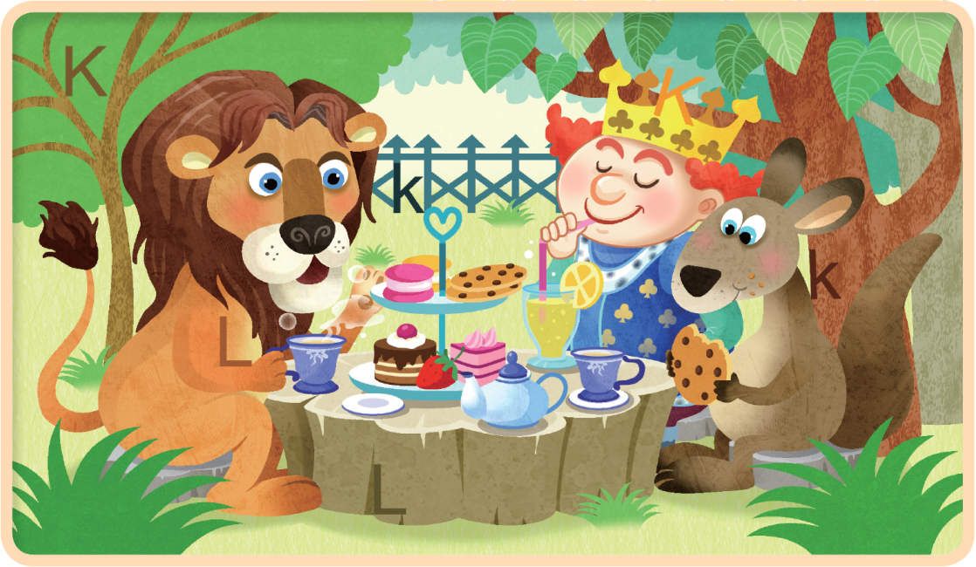

Lesson 9 Jump Up 3

B. Link and Practice | • Listen and circle.  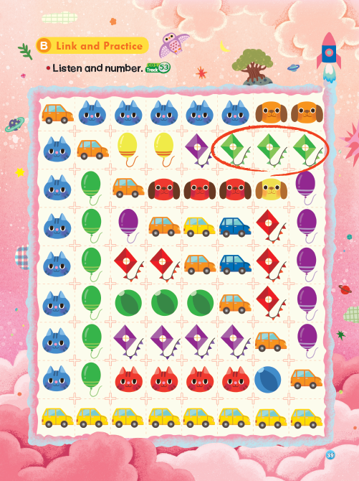
C. Link and Do | 2. Listen and circle.  1. b 2. a  3. a 4. b

D. Link and Play | • Spot the difference.  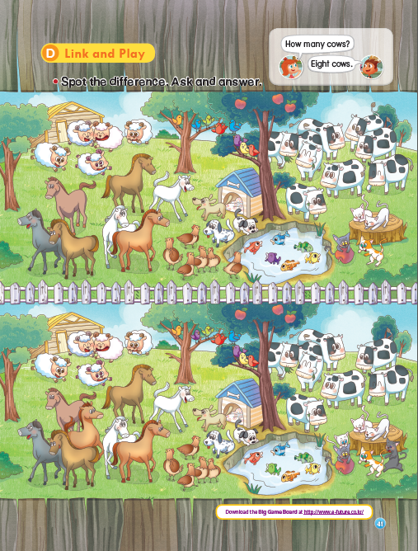

Lesson 10 Show Your Progress 1

A. Listening | 1. Listen and number.  2-1-3-6-5-4  1. Listen and circle.  1. a 2. b  3. b 4. a
B. Reading | 1. Circle the correct pair.  1. b 2. a 3. c  2. Read and match.  1. b 2. d 3. a 4. c
C. Speaking | 1. Listen and reply.  <Answers may vary.>  1. I’m six.  2. Thank you.  3. My name is Betty.  2. Look, listen, and answer.  1. It’s a cow.  2. Yes, it is.  3. It’s red.  4. Six birds.  5. Yes, it is.  6. No, it isn’t. It’s a chicken.
Make a Story | 1. Look, listen, and write the number.  2-1-4-3-5-6

Lesson 11 School Things

A. Look and Say | 2. Look and act out.  1. That’s OK.  2. I’m sorry.
D. Look and Read | 2. Look and find.  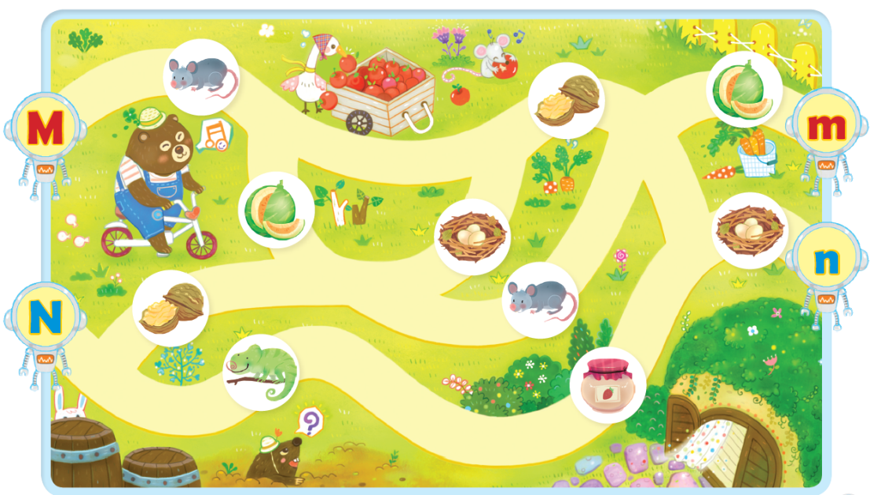

Lesson 12 My Things

A. Look and Say | 2. Look and act out.  1. Yes. Thanks.  2. Are you OK?
D. Look and Read | 2. Look and find.  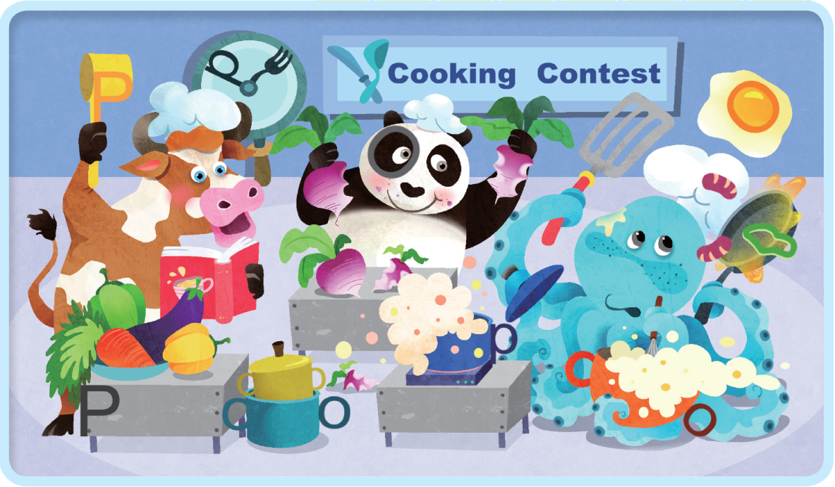

Lesson 13 Jump Up 4

B. Link and Practice | • Listen and number.  4-2-1-5-6-3
C. Link and Do | 2. Listen and circle.  1. b 2. a  3. a 4. b

Lesson 14 Actions

A. Look and Say | 2. Look and act out.  1. You’re welcome.  2. Thank you.
D. Look and Read | 2. Look and find.  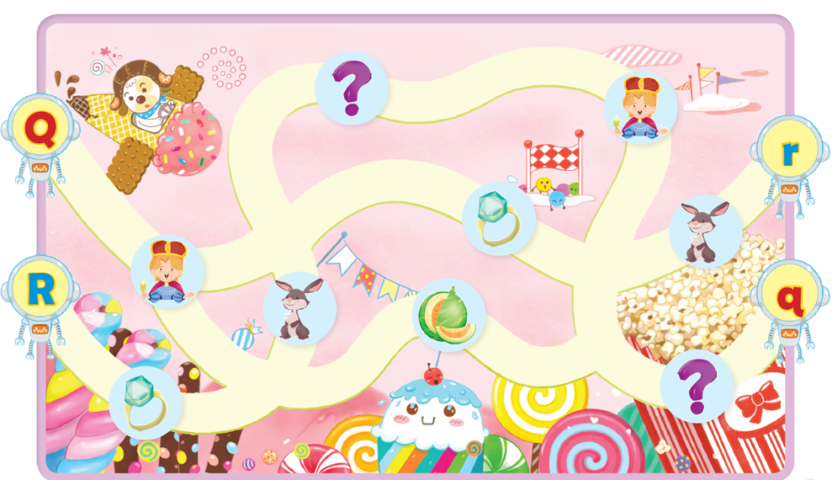

Lesson 15 More Actions

A. Look and Say | 2. Look and act out.  1. Excuse me.  2. Yes?
D. Look and Read | 2. Look and find.  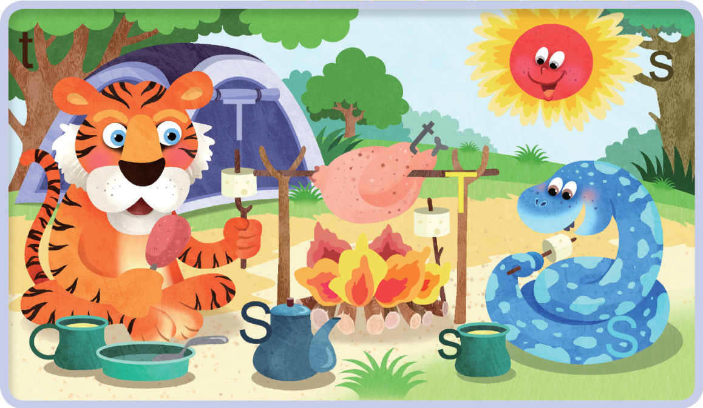

Lesson 16 Jump Up 5

B. Link and Practice | • Listen, follow, and find the boy.  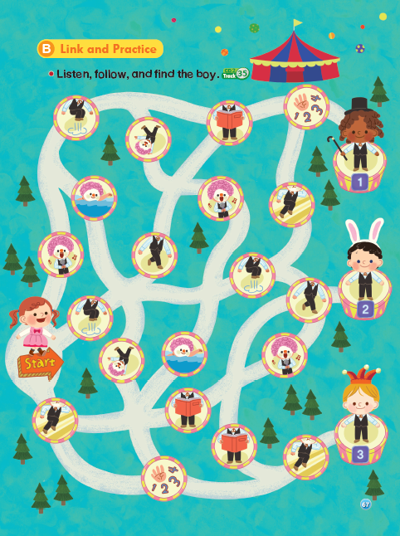
C. Link and Do | 2. Listen, trace, and match.  1. R r – d 2. S s – b 3. Q q – a 4. T t – c

Lesson 17 Fruit

A. Look and Say | 2. Look and act out.  1. I’m sorry.  2. Be quiet, please!
D. Look and Read | 2. Look and find.  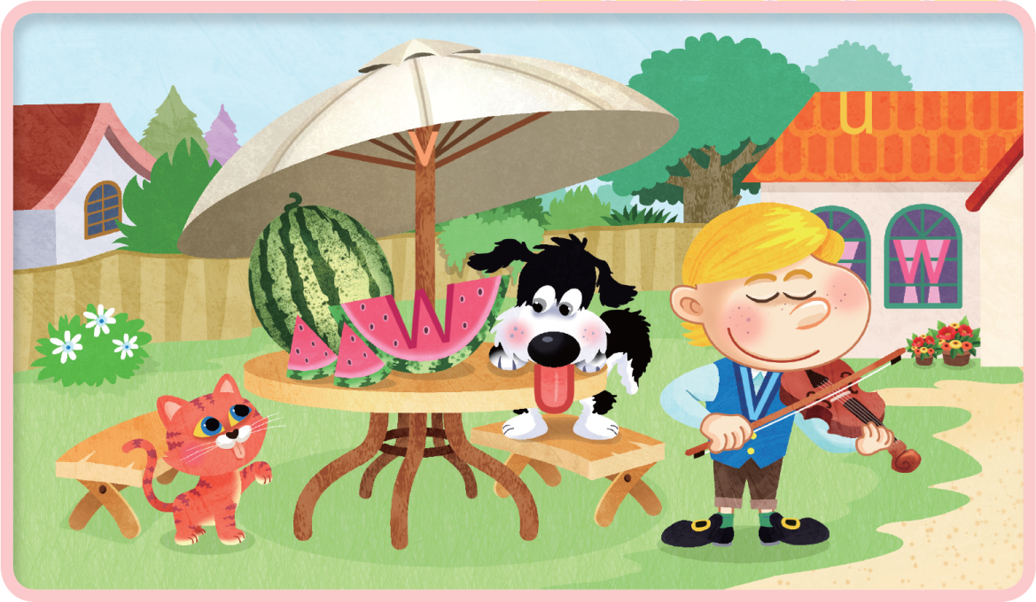

Lesson 18 Food

A. Look and Say | 2. Look and act out.  1. Me too.  2. I’m hungry.
D. Look and Read | 2. Look and find.  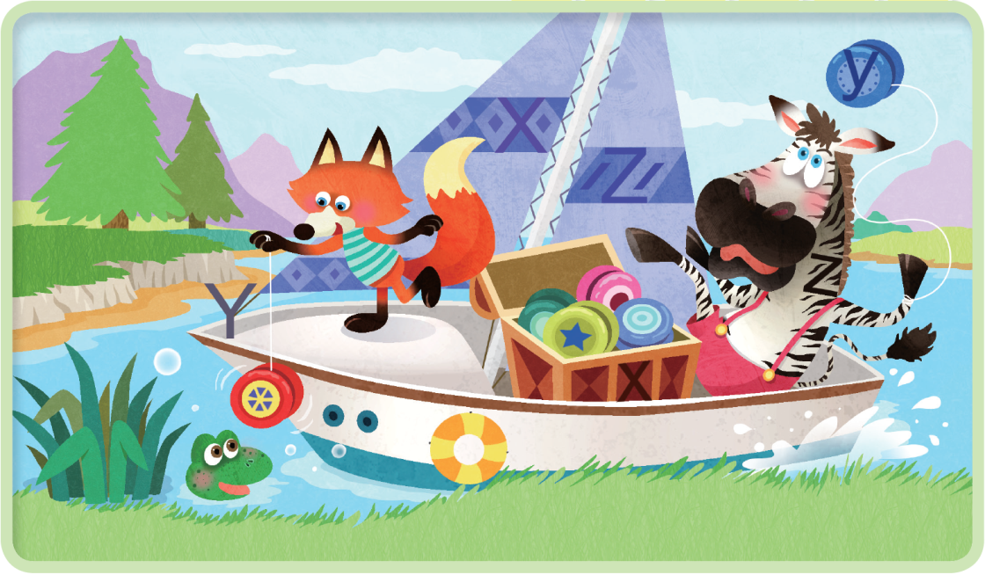

Lesson 19 Jump Up 6

B. Link and Practice | • Listen and draw or .  1.  2.  3.  4.
C. Link and Do | 2. Listen, trace, and match.  1. W w – c 2. Y y – a 3. U u – d 4. Z z – b

Lesson 20 Show Your Progress 2

A. Listening | 1. Listen and number.  5-2-4-3-6-1  1. Listen and circle.  1. b 2. a  3. a 4. b
B. Reading | 1. Circle the correct pair.  1. c 2. b 3. a  2. Read and match.  1. c 2. d 3. b 4. a
C. Speaking | 1. Listen and reply.  1. I’m sorry.  2. Yes. Thanks.  3. Me too.  2. Look, listen, and answer.  1. I like ice cream.  2. I can run.  3. No, I can’t.  4. I have apples.  5. I can read.
Make a Story | 1. Look, listen, and write the number.  2-1-3-4-6-5

