Unit 1. I Always Do My Homework

Unit Objective | You will be able to use frequency adverbs.

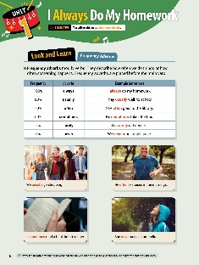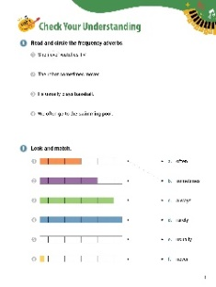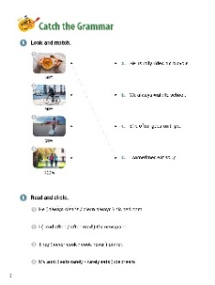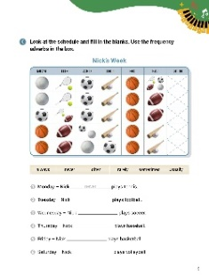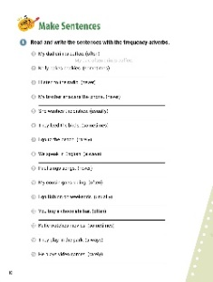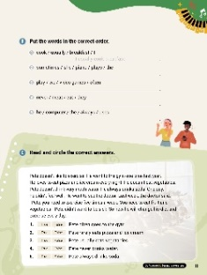

[WARM-UP]
- Have students write a list of five things they did today. Have students tell their activities to the class. (Answers vary: Brushed my teeth, came to school, studied, helped my grandparents)

[Look and Learn]
- Have students look at the chart on page 6. Go through the grammar points in the chart.
- Look at the example words and images.
- Tell students that ‘never’ is a negative frequency adverb that can only be used with positive sentences. For negative sentences, use ‘ever’.
- Have students go back to the list of activities they made in the warm-up. Tell students to put the activities into three categories: rarely, sometimes, and often.

[Step 1 Check Your Understanding]
- Have students look at Exercise A ‘Read and circle the frequency adverbs’. Tell students to read the sentences. Using the chart on page 6, have students circle the frequency adverbs.
- Answers: 1. never 2. sometimes 3. usually 4. often
- Have students look at Exercise B ‘Look and match’. Have students look at the pictures and read the words. Ask students to draw lines between the images and the frequency words that best match them.
- Answers: 1. b 2. a 3. e 4. c 5. f 6. d

[Step 2 Catch the Grammar]
- Have students look at Exercise A ‘Look and match’. Tell students to look at the pictures and read the sentences. Ask students to draw lines between the images and the sentences that best match them.
- Answers: 1. d 2. a 3. c 4. b
- Have students look at Exercise B ‘Read and circle’. Ask students to read the sentences. Have students circle the words that best complete the sentences.
- Answers: 1. always cleans 2. often read 3. never cook 3. never cook 4. rarely eats
- Have students look at Exercise C ‘Look at the schedule and fill in the blanks’. Have students look at the pictures about Nick’s week. Then, tell students to complete the sentences using the frequency adverbs in the box.
- Answers: 1. never 2. sometimes 3. often 4. usually 5. always 6. rarely

[Step 3 Make Sentences]
- Have students look at Exercise A ‘Read and write the sentences with the frequency adverbs’. Tell students to read the sentences. Then, have them write the correct words on the lines to complete the sentences.
- Answers: 1. My dad often drinks coffee. 2. Kelly sometimes bakes cookies. 3. I never listen to the radio. 4. My brother never answers the phone. 5. She usually washes the dishes. 6. They sometimes feed the birds. 7. I rarely go to the beach. 8. We always speak in English. 9. Paul never sings songs. 10. My cousin often goes skiing. 11. I usually go fishing on weekends. 12. You often buy a chocolate bar. 13. Katie sometimes watches movies. 14. They always play in the park. 15. He rarely plays video games.
- Have students look at Exercise B ‘Put the words in the correct order’. Tell students to look at words. Then, have students unscramble the words and write the correct sentences on the lines.
- Answers: 1. I usually cook breakfast. 2. She sometimes plays the piano. 3. We often play video games. 4. They never eat meat. 5. He always uses the computer.
- Have students look at Exercise C ‘Read and circle the correct answers’. Have students read the article about Pete. Then, tell students to read the statements about the paragraph and circle the correct words.
- Answers: 1. False 2. False 3. False 4. False 5. True
[Extra Unit Test]
- Have students turn to page 76 for Unit Test 1. Have the students read the chart and fill in the blanks.
- In the My Grammar Summary, tell students to write what they thought the grammar point for the unit was.
- Ask students to write what they think is the most important thing they learned from Unit 1. Have students write three examples of what they learned in Unit 1.

Unit 2. I Went to School

Unit Objective | You will be able to use to use irregular verbs in the past simple tense.

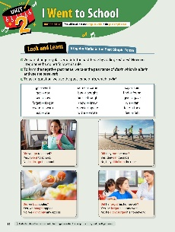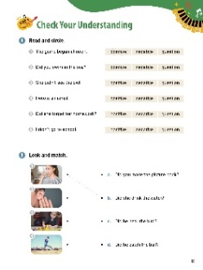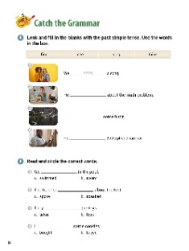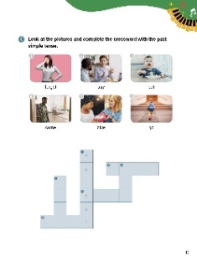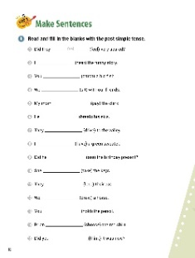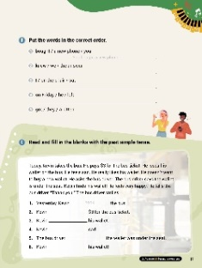

[WARM-UP]
- Ask students to write two questions using ‘did’. Have students share their questions with the class. (Answers vary: Did you go? Did he buy a toy? Did I win?)

[Look and Learn]
- Have students look at the chart on page 12. Go through the grammar points in the chart.
- Look at the example words and images.
- Tell students there are no rules for irregular verbs. Just keep practicing and it will get easier.
- Have students look at their questions. Did they use the irregular verbs from the chart? If so, have students check their work and correct any mistakes.
[Step 1 Check Your Understanding]
- Have students look at Exercise A ‘Read and circle’. Ask students to read the sentences. Then, ask them to circle the choices that best match the sentences.
- Answers: 1. positive 2. question 3. negative 4. positive 5. question 6. negative
- Have students look at Exercise B ‘Look and match’. Tell students to look at the pictures. Then, have the students read the sentences. Ask them to draw lines from the pictures to the correct sentences.
- Answers: 1. b 2. c 3. a 4. d

[Step 2 Catch the Grammar]
- Have students turn to page 14 for Exercise A ‘Look and fill in the blanks with the past simple tense’. Tell students to look at the pictures and read the words in the box. Ask students to write the correct answers on the lines to complete the sentences. Have students use the words from the box.
- Answers: 1. sang 2. thought 3. saw 4. found
- Have students look at Exercise B ‘Read and circle the correct words’. Tell students to look at words. Then, have students circle the letters of the answers that complete the sentences.
- Answers: 1. b 2. a 3. b 4. a
- Have students look at Exercise C ‘Look at the pictures and complete the crossword with the past simple tense’. Have students look at the pictures and read the words. Then, have students write the correct words in the spaces in the puzzle.
- Answers: 1. forgot 2. said 3. ate 4. came 5. gave 6. went

[Step 3 Make Sentences]

- Have students turn to page 16 for Exercise A ‘Read and fill in the blanks with the past simple tense’. Tell students to read the phrases. Then, have students write the correct words on the lines to complete the sentences.
- Answers: 1. feel 2. heard 3. caught 4. Sat 5. paid 6. broke 7. drove 8. had 9. see 10. took 11. lost 12. drew 13. held 14. chose 15. think
- Have students look at page 17 for Exercise B ‘Put the words in the correct order’. Tell students to look at words. Then, have students unscramble the words and write the correct sentences on the lines.
- Answers: 1. You bought a new phone. 2. We knew the answer. 3. I sat on the chair. 4. He left on Friday. 5. They got a kitten.
- Have students look at Exercise C ‘Read and fill in the blanks with the past simple tense.’. Have students read the paragraph about Kevin. Then, students should write the correct words on the lines to complete the sentences.
- Answers: 1. took 2. paid 3. lost 4. felt 5. said 6. found

[Extra Unit Test]
- Have students turn to page 77 for Unit Test 2. Have the students read the chart and circle the words that best complete the sentences.
- In the My Grammar Summary, tell students to write what they thought the grammar point for the unit was.
- Tell students to write what they think is the most important thing they learned from Unit 2. Tell the students to write three examples of what they learned in Unit 2.

Unit 3. They Were Talking

Unit Objective | You will be able to use the past continuous tense.

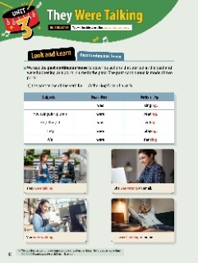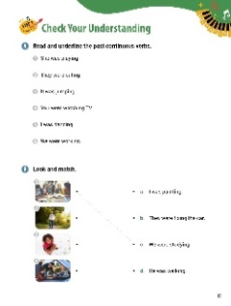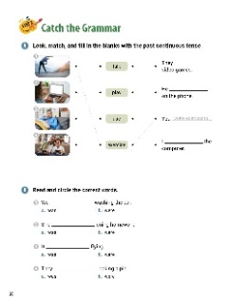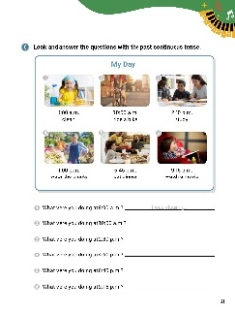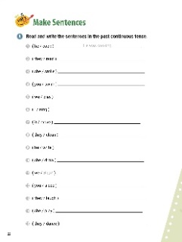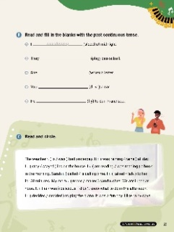

[WARM-UP]
- Ask students to think about what they were doing after school yesterday. Ask students to write two things they did (Answers vary: studied, walked, played games, watched a movie)

[Look and Learn]
- Have students look at the chart on page 18. Go through the grammar points in the chart.
- Look at the example words and images.
- Tell students that we use the past continuous tense to show an action that began before a particular time. Example: I was studying at 8:00 p.m. last night.
- Have students look at the words they wrote in the warm-up. Ask them to rewrite them using the past continuous tense. (Answers vary: was studying, was walking, was playing games, was watching a movie)

[Step 1 Check Your Understanding]
- Have students look at Exercise A ‘Read and underline the past continuous verbs’. Tell students to read the sentences. Then, ask them to underline the past continuous verbs.
- Answers: 1. was playing 2. were eating 3. was jumping 4. were watching 5. was dancing 5. were working
- Have students look at Exercise B ‘Look and match’. Tell students look at the pictures and read the sentences. Then, ask them to write draw lines between the pictures and the sentences that best match.
- Answers: 1. c 2. d 3. a 4. b

[Step 2 Catch the Grammar]
- Have students look at Exercise A ‘Look, match, and fill in the blanks with the past continuous tense’. Tell students to look at the pictures and read the words. Then, they should draw lines between the pictures, words, and sentences that best match. Ask students to write the verbs in the past continuous tense on the lines to complete the sentences.
- Answers: 1. exercise were exercising 2. use was using 3. talk was talking 4. play were playing
- Have students look at Exercise B ‘Read and circle the correct words’. Ask students to circle the letters of the answers that best complete the sentences.
- Answers: 1. b 2. a 3. a 4. b
- Have students look at Exercise C ‘Look and answer the questions with the past continuous tense’. Have students look at the pictures and read the about the day’s activities. Then, tell students to write the answers to the questions on the lines provided.
- Answers: 1. I was cleaning. 2. I was riding a bike. 3. I was studying. 4. I was watering the plants. 5. I was eating dinner. 6. I was watching a movie.

[Step 3 Make Sentences]
- Have students look at Exercise A ‘Read and write the sentences in the past continuous tense’. Tell students to read the words. Ask them to write the sentences on the lines using the words and the past continuous tense.
- Answers: 1. He was cooking. 2. They were reading. 3. She was smiling. 4. You were swimming. 5. We were playing. 6. I was singing. 7. It was moving. 8. They were cleaning. 9. He was writing. 10. She was drawing. 11. We were cleaning. 12. You were sleeping. 13. They were laughing. 14. She was playing. 15. They were dancing.
- Have students look at Exercise B ‘Read and fill in the blanks with the past continuous tense’. Have students read the sentences. Then, students should write the correct form of the verb on the lines.
- Answers: 1. was sleeping 2. were playing 3. was writing 4. were driving 5. was flying
- Have students look at Exercise C ‘Read and circle’. Have students look at the paragraph about the rainy day. Then, tell students to circle the words that best complete the sentences.
- Answers: 1. was 2. was raining 3. stayed 4. was reading 5. called 6. talked 7. made 8. was 9. decided

[Extra Unit Test]
- Have students turn to page 78 for Unit Test 3. Have the students read the chart and fill in the blanks.
- In the My Grammar Summary, tell students to write what they thought the grammar point for the unit was.
- Tell students to write what they think is the most important thing they learned from Unit 3. Tell the students to write three examples of what they learned in Unit 3.

Unit 4. I Wasn’t Sleeping

Unit Objective | You will be able to use the past continuous tense in negatives and questions.

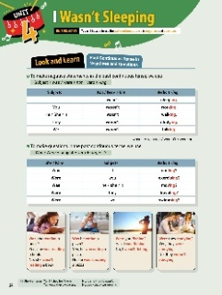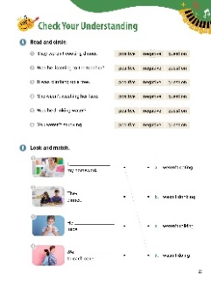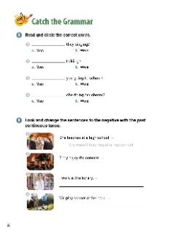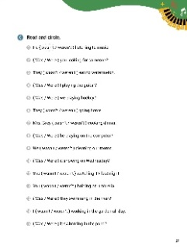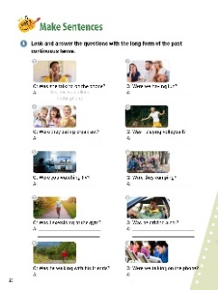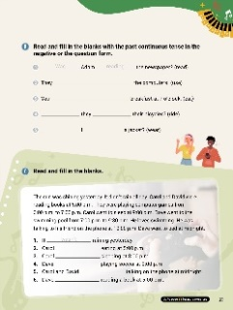

[WARM-UP]
- Have students think about what they were doing last night. Write the following questions so students can see them: ‘Were you sleeping?’, ‘Were you drinking soda?’, ‘Were you building a sandcastle?’ Then tell them to answer the questions. (Answers vary)

[Look and Learn]
- Have students look at the chart. Go through the grammar points in the chart.
- Look at the example words and images.
- Read the words and sentences together.
- Tell students that you can use short answers to these types of questions: Yes, I / she / he / it was. Yes, you / they / we were. No, I / she / he / it wasn’t. No, you / they / we weren’t.
- Tell students to look at their answers for the questions in the warm-up. Have them write sentences using their answers and the chart. (Answers vary: Yes, I was sleeping. No, I wasn’t drinking soda. No, I wasn’t building a sandcastle.)

[Step 1 Check Your Understanding]
- Have students look at Exercise A ‘Read and circle’. Ask students read the sentences. Then, have them circle whether the sentences are the negative, positive, or a question.
- Answers: 1. negative 2. question 3. positive 4. negative 5. question 6. negative
- Have students look at Exercise B ‘Look and match’. Tell students to look at the pictures and read the sentences. Then, have students complete the sentences by drawing lines from the pictures to the matching words.
- Answers: 1. d 2. a 3. b 4. c

[Step 2 Catch the Grammar]
- Have students look at Exercise A ‘Read and circle the correct words ’. Tell students to read the sentences. Then, have students circle the letters of the words that best complete the sentences.
- Answers: 1. b 2. a 3. b 4. a
- Have students look at Exercise B ‘Look and change the sentences to the negative with the past continuous tense’. Tell students to look at the pictures and read the sentences. Then, have them rewrite the sentences in the negative using the past continuous. Remind students that the ending of the second verb is -ing.
- Answers: 1. She wasn’t teaching at a high school. 2. They weren’t enjoying the concert. 3. I wasn’t working at the library. 4. We weren’t playing soccer at the park.
- Have students look at Exercise C ‘Read and circle’. Tell students to read the sentences. Then, have students circle the words that best complete the sentences.
- Answers: 1. wasn’t 2. Were 3. weren’t 4. Was 5. Were 6. weren’t 7. wasn’t 8. Was 9. weren’t 10. Was 11. wasn’t 12. weren’t 13. Were 14. wasn’t 15. Was

[Step 3 Make Sentences]
- Have students look at Exercise A ‘Look and answer the questions with the long form of the past continuous tense’. Tell students to look at the pictures and read the questions. Then, have students write the correct answers on the lines provided. Remind students to include ‘yes’ or ‘no’ in their answers.
- Answers: 1. Yes, she was talking on the phone. 2. No, we weren’t having fun. 3. No, they weren’t eating breakfast. 4. No, you weren’t playing volleyball. 5. Yes, I was watching TV. 6. Yes, they were camping. 7. No, you weren’t exercising at the gym. 8. Yes, he was driving a car. 9. No, he wasn’t walking with his friends. 10. No, we weren’t talking on the phone.
- Have students look at Exercise B ‘Read and fill in the blanks with the past continuous tense in the negative or the question form’. Have students read the sentences. Then, ask students to write the correct words on the lines to complete the sentences.
- Answers: 1. Was, reading 2. weren’t using 3. weren’t eating 4. Were, riding 5. Was, wearing
- Have students look at Exercise C ‘Read and fill in the blanks’. Tell students to read the paragraph about Carol and David. Then, have them complete the sentences using the correct words.
- Answers: 1. wasn’t 2. wasn’t 3. wasn’t 4. wasn’t 5. weren’t 6. was

[Extra Unit Test]
- Have students turn to page 79 for Unit Test 4. Have the students read the chart and fill in the blanks.
- In the My Grammar Summary, tell students to write what they thought the grammar point for the unit was.
- Ask students to write what they think is the most important thing they learned from Unit 4. Have students write three examples of what they learned in Unit 4.

Unit 5. I Will Eat Lunch

Unit Objective | You will be able to use will in the future simple tense.

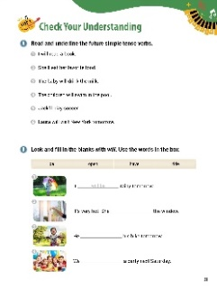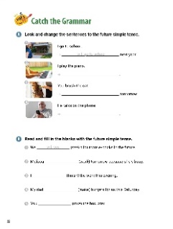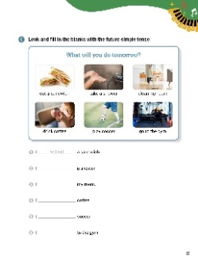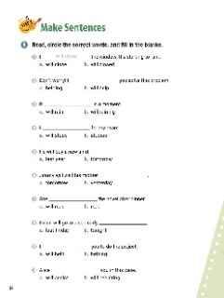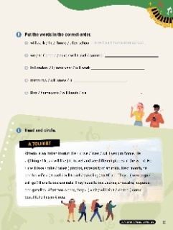

[WARM-UP]
- Have students think about the coming weekend. What do they want to do? Have students write two things they want to do and share these with the class. (Answers vary: watch TV, play games, play soccer, visit friends, go out to eat).
[Look and Learn]
- Have students look at the chart on page 30. Go through the grammar points in the chart.
- Look at the example words and images.
- Tell students that it is common to use a contraction of ‘will’.
- Have students look at their list from the warm-up. They should rewrite the words using will. Refer students to the chart and ask them to share their answers with the class. (Answers vary: I will watch TV., I will play games., I will play soccer., I will visit friends., I will go out to eat ).
[Step 1 Check Your Understanding]
- Have students look at Exercise A ‘Read and underline the future simple tense verbs’. Ask students to read the sentences. Then, tell them to underline the verbs that are in the future tense.
- Answers: 1. will read 2. ‘ll eat 3. will drink 4. will swim 5. ‘ll play 6. will visit
- Have students look at Exercise B ‘Look and fill in the blanks with will’. Tell students to look at the pictures and read the sentences. Then, have students write the correct words in the blanks using the words from the box.
- Answers: 1. will be 2. will open 3. will ride 4. will have
[Step 2 Catch the Grammar]
- Have students look at Exercise A ‘Look and change the sentences to the future simple tense’. Have students read the sentences. Ask them to rewrite the sentences on the lines using the future form of the verbs.
- Answers: 1. I will go to school next year. 2. I will play the piano. 3. You will brush the cat tomorrow. 4. He will talk on the phone.
- Have students look at Exercise B ‘Read and fill in the blanks with the future simple tense’. Have students read the sentences. Tell students to write the correct verbs on the lines using the verbs in the parentheses.
- Answers: 1. will see 2. will work 3. will finish 4. will make 5. will take
- Have students look at Exercise C ‘Look and fill in the blanks with the future simple tense’. Tell students to look at the pictures and the words about what will happen tomorrow. Then, have them use the chart to complete the sentences.
- Answers: 1. will eat 2. will take 3. will clean 4. will drink 5. will play 6. will go

[Step 3 Make Sentences]
- Have students look at Exercise A ‘Read, circle the correct words, and fill in the blanks’. Tell students to read the sentences. Then, ask them to circle the letters of the correct words and write the answers on the lines.
- Answers: 1. will close 2. will help 3. will rain 4. will study 5. tomorrow 6. tomorrow 7. will read 8. tonight 9. will help 10. will assist
- Have students look at Exercise B ‘Put the words in the correct order’. Tell students to look at words. Then, have students unscramble the words and write the correct sentences on the lines.
- Answers: 1. He will walk home after school. 2. We will travel to Canada next summer. 3. I will work in London next year. 4. It will snow tomorrow. 5. Bob will finish his homework.
- Have students look at Exercise C ‘Read and circle’. Have students read the paragraph about Alfredo the tourist. Then, have students circle the words that best complete the sentences.
- Answers: 1. lives 2. likes 3. takes 4. will travel 5. will go 6. will visit

[Extra Unit Test]
- Have students turn to page 80 for Unit Test 5. Have the students read and complete the chart.
- In the My Grammar Summary, tell students to write what they thought the grammar point for the unit was.
- Ask students to write what they think is the most important thing they learned from Unit 5. Have students write three examples of what they learned in Unit 5.

Unit 6. I Will Not Buy Bread

Unit Objective | You will be able to use will to talk about the future in negatives and questions.

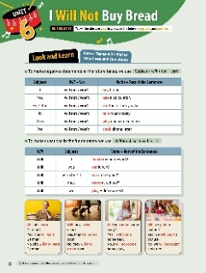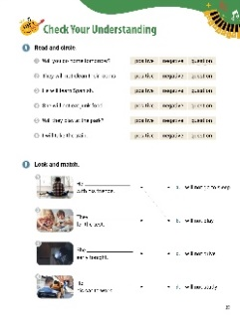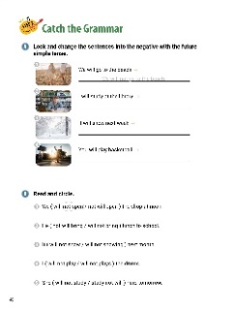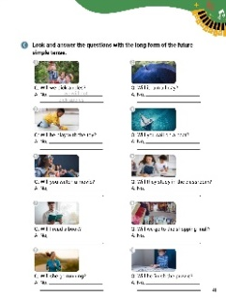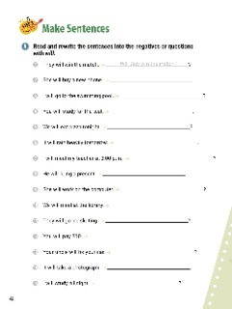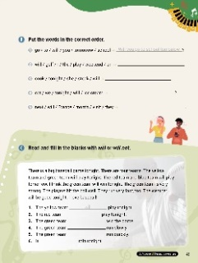

[WARM-UP]
- Have students write three things they do not want to do this weekend. Ask them to read their sentences. (Answers vary: I don’t want to study. I don’t want to clean my room. I don’t want to sweep.)

[Look and Learn]
- Have students look at the chart on page 38. Go through the grammar points in the chart.
- Look at the example words and images.
- Tell students that it is common to use the contraction of ‘will not’, which is ‘won’t’.
- Have students look at the sentences they wrote in the warm-up. Ask them to use the chart to rewrite them in the negative, future form. (Answers vary: I will not (won’t) study. I will not (won’t) clean my room. I will not (won’t) sweep.)

[Step 1 Check Your Understanding]
- Have students look at Exercise A ‘Read and circle’. Ask students to circle the words that best describe the sentences.
- Answers: 1. Question 2. negative 3. positive 4. negative 5. question 6. positive
- Have students look at Exercise B ‘Look and match’. Tell students to look at the pictures and read the sentences. Then, students should draw lines between the pictures and the sentences that describe them.
- Answers: 1. b 2. d 3. a 4. c

[Step 2 Catch the Grammar]
- Have students look at Exercise A ‘Look and change the sentences into the negative with the future simple tense’. Tell students to look at the pictures and read the sentences. Then, have students rewrite the sentences on the lines using the negative future tense.
- Answers: 1. We will not go to the beach. 2. I will not study at the library. 3. It will not snow next week. 4. You will not play basketball.
- Have students look at Exercise B ‘Read and circle’. Tell students to read the sentences. Then, have them circle the groups of words that are in the correct order.
- Answers: 1. will not open 2. will not bring 3. will not snow 4. will not play 5. will not study
- Have students look at Exercise C ‘Look and answer the questions with the long form of the future simple tense’. Tell students to look at the pictures and read the questions. Then, have students write complete sentences to answer the questions.
- Answers: 1. No, we will not pick apples. 2. No, it will not rain all day. 3. No, he will not play with the toy. 4. No, I will not sail on a boat. 5. No, I will not watch a movie. 6. No, they will not study in the classroom. 7. No, you will not read a book. 8. No, we will not go to the shopping mall. 9. No, she will not go running. 10. No, he will not finish the puzzle.

[Step 3 Make Sentences]
- Have students look at Exercise A ‘Read and rewrite the sentences into the negatives or questions with will’. Tell the students to read the sentences. Then, have students write new sentences on the lines by switching them into negative future tense sentences or questions.
- Answers: 1. Will they win the match? 2. She will not buy a new phone. 3. Will I go to the swimming pool? 4. You will not study for the test. 5. Will we eat pizza tonight? 6. It will not rain heavily tomorrow. 7. Will I meet my teacher at 3:00 p.m.? 8. He will not bring a present. 9. Will she work on the computer? 10. We will not meet at the library. 11. Will they go ice skating? 12. You will not pay $10. 13. Will your uncle fix your car? 14. It will not take a photograph. 15. Will I study all night?
- Have students look at Exercise B ‘Put the words in the correct order’. Tell students to look at words. Then, have students unscramble the words and write the correct sentences on the lines.
- Answers: 1. Will you go to school tomorrow? 2. I will play golf on the weekend. 3. She will cook steak tonight. 4. Will we eat ice cream tonight? 5. They will visit France next month.
- Have students look at Exercise C ‘Read and fill in the blanks with will or will not’. Tell students to read the paragraph about the baseball game. Then, have them complete the sentences with the correct words.
- Answers: 1. will 2. will not 3. will 4. will not 5. will 6. will not

[Extra Unit Test]
- Have students turn to page 81 for Unit Test 6. Have the students read the chart and fill in the blanks.
- In the My Grammar Summary, tell students to write what they thought the grammar point for the unit was.
- Ask students to write what they think is the most important thing they learned from Unit 6. Have the students write three examples of what they learned in Unit 6.

Unit 7. Every Student Takes the Test

Unit Objective | You will be able to use every and all as determiners in a sentence.

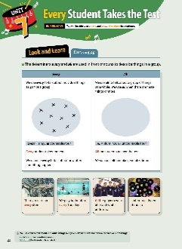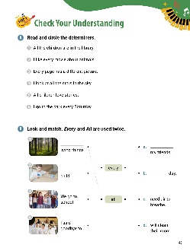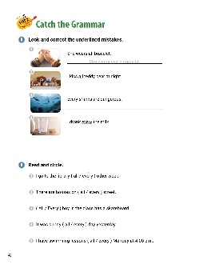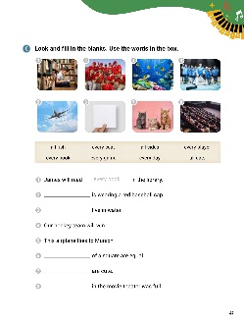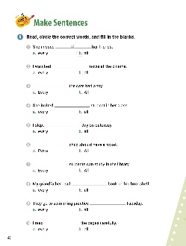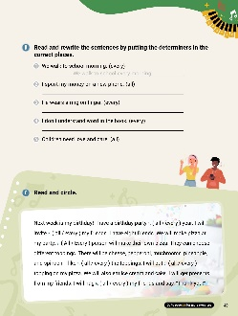

[WARM-UP]
- Have students write two things that are true about everyone in class. Have them write two things that are different. Have students share their answers. (Answers vary: Everyone has pencils. Everyone is sitting. Everyone is a student.// Everyone has a different shirt. Everyone has a different hairstyle. Everyone has a different pencil case.)

[Look and Learn]
- Have students look at the chart on page 44. Go through the grammar points in the chart.
- Look at the example words and images.
- Tell students that we use ‘each’ to talk about individual things in a group. We use ‘each’ when there are two or more things (each + singular countable noun). Example: Each student has a desk.
- Have students look at their list from the warm-up. Tell students to write ‘all’ by the sentences that include everyone in class. (Answers vary)

[Step 1 Check Your Understanding]
- Have students look at Exercise A ‘Read and circle the determiners’. Tell students to read the sentences. Then, have students circle the words ‘all’ or ‘every’.
- Answers: 1. All 2. every 3. Every 4. all 5. All 6. Every
- Have students look at Exercise B ‘Look and match’. Have students look at the pictures and read the sentences. Tell students to draw lines between the words to complete the sentences. Remind students that ‘all’ and ‘every’ are used twice.
- Answers: 1. All, c 2. Every, d 3. every, b 4. all, a

[Step 2 Catch the Grammar]
- Have students look at Exercise A ‘Look and correct the underlined mistakes’. Tell students to read the sentences. Then, have them underline the parts of the sentences that are wrong. Ask students to rewrite the corrected sentences on the lines.
- Answers: 1. She wears every bracelet. 2. I kiss every teddy bear at night. 3. All sharks are dangerous. 4. I drank all the milk.
- Have students look at Exercise B ‘Look and circle’. Tell students to read the sentences. Ask them to circle the correct answers to complete the sentences.
- Answers: 1. every 2. every 3. Every 4. all 5. every
- Have students look at Exercise C ‘Look and fill in the blanks’. Tell students to look at the pictures and read the words in the box. Then, have students complete the sentences with the correct words based on the pictures.
- Answers: 1. every book 2. Every player 3. All fish 4. every game 5. every day 6. All sides 7. All cats 8. Every seat

[Step 3 Make Sentences]
- Have students look at Exercise A ‘Read, circle the correct words, and fill in the blanks’. Tell students to read the sentences. Then, have students to circle the letters of the correct answers. Ask students to write the words on the lines.
- Answers: 1. b 2. a 3. b 4. a 5. b 6. a 7. b 8. a 9. a 10. b
- Have students look at Exercise B ‘Read and rewrite the sentences by putting the determiners in the correct places’. Tell students to read the sentences. Then, have students rewrite the sentences on the lines using the words in parentheses.
- Answers: 1. We walk to school every morning. 2. I spent all my money on a new phone. 3. He wears a ring on every finger. 4. I don’t understand every word in the book. 5. All children need love and care.
- Have students look at Exercise C ‘Look and circle’. Read the paragraph about the upcoming birthday. Tell students to complete the sentences by circling the correct words.
- Answers: 1. every 2. all 3. Every 4. all 5. every 6. all

[Extra Unit Test]
- Have students turn to page 82 for Unit Test 7. Have the students read the chart and fill in the blanks.
- In the My Grammar Summary, have students write what they thought the grammar point for the unit was.
- Tell students to write what they think is the most important thing they learned from Unit 7. Ask the students to write three examples of what they learned in Unit 7.

Unit 8. She Plays the Piano and the Guitar

Unit Objective | You will be able to use and, but, and or as conjunctions in a sentence.

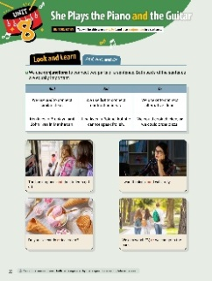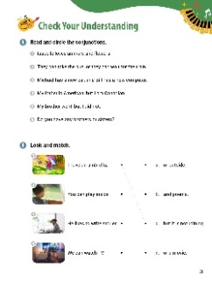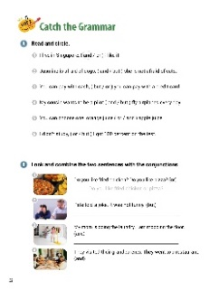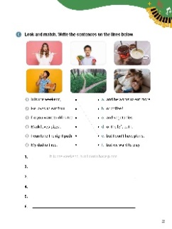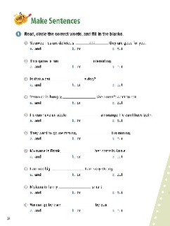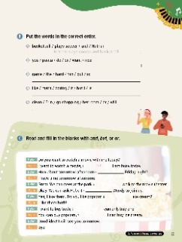

[WARM-UP]
- Have students think about their favorite games. Then, have students write two things they have to do during those games. Have students talk about their answers. (Answers vary: kick the ball, stop goals, catch the ball, hit, use a racket, keep score)

[Look and Learn]
- Have students look at the chart on page 50. Go through the grammar points in the chart.
- Look at the example words and images.
- Remind students that they should use a comma if both parts separated by the conjunction are complete sentences.
- Have students look at their words from the warm-up. Tell students to write their words using the conjunctions. Go over their answers as a class. (Answers vary: kick the ball and stop goals, catch the ball or hit it, use a racket and keep score)

[Step 1 Check Your Understanding]
- Have students look at Exercise A ‘Read and circle the conjunctions’. Ask students to read the sentences. Then, have students draw circles around ‘and’, ‘but’ and ‘or’.
- Answers: 1. and 2. or 3. and 4. but 5. but 6. or
- Have students look at Exercise B ‘Look and match’. Have students look at the pictures and read the sentences. Then, tell students to draw lines between the pictures and the correct sentences.
- Answers: 1. c 2. a 3. b 4. d

[Step 2 Catch the Grammar]
- Have students look at Exercise A ‘Read and circle’. Tell students to read the sentences. Then, have students complete the sentences by circling the correct conjunction.
- Answers: 1. and 2. but 3. or 4. and 5. or 6. but
- Have students look at Exercise B ‘Look and combine the two sentences with the conjunctions’. Have students look at the pictures and read the sentences. Tell students to combine the sentences to create a new sentence.
- Answers: 1. Do you like fried chicken or pizza? 2. Pete told a joke, but it was not funny. 3. My mom is doing the laundry, and I am mopping the floor. 4. They visited their grandparents, and they went to a restaurant.
- Have students look at Exercise C ‘Look and match’. Have students look at the pictures and read the parts of the sentences. Tell them to draw lines between the correct words. Then, ask students write the complete sentences on the lines.
- Answers: 1. e It is the weekend, but I don’t have plans. 2. c He loves to eat fruit and vegetables. 3. b Do you want to drink tea or coffee? 4. a Mark loves pizza, and he wants to eat more. 5. d I can take the right path or the left path. 6. f My dad is tired, but we want to play.
[Step 3 Make Sentences]
- Have students look at Exercise A ‘Read, circle the correct words, and fill in the blanks'. Tell students to read the sentences. Then, have students circle the letters of the correct words. Then, students should write the answers on the lines to complete the sentences.
- Answers: 1. a 2. a 3. b 4. c 5. b 6. c 7. a 8. c 9. a 10. b
- Have students look at Exercise B ‘Put the words in the correct order’. Tell students to look at words. Then, have students unscramble the words and write the correct sentences on the lines.
- Answers: 1. Nathan plays soccer and basketball. 2. Do you want pasta or rice? / Do you want rice or pasta? 3. The game is hard but fun. / The game is fun but hard. 4. Math is boring, but I like it. 5. Erin will clean her room or go shopping. / Erin will go shopping or clean her room.
- Have students look at Exercise C ‘Read and fill in the blanks with and, but, or or’. Have students read the conversation. Ask them to complete the sentences using the correct conjunctions.
- Answers: 1. but 2. or 3. and 4. and 5. or 6. but 7. and

[Extra Unit Test]
- Have students turn to page 83 for Unit Test 8. Have the students read the chart and fill in the blanks.
- In the My Grammar Summary, tell students to write what they thought the grammar point for the unit was.
- Have students write what they think is the most important thing they learned from Unit 8. Ask the students to write three examples of what they learned in Unit 8.

Unit 9. I Sleep Less Than My Parents

Unit Objective | You will be able to use regular and irregular comparative adjectives.

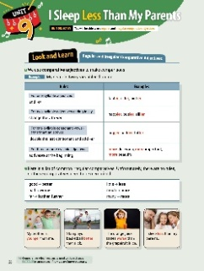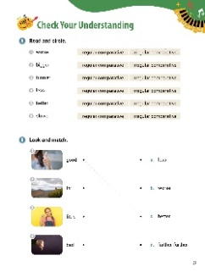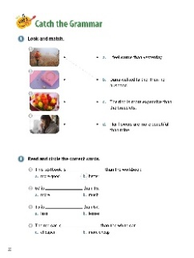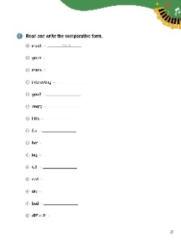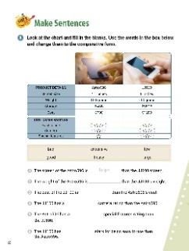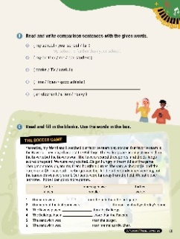

[WARM-UP]
- Have students think about their family members. Ask them to write about two people. What makes them different? (Answers vary: my brother, tall; my sister, young; my dad, strong; my grandmother, cheerful)

[Look and Learn]
- Have students look at the chart on page 56. Go through the grammar points in the chart.
- Look at the example words and images.
- Tell students that comparative adjectives can be used to show change. Example: Houses are getting more and more expensive.
- Have students look at their lists from the warm-up. Then, tells students to write comparatives about their family members. Have students share their answers. (Answers vary: My brother is taller than me. My sister is younger than me. My father is stronger than me. My grandmother is more cheerful than me.)

[Step 1 Check Your Understanding]
- Have students look at Exercise A ‘Look and circle’. Ask students to read the words. Then, have them circle the type of comparative the word is. Students can use the chart.
- Answers: 1. irregular comparative 2. regular comparative 3. regular comparative 4. irregular comparative 5. irregular comparative 6. regular comparative
- Have students look at Exercise B ‘Look and match’. Tell students to look at the pictures. Then, have students read the words. Ask students to draw lines between the pictures and their comparatives.
- Answers: 1. c 2. d 3. a 4. b

[Step 2 Catch the Grammar]
- Have students look at Exercise A ‘Look and match’. Have students look at the pictures and read the sentences. Then, tell students to draw lines to make matches.
- Answers: 1. b 2. c 3. d 4. a
- Have students look at Exercise B ‘Read and circle the correct words’. Have students read the sentences. Then, ask them to circle the letters of the words that best complete the sentences.
- Answers: 1. b 2. a 3. a 4. a
- Have students look at Exercise C ‘Read and write the comparative form’. Tell students to look at the words and write the comparatives on the lines. Students can use the chart to help them.
- Answers: 1. more 2. greater 3. more 4. more interesting 5. better 6. angrier 7. less 8. farther, further 9. hotter 10. bigger 11. taller 12. sadder 13. drier 14. worse 15. more difficult

[Step 3 Make Sentences]
- Have students look at Exercise A ‘Look at the chart and fill in the blanks’. Tell students to read the charts and read the sentences. Then, ask them to complete the sentences by writing the correct answers on the lines.
- Answers: 1. larger 2. heavier 3. more expensive 4. better 5. worse 6. fewer
- Have students look at Exercise B ‘Read and write comparison sentences with the given words’. Tell students to read the words. Then, have students write sentences on the lines using the comparative words.
- Answers: 1. My school is farther than your school. 2. My brother is a worse student than me. 3. Books are more useful than TV. 4. Tina is a better athlete than Ryan. / Ryan is a better athlete than Tina. 5. An elephant is heavier than a lion.
- Have students look at Exercise C ‘Read and fill in the blanks’. Tell students to read about the soccer game. Then, have students write the comparative words from the box on the lines to complete the sentences.
- Answers: 1. farther 2. closer 3. better 4. worse 5. more expensive 6. smaller

[Extra Unit Test]
- Have students turn to page 84 for Unit Test 9. Have the students read the chart and fill in the blanks.
- In the My Grammar Summary, tell students to write what they thought the grammar point for the unit was.
- Ask students to write what they think is the most important thing they learned from Unit 9. Tell the students to write three examples of what they learned in Unit 9.

Unit 10. Paris Is the Biggest City in France

Unit Objective | You will be able to use superlative adjectives.

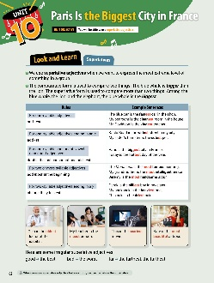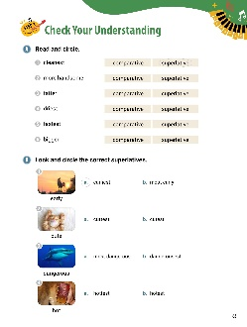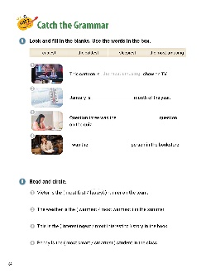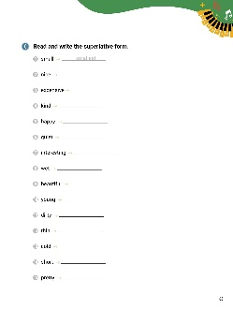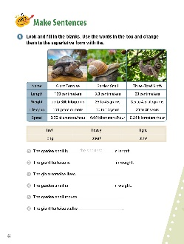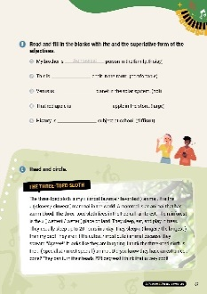

[WARM-UP]
- Have students write who they think the best actor, actress, and singer are. Have them share with the class. (Answers vary)

[Look and Learn]
- Have students look at the chart on page 62. Go through the grammar points in the chart.
- Look at the example words and images.
- Tell students that when we use a superlative adjective before a noun, we use ‘the’ before the superlative.
- Ask students use their lists from the warm-up. Have students write sentences using the superlative. (Answers vary: Bob is the best actor. Mary is the most intelligent actress. Sue is the loudest singer.)

[Step 1 Check Your Understanding]
  - Have students look at Exercise A ‘Read and circle’. Have students look at the words. Ask them to circle whether the word is a superlative or comparative. Students can use the chart.
  - Answers: 1. superlative 2. comparative 3. comparative 4. superlative 5. superlative 6. comparative
Have students look at Exercise B ‘Look and circle the correct superlatives.’. Tell students look at the pictures and read the words. Have students circle the correct words.
- Answers: 1. a 2. b 3. a 4. a
[Step 2 Catch the Grammar]
  - Have students look at Exercise A ‘Look and fill in the blanks’. Tell students to read the sentences. Then, ask them to write the words from the box in the blanks to make complete sentences.
  - Answers: 1. the most amusing 2. the coldest 3. easiest 4. sleepiest
- Have students look at Exercise B ‘Read and circle’. Have students read the sentences and choose the correct superlative.
- Answers: 1. fastest 2. warmest 3. most interesting 4. smartest
- Have students look at Exercise C ‘Read and write the superlative form’. Have students read the words and write the matching superlatives on the lines.
  - * Answers: 1. smallest 2. nicest 3. most expensive 4. kindest 5. happiest 6. quietest 7. most interesting 8. wettest 9. most beautiful 10. youngest 11. dirtiest 12. thinnest 13. coldest 14. shortest 15. prettiest

[Step 3 Make Sentences]
  - Have students look at Exercise A ‘Look and fill in the blanks’. Ask students to read the chart. Then, have students complete the sentences by writing the correct superlatives from the box on the lines. Remind students to use ‘the’.
  - Answers: 1. the shortest 2. the heaviest 3. the longest 4. the lightest 5. the slowest 6. the fastest
  - Have students look at Exercise B ‘Read and fill in the blanks with the and the superlative form of the adjectives’. Tell students to read the sentences. Then, have students write the correct superlatives on the lines. Remind students to use ‘the’.
  - Answers: 1. the noisiest 2. the most comfortable 3. the hottest 4. the largest 5. the most difficult
  - Have students look at Exercise C ‘Read and circle’. Have students read about the three-toed sloth. Tell students to circle the correct superlatives.
  - Answers: 1. most favorite 2. slowest 3. wettest 4. longer 5. the cutest 6. most special

[Extra Unit Test]
  - Have students turn to page 85 for Unit Test 10. Have the students read the chart and fill in the blanks.
  - In the My Grammar Summary, tell students to write what they thought the grammar point for the unit was.
  - Ask students to write what they think is the most important thing they learned from Unit 10. Have students write three examples of what they learned in Unit 10.

