Unit 1. Look at the Bicycle

Unit Objective | You will be able to use common nouns, proper nouns, collective nouns, and articles.

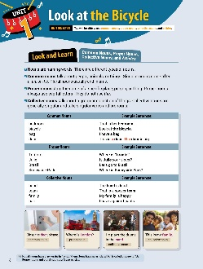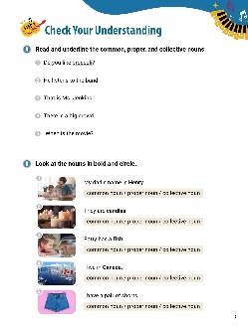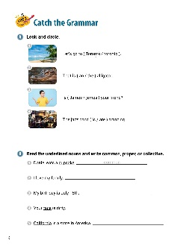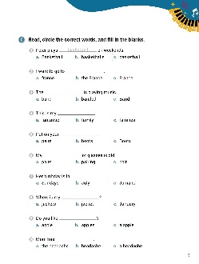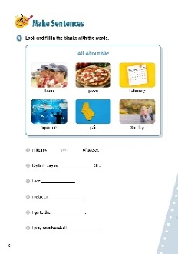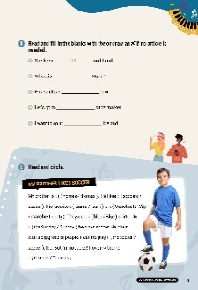

[WARM-UP]
- Have students write a list of five nouns. Have students tell their nouns to the class. (Answers vary.)

[Look and Learn]
- Have students look at the chart on page 6. Go through the grammar points in the chart.
- Look at the example words and images.
- Tell students that not all nouns have a, an, or the in front of them. Some have no article, which is called the zero article. Proper nouns and plural nouns don’t use articles.
- Have students go back to the list of nouns they made in the warm-up. Tell students to put the nouns into three categories, common, proper, or collective.

[Step 1 Check Your Understanding]
- Have students look at Exercise A ‘Look and underline the common, proper, and collective nouns’. Tell students to read the sentences. Using the chart, have students underline the three kinds of nouns. Students can use the chart on page 6.
- Answers: 1. broccoli 2. band 3. Ms. Jenkins 4. crowd 5. movie
- Have students look at Exercise B ‘Look at the nouns in bold and circle’. Have students look at the pictures and read the sentences. Ask students to circle the category that best describes the bolded word (common noun, proper noun, or collective noun).
- Answers: 1. proper noun 2. common noun 3. common noun 4. proper noun 5. collective noun

[Step 2 Catch the Grammar]
- Have students look at Exercise A ‘Look and circle’. Tell students to look at the pictures. Then, have them circle the correct words to complete the sentences.
- Answers: 1. Toronto 2. an 3. James 4. is
- Have students look at Exercise B ‘Read the underlined nouns and write common, proper, or collective’. Ask students to read the sentences. Have students write the types of nouns on the lines.
- Answers: 1. common 2. collective 3. proper 4. common 5. proper
- Have students look at Exercise C ‘Read, circle the correct words, and fill in the blanks.’ Have students look at the pictures and draw lines between the pictures and the words. Then, tell students to complete the sentences.
- Answers: 1. c 2. c 3. a 4. b 5. b 6. c 7. B 8. b 9. b 10. c

[Step 3 Make Sentences]
- Have students look at Exercise A ‘Look and fill in the blanks with the words’. Tell students to look at the pictures and read the words. Then, have them write the correct words on the lines to complete the sentences.
- Answers: 1. pair 2. February 3. pizza 4. Sunday 5. aquarium 6. team
- Have students look at Exercise B ‘Read and fill in the blanks with the or draw an X if no article is needed’. Tell students to read the sentences. Then, have students write the correct answers on the lines.
- Answers: 1. the 2. X 3. the 4. the 5. X
- Have students look at Exercise C ‘Read and circle.’ Have students read the article about Thomas. Then, tell students to circle the correct words to complete the sentences.
- Answers: 1. Thomas 2. soccer 3. team 4. Manchester City 5. blue 6. Sunday
7. soccer 8. Thomas

[Extra Unit Test]
- Have students turn to page 76 for Unit Test 1. Have the students read the chart and fill in the blanks.
- In the My Grammar Summary, tell students to write what they thought the grammar point for the unit was.
- Tell students to write what they think is the most important thing they learned from Unit 1. Tell the students to write three examples of what they learned in Unit 1.

Unit 2. It Is Rainy

Unit Objective | You will be able to use the empty it in sentences.

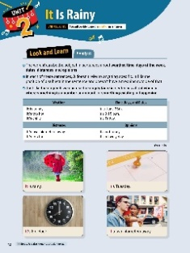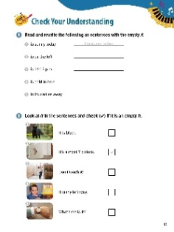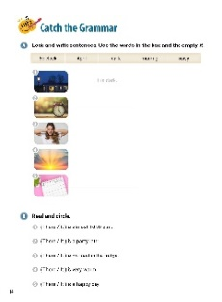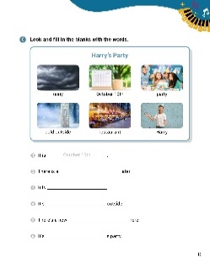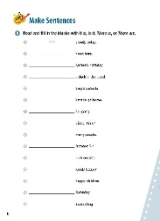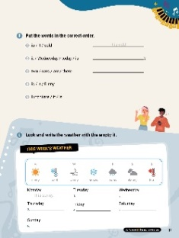

[WARM-UP]
- Ask students to write two sentences using ‘it’. Have students share their sentences with the class.

[Look and Learn]
- Have students look at the chart on page 12. Go through the grammar points in the chart.
- Look at the example words and images.
- Tell students ‘empty it’ is also known as the ‘dummy it’.

[Step 1 Check Your Understanding]
- Have students look at Exercise A ‘Look and rewrite the following as sentences with the empty it’. Ask students to read the phrases. Then, ask them to write complete sentences on the lines using ‘it’.
- Answers: 1. It is sunny today. 2. It is on the left. 3. It is 12:15 p.m. 4. It is cold in here. 5. It is four miles away.
- Have students look at Exercise B ‘Look at it in the sentences and check ( ) if it is an empty it’. Tell students to look at the pictures. Then, have the students read the sentences. Ask them to place checks in the boxes next to sentences with the 'empty it'.
- Answers: 1. X 2. Yes (check mark) 3. X 4. Yes (check mark) 5. Yes (check mark)

[Step 2 Catch the Grammar]
- Have students turn to page 14 for Exercise A ‘Look and write the sentences’. Tell students to look at the pictures and read the words in the box. Ask students to write complete sentences on the lines using the ‘empty it’ and the words in the box.
- Answers: 1. It is dark. 2. It is 5 o’clock. 3. It is noisy. 4. It is morning. 5. It is April.
- Have students look at Exercise B ‘Put the words in the correct order’. Tell students to look at words. Then, have students unscramble the words and write the correct sentences on the lines.
- Answers: 1. It 2. There 3. There 4. It 5. It
- Have students look at Exercise C ‘Read and write the weather with the empty it’. Have students look at the pictures read the words. Then, have students write the correct words to make complete sentences.
- Answers: 1. October 10th 2. party 3. rainy 4. cold 5. restaurant 6. Harry

[Step 3 Make Sentences]
- Have students turn to page 16 for Exercise A ‘Look and fill in the blanks with It is, Is it, There is, or There are’. Tell students to read the phrases. Then, have students write the correct words on the lines to complete the sentences.
- Answers: 1. It is 2. It is 3. It is 4. There is 5. It is 6. It is 7. It is 8. Is it 9. There are 10. It is 11. It is 12. Is it 13. There are 14. It is 15. It is
- Have students look at page 17 for Exercise B ‘Put the words in the correct order’. Tell students to look at words. Then, have students unscramble the words and write the correct sentences on the lines.
- Answers: 1. It is cold. 2. Is it Wednesday today? 3. There are two cars. 4. It is funny. 5. It is lunchtime.
- Have students look at Exercise C ‘Read and write the weather with the empty it’. Have students look at the weather chart for the week. Then, students should write sentences about the weather on the lines.
- Answers: 1. It is cold. 2. It is windy. 3. It is snowy. 4. It is rainy. 5. It is cloudy. 6. It is hot.

[Extra Unit Test]
- Have students turn to page 77 for Unit Test 2. Have the students read the chart and circle the words that best complete the sentences.
- In the My Grammar Summary, tell students to write what they thought the grammar point for the unit was.
- Tell students to write what they think is the most important thing they learned from Unit 2. Tell the students to write three examples of what they learned in Unit 2.

Unit 3. Are There Any Ice Cubes?

Unit Objective | You will be able to use some and any to talk and ask about quantities.

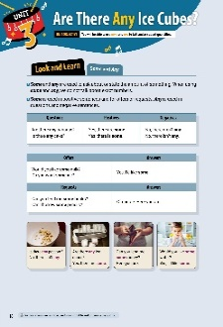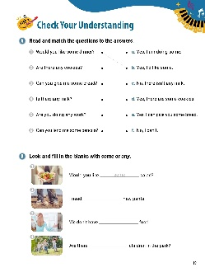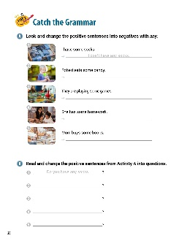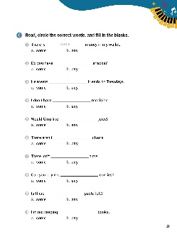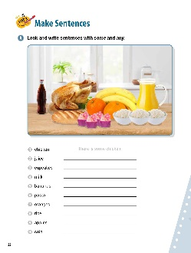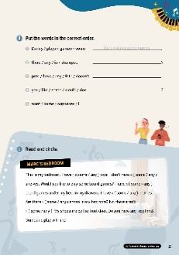

[WARM-UP]
- Ask students to look around the room and write four things they see with the number of things they see. Ask students to read these out loud (Answers vary: three chairs, one desk, two books, five pencils.)

[Look and Learn]
- Have students look at the chart on page 18. Go through the grammar points in the chart.
- Look at the example words and images.
- Remind students that ‘some’ and ‘any’ can both be used for countable and uncountable nouns.
- Have students look at the words they wrote in the warm-up. Ask them to replace the numbers with ‘some’ or ‘any’. Then, have them ask questions using their words and answer using their words. (Answers vary: Are there some chairs? No, there aren’t any. Are there some pencils? Yes, there are some.)
[Step 1 Check Your Understanding]
- Have students look at Exercise A ‘Read and match the questions to the answers’. Tell students to read the questions and draw lines to the correct answers.
- Answers: 1. b 2. d 3. e 4. c 5. a 6. f
- Have students look at Exercise B ‘Look and fill in the blanks with some or any’. Tell students look at the pictures. Then, ask them to write the correct words to complete the sentences.
- Answers: 1. some 2. some 3. any 4. any

[Step 2 Catch the Grammar]
- Have students look at Exercise A ‘Look and change the positive sentences into negatives with any’. Tell students to look at the pictures. Then, they should write negative sentences about the pictures with the word ‘any’.
- Answers: 1. I don’t have any socks. 2. Robert doesn’t eat any candy. 3. They aren’t playing any games. 4. She doesn’t have any homework. 5. Mom doesn’t buy any books.

- Have students look at Exercise B ‘Look and change the positive sentences from Activity A into questions’. Ask students to look at Exercise A again. Then, have students re-write the sentences on the lines, making them questions.
- Answers: 1. Do you have (any) socks? 2. Does Robert eat (any) candy? 3. Are they playing (any) games? 4. Does she have (any) homework? 5. Does Mom buy (any) books?
- Have students look at Exercise C ‘Circle the correct words, and fill in the blanks’. Have students read the sentences. Then, tell students to circle the letters of the words that best complete the sentences. They should write the answers on the lines provided.
- Answers: 1. some 2. any 3. some 4. any 5. some 6. any 7. any 8. some 9. any 10. any

[Step 3 Make Sentences]
- Have students look at Exercise A ‘Look and write sentences with some and any’. Tell students to look at the picture. Ask them what they see. Then, ask them to write the sentences on the lines that talk about the items in the picture using the words ‘some’ and ‘any’.
- Answers: 1. There is some chicken. 2. There is some juice. 3. There are some cupcakes. 4. There isn’t any milk. 5. There are some bananas. 6. There isn’t any pasta. 7. There are some oranges. 8. There is some rice. 9. There aren’t any apples. 10. There is some cola.
- Have students look at Exercise B ‘Put the words in the correct order’. Have students look at the words. Then, tell them to unscramble the words to make sentences. Then, students should write the sentences on the lines.
- Answers: 1. Danny plays some games. 2. Is there any shampoo? 3. Rita doesn’t have any pets. 4. Would you like some rice? 5. I want some cupcakes.
- Have students look at Exercise C ‘Read and circle’. Have students look at the paragraph about Marc’s bedroom. Then, tell students to circle the words that best complete the sentences.
- Answers: 1. some 2. any 3. some 4. some 5. any 6. any

[Extra Unit Test]
- Have students turn to page 78 for Unit Test 3. Have the students read the chart and fill in the blanks.
- In the My Grammar Summary, tell students to write what they thought the grammar point for the unit was.
- Tell students to write what they think is the most important thing they learned from Unit 3. Tell the students to write three examples of what they learned in Unit 3.

Unit 4. The Laptop Is Mine

Unit Objective | You will be able to use possessive adjectives and pronouns.
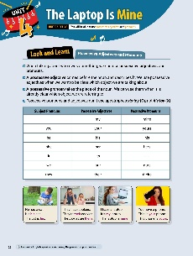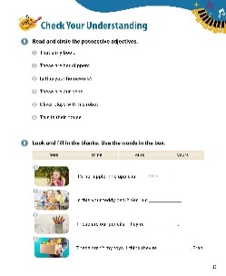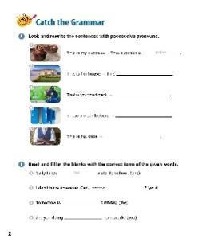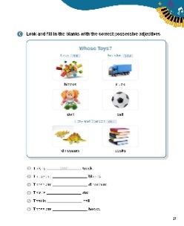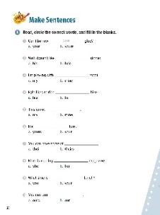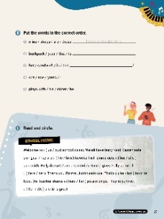

[WARM-UP]
- Have students look around the room. Have them write down five objects they see. Ask them who the objects belong to (students should use the phrase ‘The <object> belongs to _____’. (Answers vary: The pencil belongs to Min. The book belongs to me. The door belongs to the school.)

[Look and Learn]
- Have students look at the chart. Go through the grammar points in the chart.
- Look at the example words and images.
- Read the words and sentences together.
- Tell students that generally, English speakers avoid using the possessive pronoun for it.
- Tell students to look at the word lists again. Have them write the correct possessive pronoun for the objects. Ask students to talk about their lists using the phrase ‘That is ____ <object>’ . (Answers vary: That is her pencil. That is his book. That is our door. That is its toy.)

[Step 1 Check Your Understanding]
- Have students look at Exercise A ‘Look and circle the possessive adjectives’. Ask students to look read the sentences. Then, have them circle the words that best complete the sentences.
- Answers: 1. my 2. her 3. your 4. our 5. his 6. their
- Have students look at Exercise B ‘Look and fill in the blanks’. Tell students to look at the pictures and read the sentences. Then, have students complete the sentences by writing the correct possessive pronouns from the box on the lines.
- Answers: 1. hers 2. mine 3. ours 4. yours

[Step 2 Catch the Grammar]
- Have students look at Exercise A ‘Look and rewrite the sentences with possessive pronouns’. Tell students to read the sentences. Then, have students write new sentences on the lines using the possessive pronouns.
- Answers: 1. This cupcake is mine. 2. This house is hers. 3. That backpack is yours. 4. These lockers are ours. 5. This shoe is his.
- Have students look at Exercise B ‘Read and fill in the blanks with the correct form of the given words’. Tell students to read the sentences. Then, have them fill in the blanks using the correct possessive adjective.
- Answers: 1. her 2. yours 3. my 4. your
- Have students look at Exercise C ‘Look and fill in the blanks with the correct possessive adjectives’. Tell students to look at the pictures and read the words. Then, have students write the missing words on the blank lines.
- Answers: 1. your 2. my 3. our 4. my 5. your 6. our

[Step 3 Make Sentences]
- Have students look at Exercise A ‘Read, circle the correct words, and fill in the blanks’. Tell students to circle the letters of the correct answers. Then, have students write the correct answers on the lines provided.
- Answers: 1. your 2. his 3. my 4. his 5. mine 6. your 7. theirs 8. her 9. your 10. ours
- Have students look at Exercise B ‘Read and fill in the blanks’. Have students look at the words. Then, tell them to unscramble the words to make sentences. Then, students should write the sentences on the lines.
- Answers: 1. Those shoes are mine. 2. That is your backpack. 3. Is this her sandwich? 4. I can use yours. 5. He plays with his sister.
- Have students look at Exercise C ‘Read and circle’. Tell students read the paragraph about the picnic. Then, have them circle the words that best complete the sentences.
- Answers: 1. our 2. his 3. her 4. hers 5. his 6. her 7. Our

[Extra Unit Test]
- Have students turn to page 79 for Unit Test 4. Have the students read the chart and fill in the blanks.
- In the My Grammar Summary, tell students to write what they thought the grammar point for the unit was.
- Tell students to write what they think is the most important thing they learned from Unit 4. Tell the students to write three examples of what they learned in Unit 4.

Unit 5. They Aren’t Riding Bikes

Unit Objective | You will learn the difference between the present continuous tense in positives, negatives, and questions.

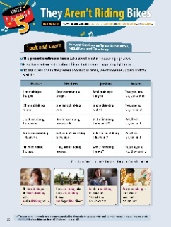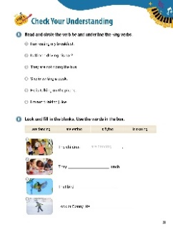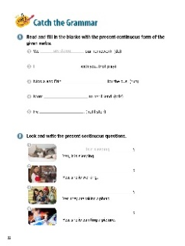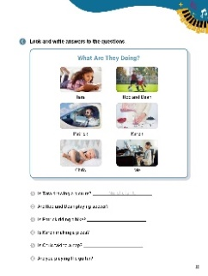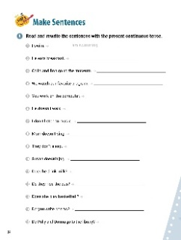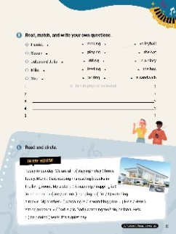

[WARM-UP]
- Have students think about the activities they do daily. Tell them to write three activities they do every day. (Answers vary: shower, brush teeth, study, walk, watch TV, play games).

[Look and Learn]
- Have students look at the chart on page 30. Go through the grammar points in the chart.
- Look at the example words and images.
- Tell students that the present continuous is most commonly used with action verbs (walk, cook, write) and not with non-action verbs (love, see, own). Example: He is walking to school. (O) She is owning a car. (X).
- Have students look at their list and re-write the words in the present continuous form (Answers vary: am showering, am brushing teeth, am studying, am watching TV, am playing games).
[Step 1 Check Your Understanding]
- Have students look at Exercise A ‘Look and circle the verb be and underline the -ing verbs’. Ask students to read the sentences. Then, tell them to circle the be verb and underline the -ing verbs. Answers: 1. I am eating my breakfast. 2. Is Simon driving his car? 3. They are not riding the bus. 4. She is writing a book. 5. He is talking on the phone. 6. I’m not drinking juice.
- Have students look at Exercise B ‘Look and fill in the blanks’. Tell students to look at the pictures and read the sentences. Then, have students write the correct words in the blanks using the words from the box.
- Answers: 1. are dancing 2. are eating 3. is flying 4. is skating
[Step 2 Catch the Grammar]
- Have students look at Exercise A ‘Read and fill in the blanks with the present continuous form of the given verbs’. Have students look at the words at the end of the sentences. Tell them to change them to the present continuous form and write them on the lines to complete the sentences.
- Answers: 1. are doing 2. am not playing 3. are running 4. is talking 5. is not listening

- Have students look at Exercise B ‘Look and write the present continuous questions’. Tell students to look at the pictures. Then, have students read the sentences. Tell students to write the questions that match the pictures.
- Answers: 1. Is it sleeping? 2. Is she working? 3. Are they taking a photo? 4. Is she painting a picture?
- Have students look at Exercise C ‘Look and write answers to the questions.’. Tell students to look at the pictures. Then, have them use the chart to write answers to the questions.
- Answers: 1. No, she isn’t. 2. Yes, they are. 3. No, he isn’t. 4. No, she isn’t. 5. Yes, he is. 6. No, I’m not.

[Step 3 Make Sentences]

- Have students look at Exercise A ‘Look and rewrite the sentences with the present continuous tense’. Tell to write the sentences in the present continuous form.
- Answers: 1. I am swimming. 2. He is eating breakfast. 3. Colin and Ron are going to the museum. 4. We are watching our favorite program. 5. You are working on the computer. 6. He isn’t walking. 7. I’m not listening to music. 8. Mom isn’t singing. 9. They aren’t sleeping. 10. Susan isn’t jogging. 11. Is he drinking milk? 12. Are they riding the bus? 13. Is she playing basketball? 14. Are you writing poems? 15. Are Polly and Donna going to the library?
- Have students look at Exercise B ‘Read, match, and write your own questions’. Read the words. Ask students to draw lines between the phrases in the columns. Then, have students write their own questions using the connected words.
- Answers: (Answers may vary.) 1. Harriet, playing, volleyball 2. Susan, writing, in a diary 3. Jules and Julia, riding, the bus 4. Mike, feeding, the cat 5. You, making, a sandwich
- 1. Is Harriet playing volleyball?
- 2. Is Susan writing in a diary?
- 3. Are Jules and Julia riding the bus?
- 4. Is Mike feeding the cat?
- 5. Are you making a sandwich?
- Have students look at Exercise C ‘Read and circle’. Have students read the paragraph about Sunday. Then, have students circle the words that best complete the sentences.
- Answers: 1. staying 2. is reading 3. is napping 4. am not 5. I’m 6. is watching 7. He’s 8. Is Dad 9. doing

[Extra Unit Test]
- Have students turn to page 80 for Unit Test 5. Have the students read the chart and fill in the blanks.
- In the My Grammar Summary, tell students to write what they thought the grammar point for the unit was.
- Tell students to write what they think is the most important thing they learned from Unit 5. Tell the students to write three examples of what they learned in Unit 5.

Unit 6. I Was Tired

Unit Objective | You will be able to use the past simple tense with the verb be.

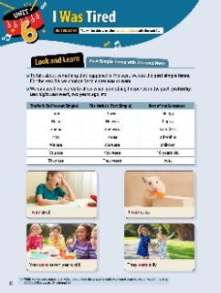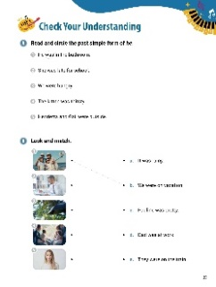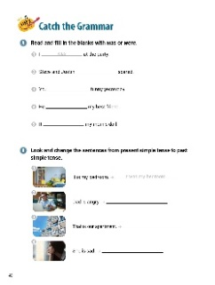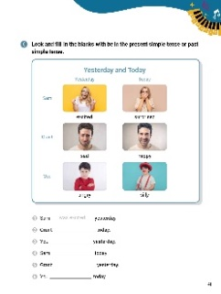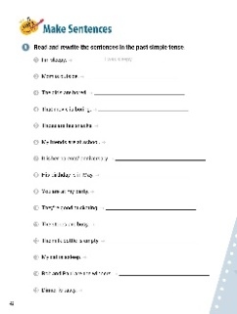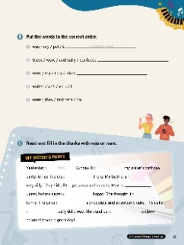

[WARM-UP]
- Have students write three things they did yesterday. Ask them to read their sentences. (Answers vary: I watched TV. I did homework. I studied math.)

[Look and Learn]
- Have students look at the chart on page 38. Go through the grammar points in the chart.
- Look at the example words and images.
- Tell students that while we can use contractions with the verb ‘be’ in the present simple, we cannot contract ‘was’ or ‘were’ in the past. Example: I’m bored. (O) //
I’s bored. (X).
- Tell students to look at the list of things they did yesterday. Have them write how they felt about those activities using the chart. (Answers vary: I watched TV. I was happy.// I did homework. I was tired.// I studied math. I was sleepy.)
[Step 1 Check Your Understanding]
- Have students look at Exercise A ‘Look and circle the past simple form of be’. Ask students to circle the words that complete the sentences.
- Answers: 1. was 2. was 3. were 4. was 5. were
- Have students look at Exercise B ‘Look and match’. Tell students to look at the pictures and read the sentences. Then, students should draw lines between the pictures and the sentences that describe them.
- Answers: 1. b 2. d 3. a 4. e 5. c

[Step 2 Catch the Grammar]
- Have students look at Exercise A ‘Read and fill in the blanks with was or were’. Tell students to look at the sentences. Then, have students write the correct form of the be verb in the blanks.
- Answers: 1. was 2. were 3. were 4. was 5. was
- Have students look at Exercise B ‘Look and change the sentences from present simple tense to past simple tense’. Tell students to read the sentences. Then, have them rewrite the sentences in the past tense.
- Answers: 1. It was my bedroom. 2. Dad was angry. 3. That was our apartment. 4. She was sad.

- Have students look at Exercise C ‘Look and fill in the blanks with be in the present simple tense or past simple tense. Tell students to look at the pictures and read the words. Then, have them complete the sentences with the correct verbs.
- Answers: 1. was excited 2. is happy 3. were angry 4. is surprised 5. was sad 6. are silly

[Step 3 Make Sentences]
- Have students look at Exercise A ‘Read and rewrite the sentences in the past simple tense’. Tell the students to read the sentences. Then, have students write new sentences on the lines by switching the verbs with the past tense verbs.
- Answers: 1. I was sleepy. 2. Mom was outside. 3. The girls were bored. 4. That movie was boring. 5. Those were his snacks. 6. My friends were at school. 7. It was her parents’ anniversary. 8. His birthday was in May. 9. You were at my party. 10. They were good at skating. 11. The stores were busy. 12. The milk bottle was empty. 13. My cat was asleep. 14. Rob and Paul were the winners. 15. Dinner was tasty.
- Have students look at Exercise B ‘Put the words in the correct order’. Tell students to look at words. Then, have students unscramble the words and write the correct sentences on the lines.
- Answers: 1. It was my pet. 2. Steve and Sally were confused. 3. They were my ideas. 4. I was your waiter. 5. They were his and hers.
- Have students look at Exercise C ‘Read and fill in the blanks with was or were’. Tell students to read the paragraph about the party. Then, have them complete the sentences with the correct words.
- Answers: 1. was 2. was 3. were 4. were 5. was 6. was 7. was 8. was 9. was 10. were

[Extra Unit Test]
- Have students turn to page 81 for Unit Test 6. Have the students read the chart and fill in the blanks.
- In the My Grammar Summary, tell students to write what they thought the grammar point for the unit was.
- Tell students to write what they think is the most important thing they learned from Unit 6. Tell the students to write three examples of what they learned in Unit 6.

Unit 7. They Weren’t at the Lake

Unit Objective | You will be able to use the past simple tense be in negatives and questions.

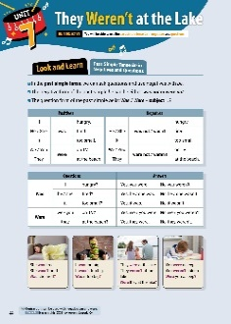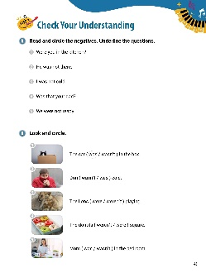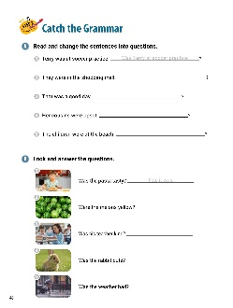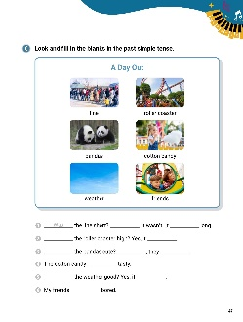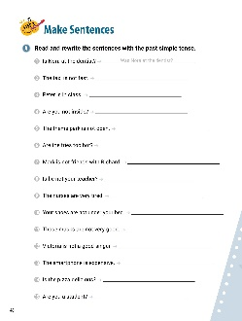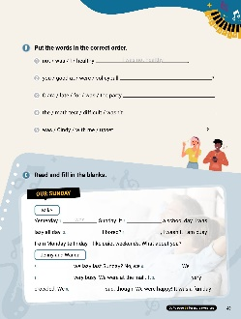

[WARM-UP]
- Have students write three sentences about how they felt yesterday. Have students share their answers. (Answers vary: I was hungry. I was tired. I was sad. I was excited.)
[Look and Learn]
- Have students look at the chart on page 44. Go through the grammar points in the chart.
- Look at the example words and images..
- Tell students that contractions can be used with negative ‘was’ and ‘were’. Example: It wasn't his. (O) //They weren’t bored. (O).
- Have students look at their list of sentences. Tell students to write the sentences as ‘was’ questions. (Answers vary: Was I hungry? Was I tired? Was I sad?)

[Step 1 Check Your Understanding]
- Have students look at Exercise A ‘Read and circle the negatives. Underline the questions’. Tell students to read the sentences. Then, have students circle the words that make the sentences negative. Have students underline any questions.
- Answers: 1. Were you in the kitchen? 2. He was not there. 3. I was not cold. 4. Was that your dad? 5. We were not ready.
- Have students look at Exercise B ‘Look and circle’. Have students look at the pictures and read the sentences. Tell students to circle the words that best complete the sentences.
- Answers: 1. was 2. was 3. weren’t 4. weren’t 5. wasn’t

[Step 2 Catch the Grammar]
- Have students look at Exercise A ‘Read and change the sentences into questions’. Tell students to read the sentences. Then, have them rewrite the sentences as questions.
- Answers: 1. Was Terry at soccer practice? 2. Were they in the shopping mall? 3. Was that a good day? 4. Were her cousins upset? 5. Were the children at the beach?
- Have students look at Exercise B ‘Look and answer the questions’. Tell students to look at the pictures. Then, have students read the questions. Tell students to write the correct answers on the lines.
- Answers: 1. Yes, it was. 2. No, they weren’t. 3. Yes, she was. 4. Yes, it was. 5. Yes, it was.

- Have students look at Exercise C ‘Look and fill in the blanks in the past simple tense’. Tell students to look at the pictures and read the words. Then, have students complete the sentences with the correct words based on the pictures.
- Answers: 1. Was, No, was 2. Was, was 3. Were, Yes, were 4. was 5. Was, was 6. weren’t

[Step 3 Make Sentences]
- Have students look at Exercise A ‘Read and rewrite the sentences with the past simple tense’. Tell students to read the sentences. Then, have students write new sentences on the lines using the correct past tense verbs.
- Answers: 1. Was Nora at the dentist? 2. The taxi was not fast. 3. Peter was in class. 4. Weren’t you inside? / Were you not inside? 5. The theme park was not / wasn’t open. 6. Were the fries too hot? 7. Mark was not / wasn’t friends with Richard. 8. Wasn’t he your teacher? / Was he not your teacher? 9. The nurses were very tired. 10. Your shoes were not / weren’t under your bed. 11. Those masks were not / weren’t very good. 12. Victoria was not / wasn’t a good singer. 13. The smartphone was not / wasn’t expensive. 14. Was the pizza delicious? 15. Were you a student?
- Have students look at Exercise B ‘Put the words in the correct order’. Tell students to look at words. Then, have students unscramble the words and write the correct sentences on the lines.
- Answers: 1. I was not healthy. 2. Were you good at volleyball? 3. Clara was late for the party. 4. The math test wasn’t difficult. 5. Was Cindy upset with me?
- Have students look at Exercise C ‘Look and fill in the blanks’. Read the paragraph about Sunday. Tell students to complete the sentences with the correct words.
- Answers: 1. was 2. wasn’t 3. Was 4. No 5. Were 6. weren’t 7. were 8. was 9. weren’t

[Extra Unit Test]
- Have students turn to page 82 for Unit Test 7. Have the students read the chart and fill in the blanks.
- In the My Grammar Summary, tell students to write what they thought the grammar point for the unit was.
- Tell students to write what they think is the most important thing they learned from Unit 7. Tell the students to write three examples of what they learned in Unit 7.

Unit 8. He Made His Bed

Unit Objective | You will be able to use the past simple tense with regular and irregular verbs.

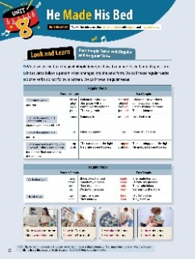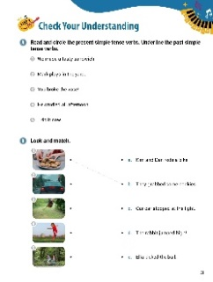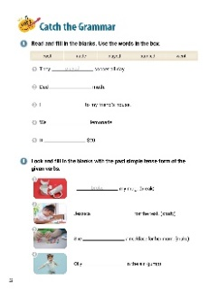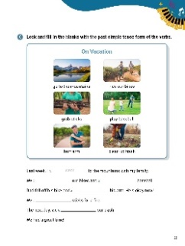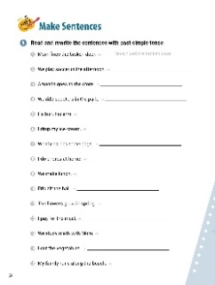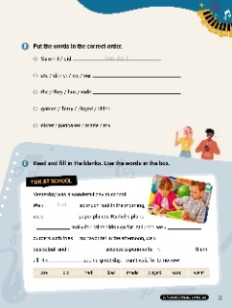

[WARM-UP]
- Have students think about their favorite programs. Then, have students write four verbs about what the characters in the programs were doing. Have students talk about the verbs they chose. (Answers vary: study, run, fight, jump, dance, travel, save)

[Look and Learn]
- Have students look at the chart on page 50. Go through the grammar points in the chart.
- Look at the example words and images.
- Remind students that, unlike verbs in the present simple tense, verbs in the past simple tense don’t change depending on whether we are talking in the first, second, or third person. Example: break, breaks = broke’.
- Have students look at their verb list from the warm-up. Tell students to write all of their verbs in the past tense. Students can use the chart to help them. Go over their answers as a class. (Answers vary: studied, ran, fought, jumped, danced, traveled, saved)

[Step 1 Check Your Understanding]
- Have students look at Exercise A ‘Read and circle the present simple tense verbs. Underline the past simple tense verbs’. Ask students to read the sentences. Then, have students draw lines under the verbs in the past tense and circle verbs in the present tense.
- Answers: 1. We made a tasty sandwich. 2. Mark plays in the yard. 3. You broke the vase! 4. He studied all afternoon. 5. I do it now.
- Have students look at Exercise B ‘Look and match’. Have students look at the pictures and read the sentences. Then, tell students to draw lines between the pictures and the correct sentences.
- Answers: 1. b 2. c 3. d 4. e 5. a

[Step 2 Catch the Grammar]
- Have students look at Exercise A ‘Read and fill in the blanks.’. Tell students to read the sentences. Then, have students complete the sentences using the words in the box.
- Answers: 1. played 2. studied 3. went 4. made 5. cost

- Have students look at Exercise B ‘Look and fill in the blanks with the past simple tense form of the given verbs’. Have students look at the pictures and read the sentences. Tell students change the verbs at the end of the sentences into the past tense.
- Answers: 1. broke 2. studied 3. made 4. jumped
- Have students look at Exercise C ‘Look and fill in the blanks with the past simple tense form of the verbs’. Have students look at the pictures and read the words. Tell them to write the correct words from the chart in the sentences. Remind students to change the words into the past tense.
- Answers: 1. went 2. rode 3. played 4. hurt 5. grabbed 6. cleaned up

[Step 3 Make Sentences]
- Have students look at Exercise A ‘Read and rewrite the sentences with past simple tense'. Tell students to read the sentences. Then, have students write new sentences on the lines using the correct past tense verbs.
- Answers: 1. Mom fixed the broken door. 2. We played soccer in the afternoon. 3. Amanda went to the store. 4. We rode scooters in the park. 5. He hurt his arm. 6. I dropped my ice cream. 7. Wendy carried some bags. 8. I did chores at home. 9. We made lunch. 10. Eric hit the ball. 11. The flowers grew in spring. 12. I paid for the meal. 13. We studied math with Mom. 14. I cut the vegetables. 15. My family ran along the beach.
- Have students look at Exercise B ‘Put the words in the correct order’. Tell students to look at words. Then, have students unscramble the words and write the correct sentences on the lines.
- Answers: 1. Sam did it. 2. We ate our dinner. 3. They rode the bus. 4. Terry played video games. 5. My sister made pancakes.
- Have students look at Exercise C ‘Read and fill in the blanks’. Read the words in the box. Have students read the paragraph about fun at school. Tell them to complete the sentences using the words in the box.
- Answers: 1. had 2. made 3. went 4. ate 5. played 6. did 7. liked 8. was

[Extra Unit Test]
- Have students turn to page 83 for Unit Test 8. Have the students read the chart and fill in the blanks.
- In the My Grammar Summary, tell students to write what they thought the grammar point for the unit was.
- Tell students to write what they think is the most important thing they learned from Unit 8. Tell the students to write three examples of what they learned in Unit 8.

Unit 9. Did She Close the Window?

Unit Objective | You will be able to use the past simple tense in negatives and questions.
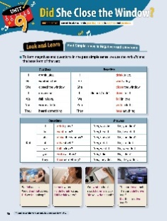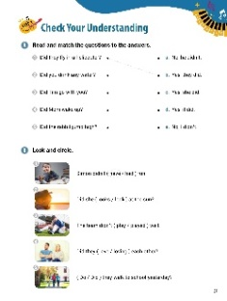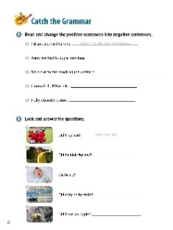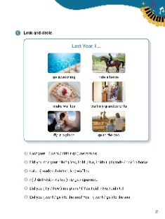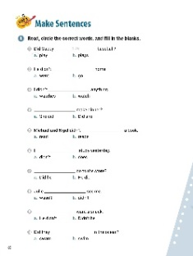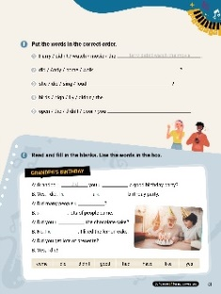

[WARM-UP]
- Have students think about what they did yesterday. Ask them to write three things they did not do yesterday. (Answers vary: not study, not go to the park, not play, not watch a show, not see my friends)

[Look and Learn]
- Have students look at the chart on page 56. Go through the grammar points in the chart.
- Look at the example words and images.
- Remind students that unlike ‘be’, the verb ‘do’ only has one past form: ‘did’.
- Have students look at their lists from the warm-up. Then, have students write sentences using the chart and ‘did not’. Have students share their answers. (Answers vary: I did not study., I did not go to the park., I did not play., I did not watch a show., I did not see my friends.)

[Step 1 Check Your Understanding]
- Have students look at Exercise A ‘Look and match the questions to the answers’. Ask students to read the questions and answers. Then, have them draw lines between the questions and the correct answers.
- Answers: 1. b 2. e 3. a 4. c 5. d
- Have students look at Exercise B ‘Look and circle’. Tell students to look at the pictures. Then, have students read the sentences. Ask students to circle the best words to complete the sentences.
- Answers: 1. have 2. look 3. play 4. love 5. Did

[Step 2 Catch the Grammar]
- Have students look at Exercise A ‘Look and change the positive sentences into negative sentences circle’. Have students read the sentences. Then, tell students to rewrite the sentences using the negative form, ‘didn’t’.
- Answers: 1. I didn’t drink your milkshake. 2. Terry didn’t want to buy a new bag. 3. We didn’t drive to the beach on the weekend. 4. Donna didn’t fall off her bike. 5. Polly didn’t close the door.
- Have students look at Exercise B ‘Look and answer the questions’. Have students look at the pictures and read the questions. Then, ask them to write sentences that answer the questions.
- Answers: 1. Yes, they did. 2. No, he didn’t. 3. Yes, he did. 4. No, they didn’t. 5. No, it didn’t.
- Have students look at Exercise C ‘Look and circle’. Tell students to look at the pictures and read the words. Tell students to circle the words that complete the sentences.
- Answers: 1. went 2. No, I didn’t. / rode 3. made 4. visited 5. fly / Yes, I did 6. go / went

[Step 3 Make Sentences]
- Have students look at Exercise A ‘Read, circle the correct words, and fill in the blanks ’. Tell students to read the sentences. Then, tell them to circle the letters of the words that complete the sentences.
- Answers: 1. play 2. go 3. watch 4. Did she 5. read 6. didn’t 7. Did he 8. didn’t 9. He didn’t 10. swim
- Have students look at Exercise B ‘Put the words in the correct order’. Tell students to look at words. Then, have students unscramble the words and write the correct sentences on the lines.
- Answers: 1. Harry didn’t watch the movie. 2. Did Andy walk home? 3. Did she sing loud? 4. The birds didn’t fly high. 5. You didn’t open the door.
- Have students look at Exercise C ‘Read and fill in the blanks’. Tell students to read the sentences about Grandpa’s birthday. Then, ask them to complete the sentences by writing the correct words from the box.
- Answers: 1. did 2. have 3. had 4. good 5. come 6. Yes 7. like 8. didn’t

[Extra Unit Test]
- Have students turn to page 84 for Unit Test 9. Have the students read the chart and fill in the blanks.
- In the My Grammar Summary, tell students to write what they thought the grammar point for the unit was.
- Tell students to write what they think is the most important thing they learned from Unit 9. Tell the students to write three examples of what they learned in Unit 9.

Unit 10. They Sang Happily

Unit Objective | You will be able to use adverbs.

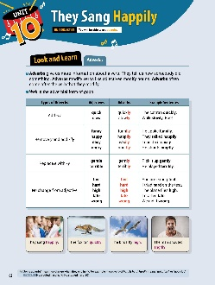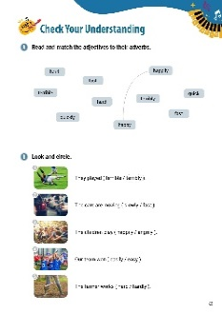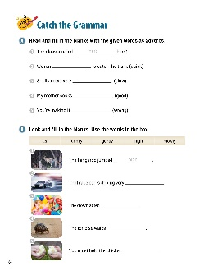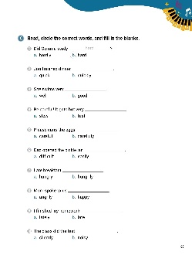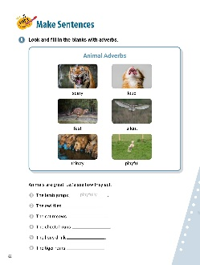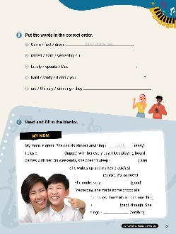

[WARM-UP]
- Have students think about a fun time they had. What did they do? How did they feel or what was it like? Have students write three verbs about what they did. Then, have students write three adjectives describing how they felt or how it was. Have them share with the class. (Answers vary: write/happy, play/excited, kicked/strong)

[Look and Learn]
- Have students look at the chart on page 62. Go through the grammar points in the chart.
- Look at the example words and images.
- Tell students that some adverbs' meanings change when they end in -ly. For example, the adverb of ‘hard’ is ‘hard’. ‘Hardly’ means ‘not often’ or ‘not a lot’. Example: He studied hardly. (X) He studied hard. (O)
- Ask students use their lists from the warm-up. Have students write their verbs and adjectives as verb and adverb pairs. Have students use the chart and ask them to share their pairs ((Answers vary: write/happily, play/excitedly, kick/strongly)

[Step 1 Check Your Understanding]
  - Have students look at Exercise A ‘Read and match the adjectives to their adverbs’. Have students look at the words. Ask students to draw lines between the adjectives and the matching adverbs.
  - Answers: Adjectives : Adverbs hard : hard terrible : terribly fast : fast quick : quickly happy : happily
  - Have students look at Exercise B ‘Look and circle’. Tell students look at the pictures and read the sentences. Have students circle the correct adverbs.
  - Answers: 1. terribly 2. slowly 3. happily 4. easily 5. hard

[Step 2 Catch the Grammar]
  - Have students look at Exercise A ‘Read and fill in the blanks with the given words as adverbs’. Tell students to read the sentences. Then, ask them to rewrite the words at the end of sentences as adverbs.
  - Answers: 1. hard 2. quickly 3. slowly 4. well 5. wrong
- Have students look at Exercise B ‘Look and fill in the blanks’. Have students look at the pictures. Tell students to write the correct words from the box on the lines.
  - Answers: 1. high 2. fast 3. funnily 4. slowly 5. gently

  - Have students look at Exercise C ‘Read, circle the correct words, and fill in the blanks’. Have students read the sentences. Then, ask them to complete the sentences by circling the correct adverb.
  - Answers: 1. b. hard 2. b. quickly 3. a. well 4. b. fast 5. b. carefully 6. b. easily 7. b. hungrily 8. a. angrily 9. b. late 10. a. silently

[Step 3 Make Sentences]
  - Have students look at Exercise A ‘Look and fill in the blanks with adverbs’. Ask students to look at the pictures and read the words under them. Then, have students complete the sentences by writing the correct adverbs.
  - Answers: 1. playfully 2. silently 3. loudly 4. fast 5. thirstily 6. scarily
  - Have students look at Exercise B ‘Put the words in the correct order’. Tell students to look at words. Then, have students unscramble the words and write the correct sentences on the lines.
  - Answers: 1. Gavin drove fast. 2. It rained hard yesterday. 3. Dad speaks loudly. 4. Didn’t you study hard? 5. They are drinking thirstily.
  - Have students look at Exercise C ‘Look and fill in the blanks’. Have students look at the story about the boy’s mom. Tell students to write the correct adverbs on the lines to complete the paragraph.
  - Answers: 1. easily 2. happily 3. late 4. quickly 5. well 6. badly 7. terribly

[Extra Unit Test]
  - Have students turn to page 85 for Unit Test 10. Have the students read the chart and fill in the blanks.
  - In the My Grammar Summary, tell students to write what they thought the grammar point for the unit was.
  - Tell students to write what they think is the most important thing they learned from Unit 10. Tell the students to write three examples of what they learned in Unit 10.

