Unit 1. He Can Ride a Bike

Unit Objective | You will be able to use can and can’t in statements and questions.

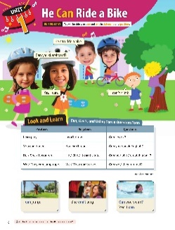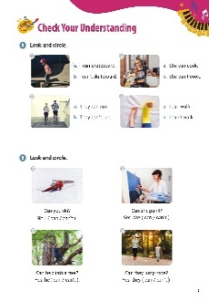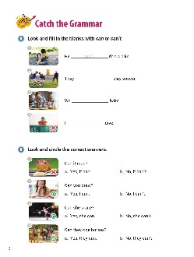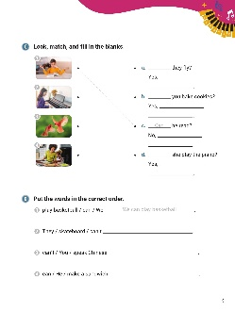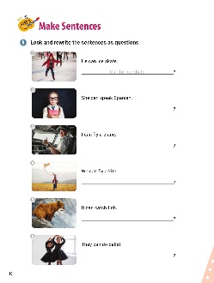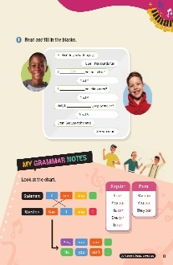

[WARM-UP]
- Have students look at the illustrations and words. Ask them what they see.

[Look and Learn]
- Have students look at the chart on page 6. Go through the grammar points in the chart.
- Look at the example words and images.
- Read the words together.
- Ask students to go back to the cartoon and circle ‘can’ and ‘can’t’.

[Step 1 Check Your Understanding]
- Have students look at Exercise A ‘Look and circle’. Tell students to look at the pictures. Then, have them circle the letters of the sentences that best describe the pictures.
- Answers: 1. a 2. a 3. a 4. b
- Have students look at Exercise B ‘Look and circle’. Have students look at the pictures and read the questions. Ask students to circle either ‘can’ or ‘can’t’ to complete the sentences.
- Answers: 1. can’t 2. can 3. can 4. can

[Step 2 Catch the Grammar]
- Have students look at Exercise A ‘Look and fill in the blanks with can or can’t’. Tell students to look at the pictures. Then, have them to write the correct words in the blanks.
- Answers: 1. can’t 2. can 3. can 4. can’t
- Have students look at Exercise B ‘Look and circle the correct answers’. Ask students to look at the pictures. Then, read the sentences. Have students circle the letters of the correct answers.
- Answers: 1. b 2. a 3. a 4. a
- Have students look at Exercise C ‘Look, match, and fill in the blanks.’ Have students look at the pictures and draw lines between the pictures and the words. Then, tell students to complete the sentences.
- Answers: 1. c; Can; he can’t 2. d; Can; she can 3. a; Can; they can 4. b; Can; I can
- Have students look at Exercise D ‘Put the words in the correct order’. Tell students to unscramble the words to make sentences. Then, have students write the correct sentences on the lines.
- Answers: 1. We can play basketball. 2. They can’t skateboard. 3. You can’t speak Chinese. 4. He can make a sandwich.

[Step 3 Make Sentences]
- Have students look at Exercise A ‘Look and rewrite the sentences as questions’. Tell students to look at the pictures and read the sentences. Then, have them write questions on the lines using the sentences.
- Answers: 1. Can he ice skate? 2. Can she speak Spanish? 3. Can I fly a plane? 4. Can we fly a kite? 5. Can it catch fish? 6. Can they do ballet?
- Have students look at Exercise B ‘Read and fill in the blanks’. Tell students to read the conversation between Max and his friend. Have students write ‘can’ or ‘can’t’ in the blanks.
- Answers: 1. Can 2. can’t 3. Can 4. can’t 5. can 6. can

[My Grammar Notes]
- Have students look at the chart on page 11. Read the chart out loud. Ask students to make their own questions using the sentences in the chart.
[Extra Unit Test]
- Have students turn to page 76 for Unit Test 1. Read the test items out loud. Have the students fill in the blank.
- In the My Grammar Summary, read each line item. Tell students to write what they thought the grammar point for the unit was.
- Tell students to write what they think is the most important thing they learned from Unit 1. Tell the students to write two examples of what they learned in Unit 1.

Unit 2. He Is Juggling

Unit Objective | You will be able to use the present continuous tense.

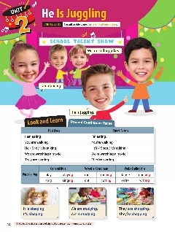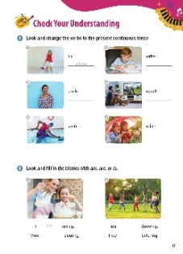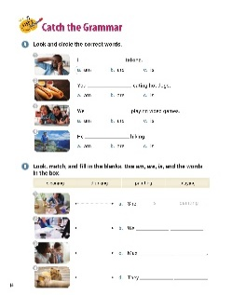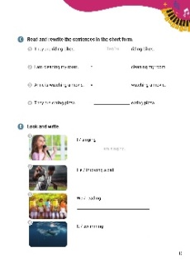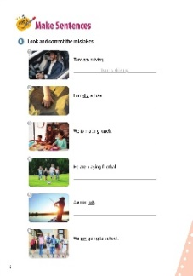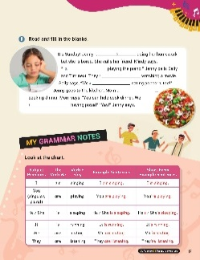

[WARM-UP]
- Have students look at the illustrations and words on page 12. Ask questions about what the students see.

[Look and Learn]
- Have students look at the chart on page 12. Go through the grammar points in the chart.
- Look at the example words and images.
- Read the words together.
- Tell students to go back to the cartoon and circle all the present continuous tense verbs.

[Step 1 Check Your Understanding]
- Have students look at Exercise A ‘Look and change the verbs to the present continuous tense’. Ask students to look at the pictures and read the verbs. Then, ask them to rewrite the verbs in the present continuous tense.
- Answers: 1. sitting 2. writing 3. smiling 4. watching 5. swimming 6. raining
- Have students look at Exercise B ‘Look and fill in the blanks with ‘am’, ‘are’, or ‘is’. Tell students to look at the pictures. Then, have the students complete the sentences with the correct form of the be verb.
- Answers: 1. am, is 2. is, are

[Step 2 Catch the Grammar]
- Have students turn to page 14 for Exercise A ‘Look and circle the correct words’. Tell students to look at the pictures. Ask students to circle the letters of the verbs that best match the pictures.
- Answers: 1. a 2. b 3. b 4. C
- Have students look at Exercise B ‘Look, match, and fill in the blanks’. Read the words in the box. Tell students to look at the pictures and draw lines between the pictures and the words. Then, have students use ‘am’, ‘are’, ‘is’, and the words in the box to make sentences.
- Answers: 1. a; She is painting. 2. c; Max is cleaning. 3. b; We are drinking.
4. d; They are playing.

- Have students look at Exercise C ‘Read and rewrite the sentences in the short form’. Read the sentences. Then, have students change the words to contractions to complete the sentences.
- Answers: 1. They’re 2. I’m 3. Anne’s 4. They’re
- Have students look at Exercise D ‘Read and write’. Have students look at the pictures. Using the words, tell students to write sentences in the present continuous.
- Answers: 1. I am singing. 2. He is throwing a ball. 3. We are reading. 4. It is swimming.

[Step 3 Make Sentences]
- Have students turn to page 16 for Exercise A ‘Look and correct the mistakes’. Tell students to read the sentences. Then, look at the underlined words. Have students rewrite the sentences on the lines using the correct form of the verb.
- Answers: 1. Tom is driving. 2. I am digging a hole. 3. We are making lunch. 4. They are playing football. 5. Alex is fishing. 6. We are going to school.
- Have students look at page 17 for Exercise B ‘Read and fill in the blanks’. Tell the students to read the story about Sunday. Then, have students complete the sentences with the correct verbs.
- Answers: 1. is 2. am 3. are 4. are 5. is 6. are

[My Grammar Notes]
- Have students look at the chart on page 17. Read the chart out loud. Tell students to make new sentences using the chart. (Answers vary: suggestions below.)
I play piano. I am playing piano.
She cooks. She is cooking.
He does his homework. He is doing his homework.
They play video games. They are playing video games.

[Extra Unit Test]
- Have students turn to page 77 for Unit Test 2. Read the test items out loud. Have the students fill in the blanks.
- In the My Grammar Summary, read each line item. Tell students to write what they thought the grammar point for the unit was.
- Tell students to write what they think is the most important thing they learned from Unit 2. Have students write two examples of what they learned in Unit 2.

Unit 3. Is Anne Skiing?

Unit Objective | You will be able to use the present continuous tense in negatives and questions.

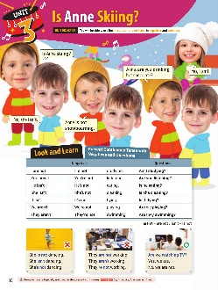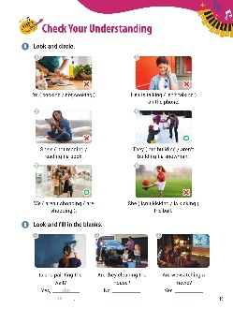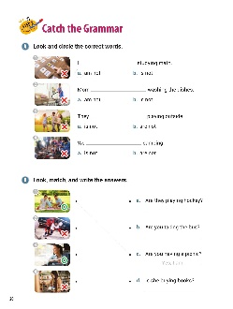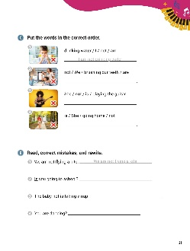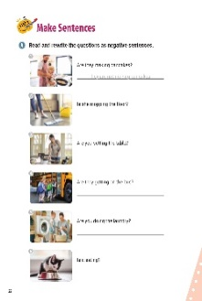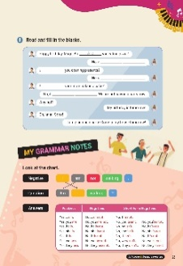

[WARM-UP]
- Have students look at the illustrations and words at the top of page 18.
- Ask students what they see. Have students read the sentences out loud.

[Look and Learn]
- Have students look at the chart on page 18. Go through the grammar points in the chart.
- Look at the example words and images.
- Read the words together.
- Remind students that some verbs are typically not used in the present continuous. Examples: be, hate, like, love, see, and wish.

[Step 1 Check Your Understanding]
- Have students look at Exercise A ‘Look and circle’. Tell students to look at the pictures. A red x means ‘not’ and a green circle means it is true. Have students circle the words that best describe the pictures.
- Answers: 1. not cooking 2. isn’t talking 3. not reading 4. are building 5. are shopping 6. isn’t kicking
- Have students look at Exercise B ‘Look and fill in the blanks’. Tell students look at the pictures. Then, ask them to write the correct words to make sentences that answer the questions.
- Answers: 1. she is 2. they aren’t 3. we are

[Step 2 Catch the Grammar]
- Have students look at Exercise A ‘Look and circle the words’. Tell students to look at the pictures. Then, they should circle the letters of the words that best match the pictures.
- Answers: 1. a 2. b 3. b 4. b
- Have students look at Exercise B ‘Look, match, and write the answers’. Ask students to look at the pictures. Have them draw lines between the pictures and the questions that match them. Then, tell students to write the sentences that answer the questions.
- Answers: 1. c; Yes, I am. 2. a; No, they aren’t. 3. b; Yes, I am. 4. d; No, she isn’t.

- Have students look at Exercise C ‘Put the words in the correct order’. Have students look at the pictures and read the words. Then, tell students to unscramble the words to write sentences that match the pictures.
- Answers: 1. I am not drinking water. 2. We are not brushing our teeth. 3. She is not playing the guitar. 4. She is not going home.
- Have students look at Exercise D ‘Read, correct mistakes, and rewrite’. Tell students to read the sentences and look at the underlined words. Then, tell students to rewrite the sentences with the correct words.
- Answers: 1. We are not flying a kite. 2. Are you going to school? 3. The baby is not taking a nap. 4. Are you dancing?

[Step 3 Make Sentences]
- Have students look at Exercise A ‘Read and rewrite the questions as negative sentences’. Tell students to look at the pictures and read the questions. Then, ask them to write the answers to the questions in the negative form.
- Answers: 1. They are not making pancakes. 2. She is not mopping the floor. 3. You are not setting the table. 4. They are not getting on the bus. 5. You are not doing the laundry. 6. It is not eating.
- Have students look at Exercise B ‘Read and fill in the blanks’. Have students read the conversation. Then, tell them to fill in the blanks to complete the sentences.
- Answers: 1. Are 2. I am not (I’m not) 3. Are 4. I am not (I’m not) 5. Is 6. she is not (she isn’t / she’s not)

[My Grammar Notes]
- Have students look at the chart on page 23. Read the chart together. Have students work in pairs. The students should take turns asking questions and answering the questions using the chart. (Answers vary: suggestions follow.)
Are you going? No, I’m not.
Is he working? Yes, he is.
Are we late? No, we aren’t.

[Extra Unit Test]
- Have students turn to page 78 for Unit Test 3. Read the test items out loud. Have the students fill in the blanks.
- In the My Grammar Summary, read each line item. Tell students to write what they thought the grammar point for the unit was.
- Tell students to write what they think is the most important thing they learned from Unit 3. Have students write two examples of what they learned in Unit 3.

Unit 4. What Are You Doing?

Unit Objective | You will be able to use the words who and what in questions along with the present continuous tense.

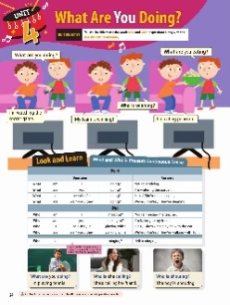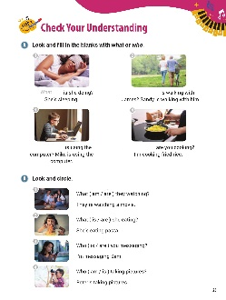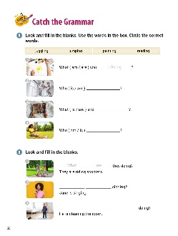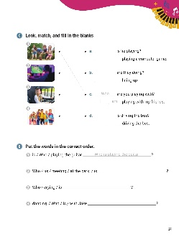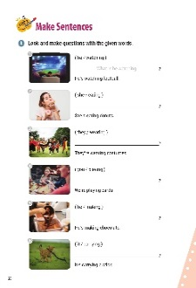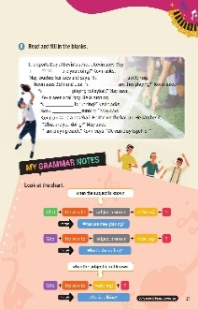

[WARM-UP]
- Have students look at the illustrations and words on page 24.

[Look and Learn]
- Have students look at the chart. Go through the grammar points in the chart.
- Look at the example words and images.
- Read the words and sentences together.
- Remind students to leave out the pronoun when you are unsure if the subject is in the 1st, 2nd, or 3rd person.
- Tell students to go back to the cartoon and circle all the ‘who’ and ‘what’ question words.

[Step 1 Check Your Understanding]
- Have students look at Exercise A ‘Look and fill in the blanks with what or who’. Ask students to look at the pictures and read the sentences. Then, have them complete the questions with the correct question words.
- Answers: 1. What 2. Who 3. Who 4. What
- Have students look at Exercise B ‘Look and circle’. Tell students to look at the pictures and read the sentences. Then, have students circle the correct verbs.
- Answers: 1. are 2. is 3. are 4. is

[Step 2 Catch the Grammar]
- Have students look at Exercise A ‘Look and fill in the blanks’. Read the words in the box. Tell students to circle the correct words to complete the questions.
- Answers: 1. are; painting 2. is; jumping 3. is; reading 4. is; juggling
- Have students look at Exercise B ‘Look and fill in the blanks’. Tell students to look at the pictures and read the sentences. Then, have them fill in the blanks using the question words and words that best match the pictures.
- Answers: 1. What are 2. Who is 3. What is he
- Have students look at Exercise C ‘Look, match, and fill in the blanks’. Tell students to look at the pictures and read the parts of the sentences. Then, have students draw lines between the pictures and the correct sentences. Students should write the missing words on the blank lines.
- Answers: 1. c; Who, I am 2. a; What, He is 3. d; Who, She is 4. b; What, They are

- Have students look at Exercise D ‘Put the words in the correct order’. Ask students to unscramble the words and write the questions on the lines provided.
- Answers: 1. Who is playing the guitar? 2. Who is meeting us at the park? 3. Who is crying? 4. Who is dancing with Jake?
[Step 3 Make Sentences]
- Have students look at Exercise A ‘Look and make questions with the given words’. Tell students to look at the pictures and read the sentences. Have them write the questions on the lines using the words in the parentheses.
- Answers: 1. What is he watching? 2. What is she eating? 3. What are they wearing? 4. What are you playing? 5. What is he making? 6. What is it carrying?
- Have students look at Exercise B ‘Read and fill in the blanks’. Tell students to read the sentences about Sports Day at Kevin’s school. Then, they should complete the sentences.
- Answers: 1. What 2. am 3. What 4. They’re 5. Who 6. is

[My Grammar Notes]
- Have students look at the chart on page 29. Read the chart together. Ask students to make new sentences using the chart. (Answers vary: What are they doing? Who is he talking to? Who is going? When are we leaving?)

[Extra Unit Test]
- Have students turn to page 79 for Unit Test 4. Read the test items out loud. Have the students fill in the blanks.
- In the My Grammar Summary, read each line item. Tell students to write what they thought the grammar point for the unit was.
- Tell students to write what they think is the most important thing they learned from Unit 4. Have students write two examples of what they learned in Unit 4.

Unit 5. I Play Soccer Every Day

Unit Objective | You will learn the difference between the present simple tense and the present continuous tense.

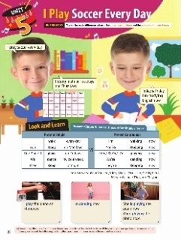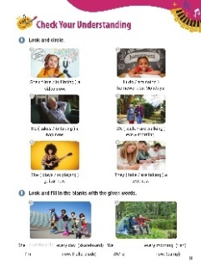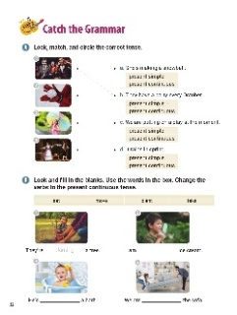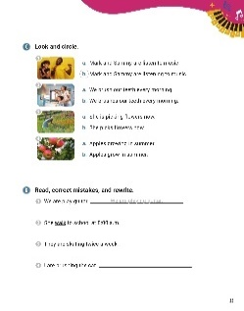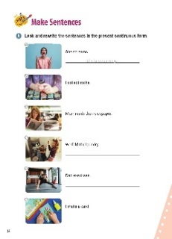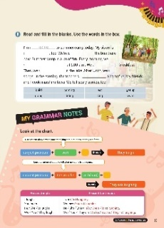

[WARM-UP]
- Have students look at the illustrations and words. Ask them to read the sentences out loud.

[Look and Learn]
- Have students look at the chart on page 30. Go through the grammar points in the chart.
- Look at the example words and images.
- Read the words together.
- Tell students that sometimes, the present continuous tense can be confused for the future tense. If the person you are speaking to is unsure of the tense, add one of the following to clarify that you mean right now: ‘now’, ‘at the moment’, or ‘at present’.
[Step 1 Check Your Understanding]
- Have students look at Exercise A ‘Look and circle’. Ask students to look at the pictures and read the sentences. Then, have students circle the words that best describe the pictures.
- Answers: 1. is filming 2. do 3. is taking 4. walk 5. is playing 6. are taking
- Have students look at Exercise B ‘Look and fill in the blanks with the given words’. Tell students to look at the pictures and read the sentences. Then, have students write the correct words in the blanks.
- Answers: 1. skateboards, rollerblading 2. fish, camping
[Step 2 Catch the Grammar]
- Have students look at Exercise A ‘Look, match, and circle the correct tense’. Have students look at the pictures. Tell students to read the sentences and draw lines between the pictures and the correct sentences. Then, have students put circles around the verb tense that is used in the sentences.
- Answers: 1. b; present simple 2. a; present continuous 3. d; present simple 4. c; present continuous
- Have students look at Exercise B ‘Look and fill in the blanks’. Read the words in the box. Tell students to look at the pictures. Then, have students use the words from the box that best complete the sentences. Remind students to change the verb tense to present continuous.
- Answers: 1. planting 2. eating 3. taking 4. moving
- Have students look at Exercise C ‘Look and circle’. Tell students to look at the pictures. Then, have students circle the letters of the sentences that best describe the pictures.
- Answers: 1. b 2. a 3. a 4. b
- Have students look at Exercise D ‘Read, correct the mistakes, and rewrite’. Tell students to read the sentences. Then, they should write the sentences on the line, replacing the underlined word with the correct word.
- Answers: 1. We are / We’re playing guitar. 2. She walks to school at 8:00 a.m. 3. They skate twice a week. 4. I am / I’m brushing the cat.

[Step 3 Make Sentences]
- Have students look at Exercise A ‘Look and rewrite the sentences in the present continuous form’. Tell students to look at the pictures and think about what is happening. Then, they need write the sentences in the present continuous form.
- Answers: 1. She is / She’s screaming. 2. I am / I’m collecting rocks. 3. Mom is / Mom’s reading the newspaper. 4. We are / We’re folding the laundry. 5. Dad is / Dad’s exercising. 6. I am / I’m making a card.
- Have students look at Exercise B ‘Read and fill in the blanks’. Read the words in the box. Ask students to write the correct words in the blanks in the paragraph about summer camp. They should use the words from the box.
- Answers: 1. going 2. coming 3. riding 4. get up 5. eat 6. swim 7. sing 8. build
[My Grammar Notes]
- Have students look at the chart on page 35. Read the chart together. Tell the students that you will tell them a sentence. They need to tell you the present continuous form of the sentence. Suggestions:
I laugh at jokes. (I am laughing at jokes.)
She watches scary shows. (She is watching scary shows.)
We eat cookies. (We are eating cookies.)

[Extra Unit Test]
- Have students turn to page 80 for Unit Test 5. Read the test items out loud. Have the students fill in the blanks.
- In the My Grammar Summary, read each line item. Tell students to write what they thought the grammar point for the unit was.
- Tell students to write what they think is the most important thing they learned from Unit 5. Have students write two examples of what they learned in Unit 5.

Unit 6. My Mother Is Kind

Unit Objective | You will learn how to use adjectives in statements.

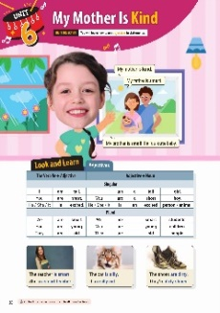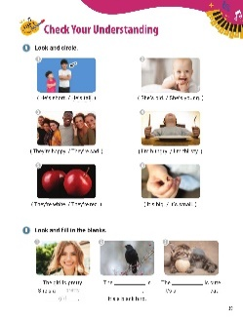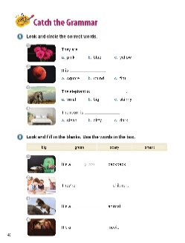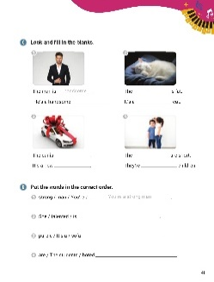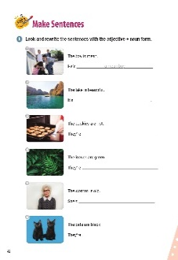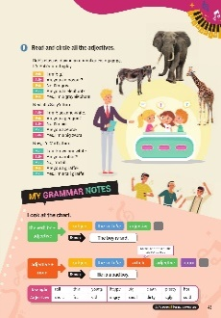

[WARM-UP]
- Have students look at the illustrations and words.
- Ask students what they see.

[Look and Learn]
- Have students look at the chart on page 38. Go through the grammar points in the chart.
- Look at the example words and images.
- Read the words together.
- Have students go back to the cartoon and circle all the adjectives.
[Step 1 Check Your Understanding]
- Have students look at Exercise A ‘Look and circle’. Ask students to look at the pictures. Students need to circle the sentences that describe the pictures.
- Answers: 1. He’s tall. 2. She’s young. 3. They’re happy. 4. I’m hungry. 5. They’re red. 6. It’s small.
- Have students look at Exercise B ‘Look and fill in the blanks’. Tell students to look at the pictures and complete the sentences.
- Answers: 1. pretty girl 2. bird, black 3. cat, cute

[Step 2 Catch the Grammar]
- Have students look at Exercise A ‘Read and circle the correct words’. Tell students to look at the pictures. Then, students should circle the letters of the adjectives that best say what is in the pictures.
- Answers: 1. a 2. b 3. b 4. a
- Have students look at Exercise B ‘Look and fill in the blanks’. Read the words in the box. Tell students to look at the pictures. Then, ask students to choose adjectives from the box to complete the sentences.
- Answers: 1. green 2. smart 3. big 4. scary
- Have students look at Exercise C ‘Read and fill in the blanks’. Tell students to look at the pictures and read the sentences. Then, have them complete the sentences with the correct nouns and adjectives.
- Answers: 1. handsome, man 2. cat, fat 3. new, car 4. children, short
- Have students look at Exercise D ‘Put the words in the correct order’. Tell students unscramble the words to make sentences. Students should write the new sentences on the lines.
- Answers: 1. You’re a strong man. 2. She is talented. 3. It’s a purple sofa. 4. The students are bored.

[Step 3 Make Sentences]
- Have students look at Exercise A ‘Look and rewrite the sentences with the adjective + noun form’. Tell the students to look at the pictures and read the sentences. Then, have students rewrite the sentences with the adjective and the noun.
- Answers: 1. a mean boy 2. a beautiful lake 3. hot cookies 4. green leaves 5. an old woman 6. black cats
- Have students look at Exercise B ‘Read and circle all the adjectives’. Tell students to read the story about the class game. Then, have them circle the adjectives they see.
- Answers: big, gray, gray// black, white, big, big//brown, white, tall, tall

[My Grammar Notes]
- Have students look at the chart on page 43. Read the chart out loud. Ask students to talk about their toys, games, and pets using the chart. Have students change the statements to use the adjective + noun form. (Answers vary. Examples follow.)
My dog is smart. He is a smart dog.
My bear is cute. She is a cute bear.
My doll is small. It is a small doll.
My game is easy. It is an easy game.

[Extra Unit Test]
- Have students turn to page 81 for Unit Test 6. Read the test items out loud. Have the students fill in the blanks.
- In the My Grammar Summary, read each line item. Tell students to write what they thought the grammar point for the unit was.
- Tell students to write what they think is the most important thing they learned from Unit 6. Have students write two examples of what they learned in Unit 6.

Unit 7. The Taxi Is Faster

Unit Objective | You will be able to use comparatives.

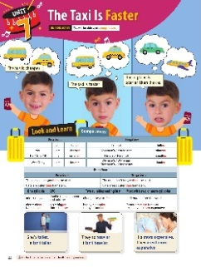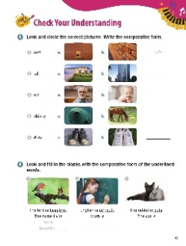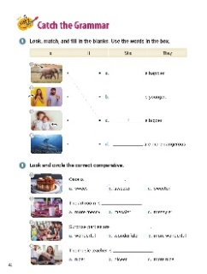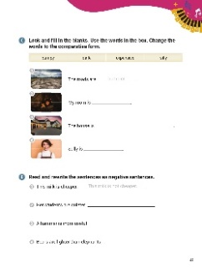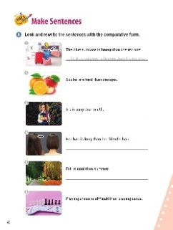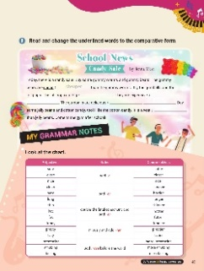

[WARM-UP]
- Have students look at the illustrations and sentences. Ask them what they see.

[Look and Learn]
- Have students look at the chart on page 44. Go through the grammar points in the chart.
- Look at the example words and images.
- Read the words together.
- Have students go back to the cartoon and circle all the comparatives.

[Step 1 Check Your Understanding]
- Have students look at Exercise A ‘Look and circle the correct pictures’. Tell students to look at the adjectives. Then, have students circle the letters of the pictures that match the words. Tell students to write the comparative forms on the lines.
- Answers: 1. a; softer 2. b; taller 3. a; older 4. b; skinnier 5. a; dirtier
- Have students look at Exercise B ‘Look and fill in the blanks with the comparative form of the underlined words’. Have students look at the pictures and read the sentences. Tell students to write the comparatives on the lines.
- Answers: 1. more beautiful 2. more difficult 3. cuter

[Step 2 Catch the Grammar]
- Have students look at Exercise A ‘Look, match, and fill in the blanks’. Read the words in the box. Tell students to look at the pictures. Then, have students draw lines between the pictures and the sentences that match them. Tell students to write the words from the box on the lines to complete the sentences.
- Answers: 1. c; It 2. a; She 3. b; He 4. d; They
- Have students look at Exercise B ‘Look and circle the correct comparative’. Tell students to look at the pictures and read the sentences. Then, have students circle the letters of the comparatives that describe the pictures.
- Answers: 1. b 2. b 3. c 4. a
- Have students look at Exercise C ‘Look and fill in the blanks’. Read the words in the box. Tell students to look at the pictures and read the sentences next to them. Then, have students complete the sentences with the words from the box. Remind students to change the words into the comparative form.
- Answers: 1. bumpier 2. darker 3. more expensive 4. sillier
- Have students look at Exercise D ‘Read and fill in the blanks’. Read the words in the box. Tell students to read the sentences. Have students rewrite the statements in the negative.
- Answers: 1. This milk is not cheaper. 2. Her students are not quieter. 3. A hammer is not more useful. 4. Bears are not lighter than elephants.

[Step 3 Make Sentences]
- Have students look at Exercise A ‘Look and rewrite the sentences with the comparative form’. Tell students to read the sentences. Then, have students write new sentences on the lines using the comparative form of the bolded words.
- Answers: 1. The blue suitcase is heavier than the red one. 2. Apples are harder than oranges. 3. Art is easier than math. 4. Her hair is longer than her friend’s hair. 5. Fall is cooler than summer. 6. Playing chess is more difficult than playing cards.
- Have students look at Exercise B ‘Read and change the underlined words to the comparative form’. Tell students to read the paragraph about the candy sale. Have students write the underlined words on the lines in the comparative form.
- Answers: 1. cheaper 2. bigger 3. more expensive 4. more delicious 5. sweeter

[My Grammar Notes]
- Have students look at the chart on page 49. Read the chart out loud. Ask students to make questions about their town based on the chart. (Answers vary: Is the yellow bus bigger than the blue bus? Is the park smaller than the school? Is the school closer to the store? Is the weather hotter than New York’s?)

[Extra Unit Test]
- Have students turn to page 82 for Unit Test 7. Read the test items out loud. Have the students fill in the blanks.
- In the My Grammar Summary, read each line item. Tell students to write what they thought the grammar point for the unit was.
- Tell students to write what they think is the most important thing they learned from Unit 7. Have students write two examples of what they learned in Unit 7.

Unit 8. I Hope to Make Many Friends Here

Unit Objective | You will be able to use want to, like to, and hope to in statements.

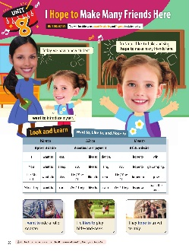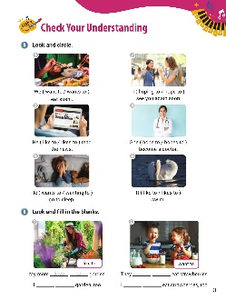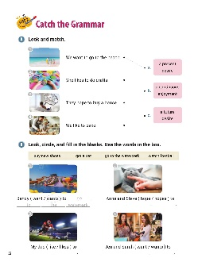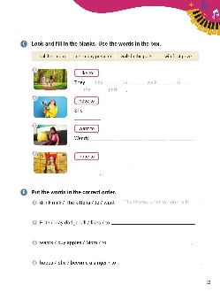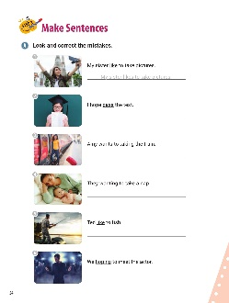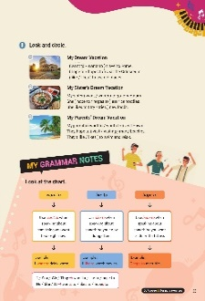

[WARM-UP]
- Have students look at the illustrations and sentences.

[Look and Learn]
- Have students look at the chart on page 50. Go through the grammar points in the chart.
- Look at the example words and images.
- Read the words together.
- Ask students to go back to the illustration and circle all the uses of ‘want to’, ‘like to’, and ‘hope to’.

[Step 1 Check Your Understanding]
- Have students look at Exercise A ‘Look and circle’. Ask students to look at the pictures and circle the correct words.
- Answers: 1. want to 2. hope to 3. likes to 4. hopes to 5. wants to 6. likes to
- Have students look at Exercise B ‘Look and fill in the blanks’. Have students read the phrases and look at the pictures. Then, tell students to complete the sentences with the words in the pictures.
- Answers: 1. likes to, like to 2. want to, want to
[Step 2 Catch the Grammar]
- Have students look at Exercise A ‘Look and match’. Tell students to look at the pictures and read the sentencesㅋ. Then, students have students draw lines to the best description of the sentences.
- Answers: 1. a 2. b 3. c 4. b
- Have students look at Exercise B ‘Look, circle, and fill in the blanks’. Read the words in the box. Have students look at the pictures. Tell students to circle the correct verbs to match the pictures. Then, have students complete the sentences using the words from the box.
- Answers: 1. wants; go to the waterpark 2. hope; get a pet 3. likes; watch football 4. want; buy new shoes
- Have students look at Exercise C ‘Look and fill in the blanks’. Read the words in the box. Have students look at the pictures. Tell them to write sentences using the words in the box and what they see in the pictures.
- Answers: 1. like to walk in the park 2. hopes to win first prize 3. wants to call her mom 4. hope to get many presents
- Have students look at Exercise D ‘Put the words in the correct order’. Have students unscramble the words and write complete sentences on the lines.
- Answers: 1. The kittens want to drink milk. 2. Pete likes to play dodgeball. 3. Mom wants to buy apples. 4. She hopes to become a singer.

[Step 3 Make Sentences]
- Have students look at Exercise A ‘Look and correct the mistakes'. Have students look at the pictures and read the sentences. The underlined words are mistakes in the sentences. Tell students to rewrite the sentences on the lines using the correct words.
- Answers: 1. My sister likes to take pictures. 2. I hope to pass the test. 3. Amy wants to take the train. 4. They want to take a nap. 5. Ted likes to fish. 6. We hope to meet the actor.
- Have students look at Exercise B ‘Look and circle’. Tell students to look at the pictures and read the sentences. Then, have students circle the words that best complete the sentences.
- Answers: 1. want to, hope to, like 2. wants, hopes to, try 3. want to, visit, like

[My Grammar Notes]
- Have students look at the chart on page 55. Read the chart out loud. Break the students into pairs. Tell students they will use the chart for the activity. In this activity, one student will say three statements with ‘I’: one sentence using ‘want to’, one sentence using ‘hope to’, and one sentence using ‘like to’. Then, their partner will say the sentences using ‘you’. The students should then switch roles and practice saying the sentences again.

[Extra Unit Test]
- Have students turn to page 83 for Unit Test 8. Read the test items out loud. Have the students fill in the blanks.
- In the My Grammar Summary, read each line item. Tell students to write what they thought the grammar point for the unit was.
- Tell students to write what they think is the most important thing they learned from Unit 8. Have students write two examples of what they learned in Unit 8.

Unit 9. Let’s Wrap the Presents

Unit Objective | You will learn how to use let’s to make suggestions.
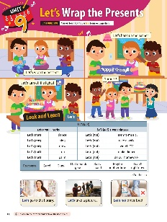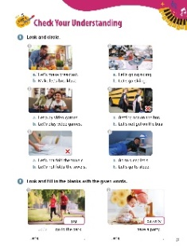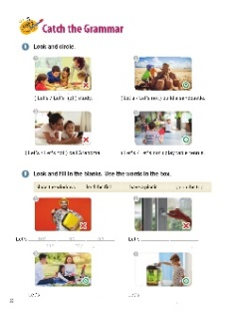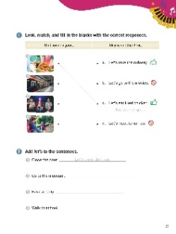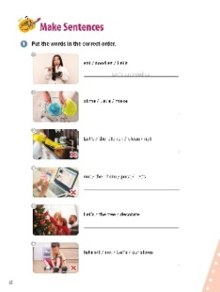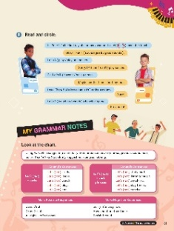

[WARM-UP]
- Have students look at the illustrations and sentences. Ask what they see in the picture.

[Look and Learn]
- Have students look at the chart on page 56. Go through the grammar points in the chart.
- Look at the example words and images.
- Read the words together.
- Tell students to go back to the cartoon and circle all the uses of let’s.

[Step 1 Check Your Understanding]
- Have students look at Exercise A ‘Look and circle’. Ask them to look at the pictures and read the words. Then, tell them to circle the letters of the correct sentences.
- Answers: 1. a 2. b 3. b 4. b 5. a 6. b
- Have students look at Exercise B ‘Look and fill in the blanks with the given words’. Tell students to look at the pictures. Then, have students read the words. Tell students to use the words to complete the sentences.
- Answers: 1. Let’s, jog 2. Let’s, eat cake

[Step 2 Catch the Grammar]
- Have students look at Exercise A ‘Look and circle’. Have students look at the pictures. Red Xs mean ‘false’ and green circles mean ‘true’. Have students circle the words that best match the pictures.
- Answers: 1. Let’s not 2. Let’s 3. Let’s not 4. Let’s
- Have students look at Exercise B ‘Look and fill in the blanks’. Read the words in the box. Have students look at the pictures and write the words that best complete the sentences.
- Answers: 1. not go on the trip 2. not close the windows 3. have a picnic 4. feed the fish
- Have students look at Exercise C ‘Look, match, and fill in the blanks with the correct responses’. Read the words in the box. Tell students to look at the pictures. Tell students to draw lines between the pictures and the sentences that describe them. Then, have students write the responses on the lines.
- Answers: 1. c; That sounds good. 2. a; That sounds good. 3. b; Maybe another time. 4. d; Maybe another time.
- Have students look at Exercise D ‘Add let’s to the sentences’. Have students read the sentences. Then, tell them to rewrite the sentences with the word ‘let’s’ at the beginning to make new sentences.
- Answers: 1. Let’s close the door. 2. Let’s go to the museum. 3. Let’s have a party. 4. Let’s walk to school.

[Step 3 Make Sentences]
- Have students look at Exercise A ‘Put the words in the correct order’. Tell students to unscramble the words to make complete sentences. Have students write the correct sentences on the lines.
- Answers: 1. Let’s eat noodles. 2. Let’s make slime. 3. Let’s not clean the kitchen. 4. Let’s not post the photo. 5. Let’s decorate the tree. 6. Let’s not take off our shoes.
- Have students look at Exercise B ‘Read and circle’. Read the conversation. Tell students to circle the correct words.
- Answers: 1. Let’s 2. sounds good 3. play 4. can’t 5. have 6. let’s go 7. watch

[My Grammar Notes]
- Have students look at the chart on page 61. Read the chart out loud. Break students into pairs. Ask students to make new conversations using the chart (Answers vary. Some suggestions follow.)
Let’s study English now. (Sorry, I am busy.)
Let’s not play video games. (Sounds good.)
Let’s play soccer. (How about another time?)

[Extra Unit Test]
- Have students turn to page 84 for Unit Test 9. Read the test items out loud. Have the students fill in the blanks.
- In the My Grammar Summary, read each line item. Tell students to write what they thought the grammar point for the unit was.
- Tell students to write what they think is the most important thing they learned from Unit 9. Have students write two examples of what they learned in Unit 9.

Unit 10. Please Stay in Your Seat

Unit Objective | You will be able to use imperative statements.

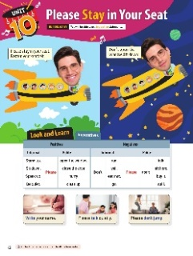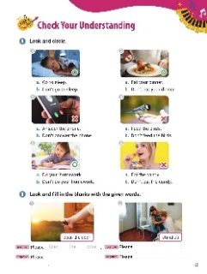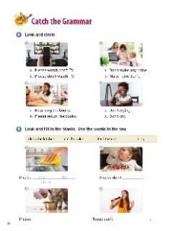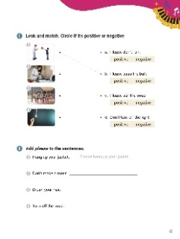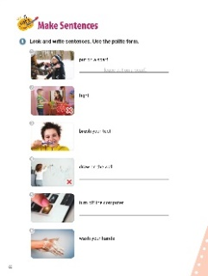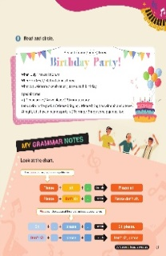

[WARM-UP]
- Have students look at the illustrations and sentences. Ask students what they see in the picture.

[Look and Learn]
- Have students look at the chart on page 62. Go through the grammar points in the chart.
- Look at the example words and images.
- Read the words together.
- Ask students go back to the cartoon and circle all the base verbs.

[Step 1 Check Your Understanding]
  - Have students look at Exercise A ‘Look and circle’. Have students look at the pictures. Red Xs mean ‘false’ and green circles mean ‘true’. Ask students to look at the pictures and circle the letters of the correct sentences.
  - Answers: 1. a 2. a 3. b 4. b 5. a 6. b
  - Have students look at Exercise B ‘Look and fill in the blanks with the given words’. Tell students look at the pictures. Have students complete the sentences using both the positive and negative forms.
  - Answers: 1. open the door, don’t open the door 2. stand up, don’t stand up

[Step 2 Catch the Grammar]
  - Have students look at Exercise A ‘Look and circle’. Tell students to look at the pictures and read the sentences. Have students circle the letters of the sentences that match the pictures.
  - Answers: 1. b 2. a 3. b 4. b
- Have students look at Exercise B ‘Look and fill in the blanks’. Read the words in the box. Have students look at the pictures. Tell students to write the correct phrases on the lines to complete the sentences.
- Answers: 1. clean the kitchen 2. eat the cake 3. feed the cat 4. sing
  - Have students look at Exercise C ‘Look and match’. Have students look at the pictures. Tell them to draw lines between the pictures and the sentences. Then, have the students circle whether the sentences are positive or negative.
  - Answers: 1. b; positive 2. c; positive 3. a; negative 4. d; negative

  - Have students look at Exercise D ‘Add please to the sentences’. Tell the students to read the sentences. Then, ask them to write new sentences on the lines using ‘please’ at the beginning.
  - Answers: 1. Please hang up your jacket. 2. Please don’t make a mess. 3. Please brush your hair. 4. Please turn off the music.

[Step 3 Make Sentences]
  - Have students look at Exercise A ‘Look and write sentences’. Ask students to look at the pictures and read the words next to them. Then, have students write polite sentences on the lines using ‘please’.
  - Answers: 1. Please put on a scarf. 2. Please don’t fight. 3. Please brush your teeth. 4. Please don’t draw on the wall. 5. Please turn off the computer. 6. Please wash your hands.
  - Have students look at Exercise B ‘Read and circle’. Tell students to read the party invitation. Then, have students complete the sentences by circling the correct words.
  - Answers: 1. come 2. Meet 3. Celebrate 4. Please arrive 5. Please bring 6. Bring

[My Grammar Notes]
- Have students look at the chart on page 67. Read the chart out loud. Then, say new sentences and have students make the sentences polite by adding 'please'. (Answers will vary. Suggestions follow.)
Sit at the table. (Please sit at the table.)
Do your homework. (Please do your homework.)
Clean your room. (Please clean your room.)

[Extra Unit Test]
- Have students turn to page 85 for Unit Test 10. Read the test items out loud. Have the students fill in the blanks.
- In the My Grammar Summary, read each line item. Tell students to write what they thought the grammar point for the unit was.
- Tell students to write what they think is the most important thing they learned from Unit 10. Have students write two examples of what they learned in Unit 10.

