Unit 1. This Is the Park

Unit Objective | You will be able to use articles and nouns.

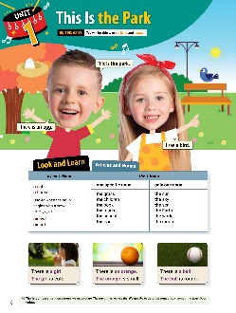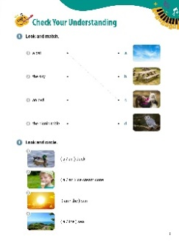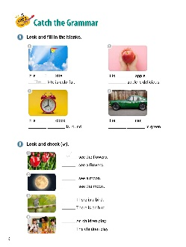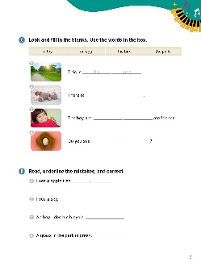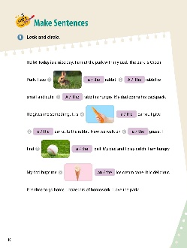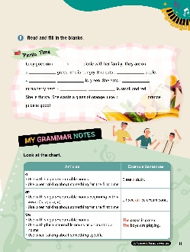

[WARM-UP]
- Have students look at the illustrations and words. Ask them what they see.

[Look and Learn]
- Have students look at the chart on page 6. Go through the grammar points in the chart.
- Look at the example words and images.
- Read the words together.
- Remind students that the first time we mention a noun, we use ‘a’ or ‘an’. The next time, we use ‘the’. We use ‘the’ to describe someone or something specific or unique.
- Ask students to go back to the cartoon and circle all the nouns and articles.

[Step 1 Check Your Understanding]
- Have students look at Exercise A ‘Look and match’. Tell students to draw a line between the words and pictures.
- Answers: 1. c 2. a 3. d 4. b
- Have students look at Exercise B ‘Look and circle’. Ask students to circle the correct articles after looking at the pictures.
- Answers: 1. a 2. an 3. the 4. the

[Step 2 Catch the Grammar]
- Have students look at Exercise A ‘Look and fill in the blanks’. Students should read the sentences. Then, tell them to write the correct words in the blanks. Students will use articles and nouns.
- Answers: 1. a, The 2. an, The 3. a, The clock 4. a, The car
- Have students look at Exercise B ‘Look and check ( )’. Ask students to look at the pictures. Then, read the sentences. Students should choose the sentences that best match the pictures.
- Answers: 1. I see the flowers. 2. I see the moon. 3. There is a bird. 4. The children play.
- Have students look at Exercise C ‘Look and fill in the blanks.’ Read the words in the box. Tell students to use the words in the box to complete the sentences.
- Answers: 1. the park 2. a toy 3. the bird 4. an egg
- Have students look at Exercise D ‘Read, underline the mistakes, and correct.’. Tell students to read the sentences and underline what is wrong in each sentence. Tell students to write the correct words on the lines.
- Answers: 1. a; an 2. a; the 3. An; A 4. A; The

[Step 3 Make Sentences]
- Have students look at Exercise A ‘Look and circle’. Tell students to look at the pictures and write the correct articles on the lines next to them.
- Answers: 1. a 2. The 3. The 4. a 5. the 6. the 7. a 8. An
- Have students look at Exercise B ‘Read and fill in the blanks’. Tell students to read the sentences in the paragraph. The paragraph is about a picnic. Students should write the correct articles and nouns in the blanks.
- Answers: 1. a 2. the 3. an 4. The apple 5. a 6. The strawberry 7. The

[My Grammar Notes]
- Have students look at the chart on page 11. Read the chart out loud. Ask students to make their own sentences using the correct articles (a, an, or the). Answers will vary. (For example, ‘I see a dog.’ ‘She has an igloo.’ ‘The cats are sleeping.’)
[Extra Unit Test]
- Have students turn to page 76 for Unit Test 1. Read the test items out loud. Have the students fill in the blank.
- In the My Grammar Summary, read each line item. Tell students to write what they thought the grammar point for the unit was.
- Tell students to write what they think is the most important thing they learned from Unit 1. Tell the students to write two examples of what they learned in Unit 1.

Unit 2. An Apple and Some Bread

Unit Objective | You will be able to use countable nouns and uncountable nouns.

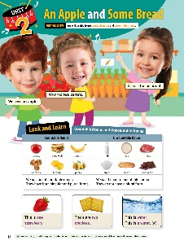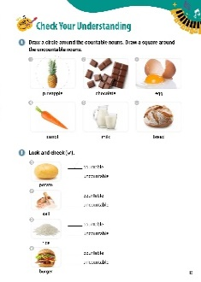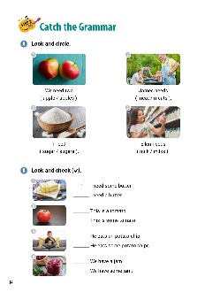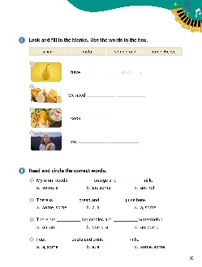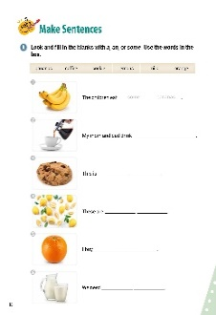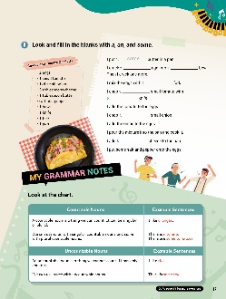
[WARM-UP]
- Have students look at the illustrations and words on page 12. Ask questions about what the students see (suggestion below):
What do the children need? (An apple. Carrots. Bread.)

[Look and Learn]
- Have students look at the chart on page 12. Go through the grammar points in the chart.
- Look at the example words and images.
- Read the words together.
- Remind students that we can use ‘a’ and ‘an’ with singular countable nouns. We can use some with plural countable nouns and uncountable nouns. Have students circle the nouns in the illustration.

[Step 1 Check Your Understanding]
- Have students look at Exercise A ‘Draw a circle around the countable nouns. Draw a square around the uncountable nouns’. Ask students to name two countable nouns (they can use the chart on page 12). As the students to name two noncountable nouns. Then have students put a circle around the countable nouns. Tell students to put a square around the noncountable nouns.
- Answers: 1. circle 2. square 3. circle 4. circle 5. square 6. square
- Have students look at Exercise B ‘Look and check ( )’. Tell students to look at the pictures. Students should put checkmarks next to the correct answer. Students can look at the chart on page 12 if they need help.
- Answers: 1. countable 2. uncountable 3. uncountable 4. countable
- Call on students to give the correct answers. Have the class say the correct answers together.

[Step 2 Catch the Grammar]
- Have students turn to page 14 for Exercise A ‘Look and circle’. Tell students to look at the pictures. Students should read the sentences to themselves. Ask students to circle the correct words that best match the pictures.
- Answers: 1. apples 2. meat 3. sugar 4. milk
- Have students look at Exercise B ‘Look and check ( )’. Read each of the sentences loud. Tell students to look at the pictures and put check marks by the sentences that match the pictures.
- Answers: 1. I need some butter. 2. This is a tomato. 3. He eats some potato chips. 4. We have some jam.
- Have students look at Exercise C ‘Look and fill in the blanks. Read the words in the box. Students should use the words in the box to complete the sentences. Answers: 1. a pear 2. some cheese 3. pasta 4. some bread
- Have students look at Exercise D ‘Read and circle the correct words’. Have students read the sentences. Tell them to circle the letters with the best answer. Answers: 1. b 2. a 3. b 4. c

[Step 3 Make Sentences]
- Have students turn to page 16 for Exercise A ‘Look and fill in the blanks with a, an, or some’. Read the words in the box. Tell students they will use these words and a, an, and some to complete the sentences.
Answers: 1. some bananas 2. some coffee 3. a cookie 4. some lemons 5. an orange 6. some milk
- Have students look at page 17 for Exercise B ‘Look and fill in the blanks with a, an, and some’. Tell the students to read the recipe. They should complete the sentences with the correct words.
- Answers: 1. some 2. an 3. a 4. a 5. a 6. a 7. a 8. some

[My Grammar Notes]
- Have students look at the chart on page 17. Read the chart out loud. Tell students to make new sentences with noncountable and countable nouns using the chart. (Answers vary: I like cookies. There is some fruit. There is a peach.)

[Extra Unit Test]
- Have students turn to page 77 for Unit Test 2. Read the test items out loud. Have the students fill in the blanks.
- In the My Grammar Summary, read each line item. Tell students to write what they thought the grammar point for the unit was.
- Tell students to write what they think is the most important thing they learned from Unit 2. Have students write two examples of what they learned in Unit 2.

Unit 3. I Read a Book

Unit Objective | You will be able to use the present simple tense.

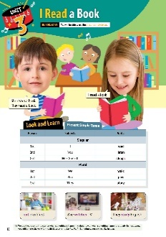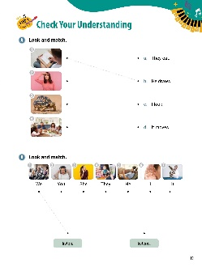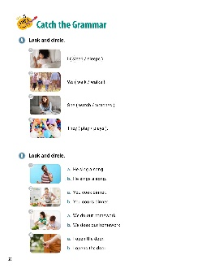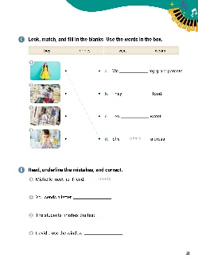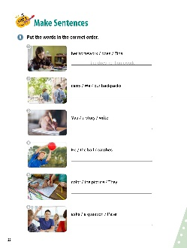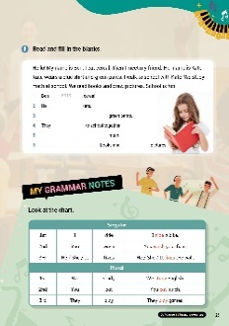

[WARM-UP]
- Have students look at the illustrations and words at the top of page 18.
- Ask students what they see. Have students read the sentences out loud.

[Look and Learn]
- Have students look at the chart on page 18. Go through the grammar points in the chart.
- Look at the example words and images.
- Read the words together.
- Remind students that we use the present simple tense when something is happening right now or when something happens regularly. In most cases, you add an -s to the verb for the third person singular he, she, it. Sometimes, you add -es, like in goes.

[Step 1 Check Your Understanding]
- Have students look at Exercise A ‘Look and match’. Tell students to draw lines between the pictures and the correct sentences.
- Answers: 1. b 2. c 3. d 4. a
- Have students look at Exercise B ‘Look and match’. Tell students to draw lines from the pronouns to the correct verbs to make sentences.
- Answers: 1. We listen. 2. You listen. 3. She listens. 4. They listen. 5. He listens. 6. I listen. 7. It listens.
[Step 2 Catch the Grammar]
- Have students look at Exercise A ‘Look and circle’. Tell students to look at the pictures. Then, they should circle the words that best match the pictures.
- Answers: 1. sleep 2. walk 3. watches 4. play
- Have students look at Exercise B ‘Look and circle’. Tell students to circle the letters of the sentences that best match the pictures.
- Answers: 1. b 2. a 3. a 4. a
- Have students look at Exercise C ‘Look, match, and fill in the blanks’. Read the words in the box. Tell students complete the sentences using the words in the box. Then, ask students to draw lines to match the sentences with the pictures.
- Answers: 1. d; wears 2. b; buy 3. a; visit 4. c; drinks
- Have students look at Exercise D ‘Read, underline the mistakes, and correct.’. Tell students to read the sentences and underline the errors in them. Then, tell students to write the correct words on the lines.
- Answers: 1. meet meets 2. sends send 3. finishes finish 4. close closes

[Step 3 Make Sentences]
- Have students look at Exercise A ‘Put the words in the correct order’. Tell students they need to unscramble the words to make a sentence. Go over number 1 together.
- Answers: 1. Tina does her homework. 2. We carry our backpacks. 3. You write a story. 4. He catches the ball. 5. They color the picture. 6. Peter asks a question.
- Have students look at Exercise B ‘Read and fill in the blanks’. Have students read the sentences about Ben’s day. Then, tell them to fill in the blanks using the words from Ben’s story.
- Answers: 1. eats 2. meets 3. Kate wears 4. walk 5. They study 6. They read, draw

[My Grammar Notes]
- Have students look at the chart on page 23. Read the chart together. Have students make new sentences and questions using the information from the chart. (Answers vary: He washes his car. She plays chess. We ride trains.)

[Extra Unit Test]
- Have students turn to page 78 for Unit Test 3. Read the test items out loud. Have the students fill in the blanks.
- In the My Grammar Summary, read each line item. Tell students to write what they thought the grammar point for the unit was.
- Tell students to write what they think is the most important thing they learned from Unit 3. Have students write two examples of what they learned in Unit 3.

Unit 4. I Don’t Like Tennis

Unit Objective | You will be able to use the present simple tense in negatives and questions.

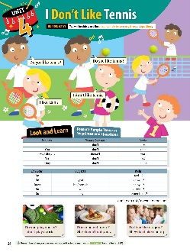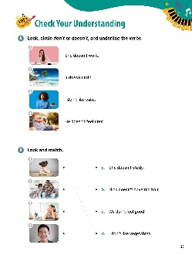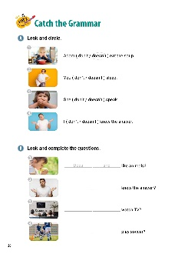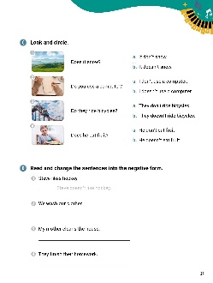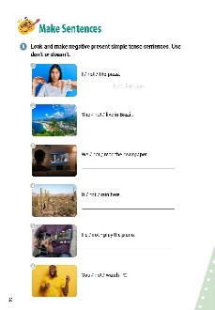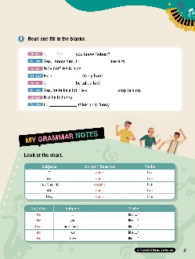

[WARM-UP]
- Have students look at the illustrations and words on page 24.

[Look and Learn]
- Have students look at the chart. Go through the grammar points in the chart.
- Look at the example words and images.
- Read the words and sentences together.
- Remind students that when you use does, do not add -s to the main verb. (Example: Does he feels ...? (X) )

[Step 1 Check Your Understanding]
- Have students look at Exercise A ‘Look, circle don’t or doesn’t, and underline the verbs ’. Ask students to circle ‘don’t’ and ‘doesn’t’ in the sentences. Then, have them underline the verbs.
- Answers: 1. doesn’t; work 2. doesn’t; rain 3. don’t; like 4. doesn’t; feel
- Have students look at Exercise B ‘Look and match’. Tell students to look at the pictures. Then, students should draw lines between the pictures and the correct sentences about the pictures.
- Answers: 1. d 2. c 3. a 4. b

[Step 2 Catch the Grammar]
- Have students look at Exercise A ‘Look and circle’. Tell students to circle the correct words to complete the sentences.
- Answers: 1. doesn’t 2. don’t 3. doesn’t 4. don’t
- Have students look at Exercise B ‘Look and complete the questions’. Tell students to fill in the blanks using the words that best match the pictures.
- Answers: 1. Does she 2. Does he 3. Do they 4. Do they
- Have students look at Exercise C ‘Look and circle’. Tell students to look at the pictures. Then, draw lines between the pictures and the correct sentences.
- Answers: 1. b 2. a 3. a 4. B
- Have students look at Exercise D ‘Read and change the sentences into the negative form ’. Ask students to read the sentences. Then, have students re-write the sentences using the negative forms of either don’t or doesn’t.
- Answers: 1. Steve doesn’t like hockey. 2. We don’t wash our clothes. 3. My mother doesn’t clean the house. 4. They don’t finish their homework.

[Step 3 Make Sentences]
- Have students look at Exercise A ‘Look and make negative present simple tense sentences. Use don’t or doesn’t ’. Tell students to look at the pictures. Have them re-write the sentences on the lines using either don’t or doesn’t.
- Answers: 1. I don’t like pizza. 2. She doesn’t live in Brazil. 3. We don’t read the newspaper. 4. It doesn’t rain here. 5. He doesn’t play the piano. 6. You don’t watch TV.
- Have students look at Exercise B ‘Read and fill in the blanks’. Tell students to read the sentences in the conversation between Melissa and James. Then, they should complete the sentences using don’t or doesn’t.
- Answers: 1. Do 2. don’t 3. doesn’t 4. Does 5. doesn’t 6. don’t

[My Grammar Notes]
- Have students look at the chart on page 29. Read the chart together. Ask students to make new sentences using the chart. (Answers vary: Does she like cookies? I don’t like tea. He doesn’t like cheese. Do they like the train? We don’t like loud noise.)

[Extra Unit Test]
- Have students turn to page 79 for Unit Test 4. Read the test items out loud. Have the students fill in the blanks.
- In the My Grammar Summary, read each line item. Tell students to write what they thought the grammar point for the unit was.
- Tell students to write what they think is the most important thing they learned from Unit 4. Have students write two examples of what they learned in Unit 4.

Unit 5. There Is a TV

Unit Objective | You will be able to use there with the verb be.

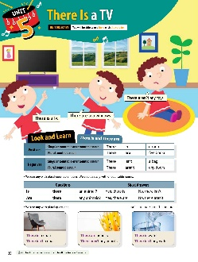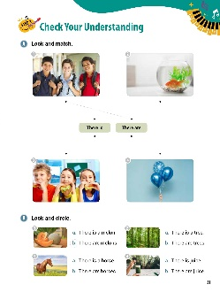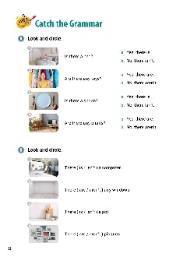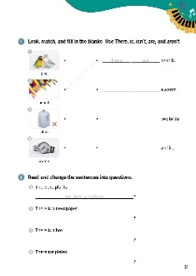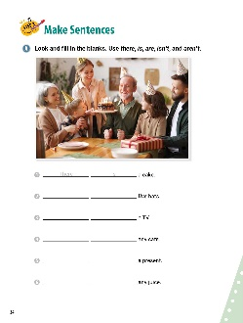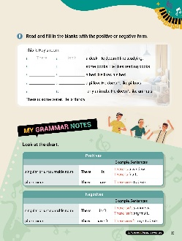

[WARM-UP]
- Have students look at the illustrations and words. Ask them to read the questions and answers out loud.

[Look and Learn]
- Have students look at the chart on page 30. Go through the grammar points in the chart.
- Look at the example words and images.
- Read the words together.
- Tell students that we use any with plural countable nouns. We also use any with uncountable nouns. We also use any with plural questions.
- Have the students go back to the cartoon and circle all the ‘there + be’ verbs.

[Step 1 Check Your Understanding]
- Have students look at Exercise A ‘Look and match’. Ask students draw lines between the pictures and the words describing the pictures.
- Answers: 1. There are 2. There is 3. There are 4. There are
- Have students look at Exercise B ‘Look and circle’. Tell students to look at the pictures. Then, students should circle the letters of the sentences that describe the pictures.
- Answers: 1. b 2. b 3. a 4. a
[Step 2 Catch the Grammar]
- Have students look at Exercise A ‘Look and circle’. Have students look at the pictures. Tell students to read the questions and put circles around the letters that answer the questions.
- Answers: 1. a 2. b 3. b 4. a
- Have students look at Exercise B ‘Look and circle’. Tell students to look at the pictures. Then, have students draw circles around the words that best complete the sentence.
- Answers: 1. is 2. aren’t 3. isn’t 4. are
- Have students look at Exercise C ‘Look, match, and fill in the blanks’. Tell students to draw lines between the pictures and the phrases that describe them. Then, have students complete the sentences using There, is, isn’t, are, and aren’t.
- Answers: 1. There are two birds. 2. There are pencils. 3. There isn’t a shirt. 4. There is a watch.
- Have students look at Exercise D ‘Read and change the sentences into questions’. Tell students to read the sentences. Then, they should change each statement into a question. Remind students they will have to rearrange the words for the questions.
- Answers: 1. Are there any plants? 2. Is there a newspaper? 3. Is there a box? 4. Are there any plates?

[Step 3 Make Sentences]
- Have students look at Exercise A ‘Look and fill in the blanks’. Tell students to look at the picture and think about what is happening. Then, they need to complete the sentences using there, is, are, isn’t, and aren’t.
- Answers: 1. There is 2. There are 3. There isn’t 4. There aren’t 5. There is 6. There isn’t
- Have students look at Exercise B ‘Read and fill in the blanks with the positive or negative form’. Ask students to write the correct words in the blanks in the paragraph about Ray’s room.
- Answers: 1. There 2. isn’t 3. There 4. are 5. There 6. is 7. There 8. isn’t 9. There 10. aren’t

[My Grammar Notes]
- Have students look at the chart on page 35. Read the chart together. Tell the students that you will tell them a sentence. They need to tell you the opposite of the sentence (positive or negative). Suggestions:
There is a window. (There isn’t a window.)
There aren’t any birds. (There are birds.)
There is a door. (There isn’t a door.)
[Extra Unit Test]
- Have students turn to page 80 for Unit Test 5. Read the test items out loud. Have the students fill in the blanks.
- In the My Grammar Summary, read each line item. Tell students to write what they thought the grammar point for the unit was.
- Tell students to write what they think is the most important thing they learned from Unit 5. Have students write two examples of what they learned in Unit 5.

Unit 6. I Can Swim!

Unit Objective | You will be able to use can and can’t.

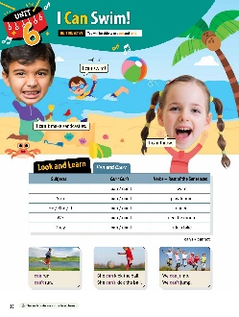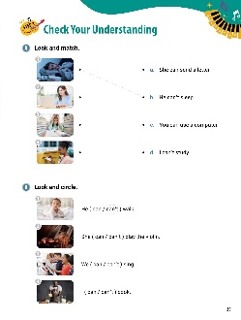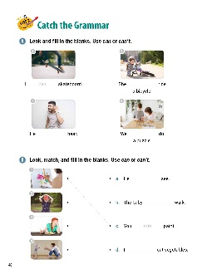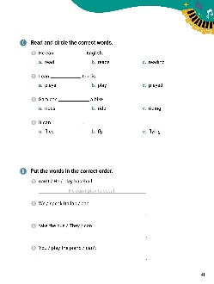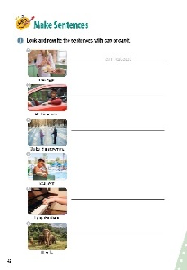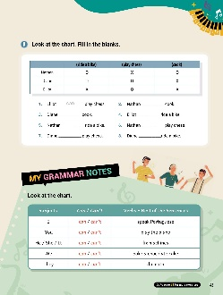

[WARM-UP]
- Have students look at the illustrations and words.
- Ask students what they see.

[Look and Learn]
- Have students look at the chart on page 38. Go through the grammar points in the chart.
- Look at the example words and images.
- Read the words together.
- Remind students that when used with 'can’, the verb is always in the basic form.

[Step 1 Check Your Understanding]
- Have students look at Exercise A ‘Look and match’. Ask students to look at the pictures. Students need to the pictures and the correct sentences.
- Answers: 1. b 2. c 3. d 4. a
- Have students look at Exercise B ‘Look and circle.’. Tell students to look at the pictures and complete the sentences by circling the correct word.
- Answers: 1. can’t 2. can 3. can 4. can’t

[Step 2 Catch the Grammar]
- Have students look at Exercise A ‘Read and circle the correct words’. Tell students to read the sentences. Then, they need to write ‘can’ or ‘can’t’ on the lines to complete the sentences.
- Answers: 1. can 2. can’t 3. can’t 4. can
- Have students look at Exercise B ‘Look, match, and fill in the blanks’. Tell students to look at the pictures. Then, ask students to draw lines between the pictures and the correct sentences. Students should write ‘can’ or ‘can’t’ on the lines to complete the sentences. Answers: 1. c; can 2. a; can’t 3. d; can’t 4. b; can
- Have students look at Exercise C ‘Read and circle the correct words’. Tell students to read the sentences. Then, have them circle the letter of the correct answers.
- Answers: 1. a 2. b 3. b 4. b
- Have students look at Exercise D ‘Put the words in the correct order’. Tell students unscramble the words to make sentences. Students should write the new sentences on the lines.
- Answers: 1. He can’t play baseball. 2. We can speak Italian. 3. They can take the bus. 4. You can’t play the piano.
[Step 3 Make Sentences]
- Have students look at Exercise A ‘Look and rewrite the sentences with can or can’t’. Tell the students to look at the pictures and read the sentences. Then, have students rewrite the sentences with ‘can’ or ‘can’t’ based on the pictures.
- Answers: 1. I can’t eat eggs. 2. He can drive a car. 3. We can build a snowman. 4. You can’t swim. 5. I can play the piano. 6. They can’t fly.
- Have students look at Exercise B ‘Look at the chart’. Read the chart about the children and what they can do. Tell students to write either ‘can’ or ‘can’t’ on the lines, using the chart.
- Answers: 1. can 2. can 3. can’t 4. can’t 5. can 6. can’t 7. can 8. can

[My Grammar Notes]

- Have students look at the chart on page 43. Read the chart out loud. Ask students to talk about themselves using the chart. For example, ‘I can ride a bike.’ ‘I can’t play soccer.’ ‘I can cook.’ ‘I can’t write a story.’

[Extra Unit Test]
- Have students turn to page 81 for Unit Test 6. Read the test items out loud. Have the students fill in the blanks.
- In the My Grammar Summary, read each line item. Tell students to write what they thought the grammar point for the unit was.
- Tell students to write what they think is the most important thing they learned from Unit 6. Have students write two examples of what they learned in Unit 6.

Unit 7. Can You Play Sports?

Unit Objective | You will be able to ask can questions.

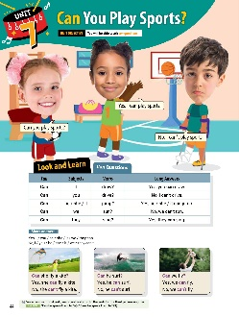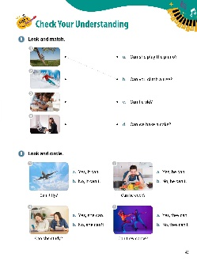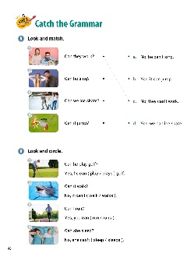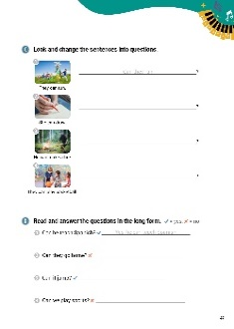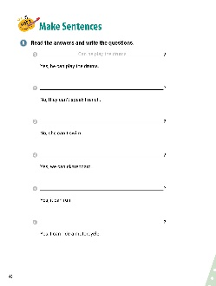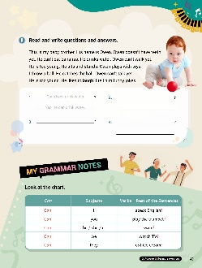

[WARM-UP]
- Have students look at the illustrations and words. Ask them what they see.

[Look and Learn]
- Have students look at the chart on page 44. Go through the grammar points in the chart.
- Look at the example words and images.
- Read the words together.
- Remind students that since ‘can’ is a modal verb, we do not add an -s to the verb for the third person singular. Example: ‘Can he speak French?’ (O) ‘Cans he speak French?’ (X).

[Step 1 Check Your Understanding]
- Have students look at Exercise A ‘Look and match’. Tell students to look at the pictures. Then, have students draw lines between the pictures and the sentences that match them.
- Answers: 1. b 2. c 3. d 4. a
- Have students look at Exercise B ‘Look and circle.’ Have students look at the pictures and read the sentences. Tell students circle the letters of the correct answers.
- Answers: 1. a 2. b 3. b 4. a

[Step 2 Catch the Grammar]
- Have students look at Exercise A ‘Look and match’. Tell students to look at the pictures. Then, have students draw lines between the pictures and the sentences that match them
- Answers: 1. c 2. a 3. d 4. b
- Have students look at Exercise B ‘Look and circle’. Tell students to look at the pictures and read the questions. Then, students should circle the letters of the correct answers to the questions.
- Answers: 1. play 2. walk 3. run 4. sleep
- Have students look at Exercise C ‘Look and change the sentences into questions’. Tell students to look at the pictures and read the sentences under them. Then, students should re-write the sentences as questions on the lines.
- Answers: 1. Can they run? 2. Can she draw? 3. Can he make a fire? 4. Can they play basketball?
- Have students look at Exercise D ‘Read and answer the questions in the long form’. Tell students to read each question. The green check marks show the answers are ‘yes’ and the red x’s show the answers are ‘no’. Have students answer the questions using ‘yes’ or ‘no’ and the rest of the statement.
- Answers: 1. Yes, he can teach Spanish. 2. No, they can’t go home. 3. Yes, it can jump. 4. No, we can’t play sports.

[Step 3 Make Sentences]
- Have students look at Exercise A ‘Read the answers and write the questions’. Tell students to read the answers. Then, students should write the best questions that match the answers on the lines. Students should use ‘can’ in the questions.
- Answers: 1. Can he play the drums? 2. Can they speak French? 3. Can she swim? 4. Can we skateboard? 5. Can it run? 6. Can you ride a motorcycle?
- Have students look at Exercise B ‘Read and write questions and answers’. Tell students to read the paragraph about Owen. Have students write four questions using ‘can’ on the lines with their answers.
- Answers: (Answers will vary. The following are examples of what students could write.) 1. Can Owen drink water? Yes, he can drink water. 2. Can Owen walk? No, he can’t walk. 3. Can Owen stand? Yes, he can stand. 4. Can Owen catch a ball? Yes, he can catch a ball. Can Owen talk? No, he can’t talk.

[My Grammar Notes]
- Have students look at the chart on page 49. Read the chart out loud. Ask students to make questions about themselves based on the chart. (Answers vary: Can I speak now? Can Min cook? Can we watch TV?)

[Extra Unit Test]
- Have students turn to page 82 for Unit Test 7. Read the test items out loud. Have the students fill in the blanks.
- In the My Grammar Summary, read each line item. Tell students to write what they thought the grammar point for the unit was.
- Tell students to write what they think is the most important thing they learned from Unit 7. Have students write two examples of what they learned in Unit 7.

Unit 8. I Am in the Room

Unit Objective | You will be able to use in, on, and under with places.

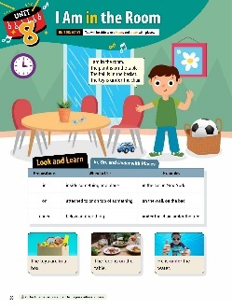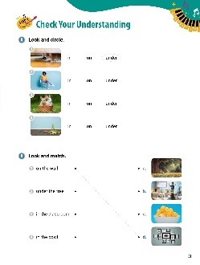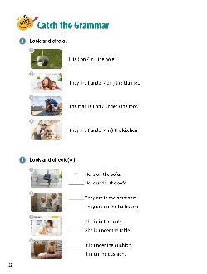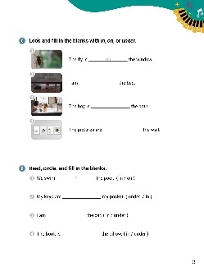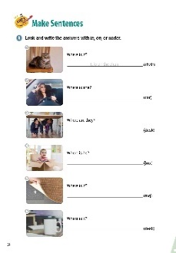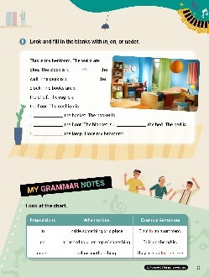

[WARM-UP]
- Have students look at the illustrations and words.

[Look and Learn]
- Have students look at the chart on page 50. Go through the grammar points in the chart.
- Look at the example words and images.
- Read the words together.
- Ask students to go back to the cartoon and circle the prepositions of place.

[Step 1 Check Your Understanding]
- Have students look at Exercise A ‘Look and circle’. Ask students to look at the pictures and circle the correct prepositions.
- Answers: 1. under 2. on 3. in 4. on
- Have students look at Exercise B ‘Look and match’. Have students read the phrases and look at the pictures. Then, tell students to draw lines to match the phrases with the correct pictures.
- Answers: 1. d 2. a 3. b 4. c

[Step 2 Catch the Grammar]
- Have students look at Exercise A ‘Look and circle’. Tell students to read the sentences. Then, students should circle the prepositions that best complete the sentences.
- Answers: 1. in 2. under 3. on 4. in
- Have students look at Exercise B ‘Look and check()’. Have students look at the pictures. Then, students should read the sentences. Have students put check marks by the correct sentences.
- Answers: 1. He is on the sofa. 2. They are in the bathroom. 3. She is under the table. 4. It is on the cushion.
- Have students look at Exercise C ‘Look and fill in the blanks with in, on, or under ’. Have students look at the pictures. Tell them to write the correct prepositions on the lines.
- Answers: 1. on 2. under 3. in 4. on
- Have students look at Exercise D ‘Read, circle, and fill in the blanks’. Have students read the sentences. Then, students should circle the prepositions that best complete the sentences. Tell students to write the correct prepositions in the blanks.
- Answers: 1. in 2. in 3. in 4. under

[Step 3 Make Sentences]
- Have students look at Exercise A ‘Look and write the answers with in, on, or under'. Have students look at the pictures and read the questions. Using the words at the end of the sentences, students should write the answers on the lines.
- Answers: 1. It is on the chair. 2. She is in the car. 3. They are under the desk. 4. He is in the box. 5. It is under the rug. 6. It is on the desk.
- Have students look at Exercise B ‘Look and fill in the blanks with in, on, or under’. Tell students to read the paragraph about the bedroom. Have students complete the sentences using the prepositions in, on, or under.
- Answers: 1. on 2. under 3. on 4. on 5. in 6. on 7. on 8. under

[My Grammar Notes]
- Have students look at the chart on page 55. Read the chart out loud. Tell students they will use the chart for the activity. In this activity, students will look around the classroom. Point to an object in the classroom. Students need to make a sentence about the object you point to using a preposition from the chart. (Suggestions: Point to a book on a desk: ‘The book is on the desk.’ Point to a file on the shelf. ‘The file is on the shelf’. Point to a rug. ‘The rug is under the table’.)

[Extra Unit Test]
- Have students turn to page 83 for Unit Test 8. Read the test items out loud. Have the students fill in the blanks.
- In the My Grammar Summary, read each line item. Tell students to write what they thought the grammar point for the unit was.
- Tell students to write what they think is the most important thing they learned from Unit 8. Have students write two examples of what they learned in Unit 8.

Unit 9. I My Birthday Is In June

Unit Objective | You will be able to use in, on, and at with time.

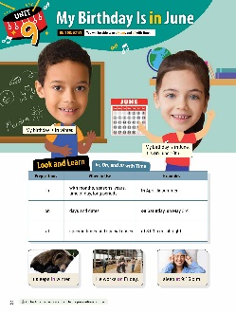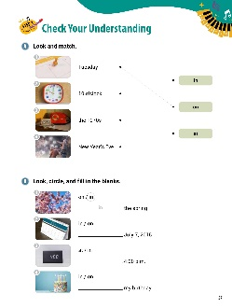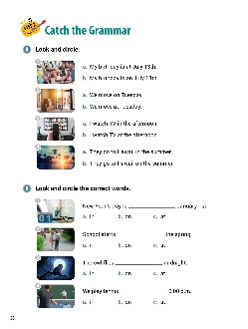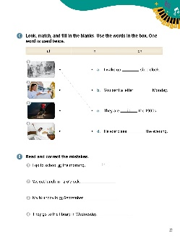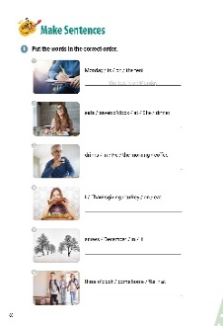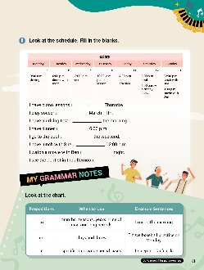

[WARM-UP]
- Have students look at the illustrations and words. Ask what they see in the picture.

[Look and Learn]
- Have students look at the chart on page 56. Go through the grammar points in the chart.
- Look at the example words and images.
- Read the words together.
- Tell students to go back to the cartoon and circle the prepositions of time.

[Step 1 Check Your Understanding]
- Have students look at Exercise A ‘Look and match’. Ask them to look at the pictures and read the words. Then, tell them to draw lines from the pictures to match the correct prepositions.
- Answers: 1. on 2. at 3. in 4. on
- Have students look at Exercise B ‘Look, circle, and fill in the blanks’. Tell students to look at the pictures. Then, have students read the words. Have students circle the correct prepositions and write them in the blanks.
- Answers: 1. in 2. on 3. at 4. on

[Step 2 Catch the Grammar]
- Have students look at Exercise A ‘Look and circle’. Have students look at the pictures. Then, they should circle the letters of the sentences that best describe the pictures.
- Answers: 1. b 2. a 3. a 4. a
- Have students look at Exercise B ‘Look and circle the correct words’. Have students look at the pictures and read the sentences. Then, tell them to circle the letters of the prepositions that best complete the sentences.
- Answers: 1. b 2. a 3. c 4. c
Have students look at Exercise C ‘Look, match, and fill in the blanks’. Read the words in the box. Tell students to look at the pictures. Tell students to draw lines between the pictures and the sentences that describe them. Then, have students write the prepositions on the lines to complete the sentences. One word from the box is used twice.
- Answers: 1. c; in 2. b; on 3. d; in 4. a; at
- Have students look at Exercise D ‘Read and correct the mistakes’. Have students read the sentences. Then, tell them to write the correct prepositions on the lines.
- Answers: 1. in 2. at 3. in 4. on

[Step 3 Make Sentences]
- Have students look at Exercise A ‘Put the words in the correct order’. Tell students to unscramble the words to make complete sentences. Have students write the correct sentences on the lines.
- Answers: 1. The test is on Monday. 2. She eats dinner at seven o'clock. 3. He drinks coffee in the morning. 4. I eat turkey on Thanksgiving. 5. It snows in December. 6. We come home at three o’clock.
- Have students look at Exercise B ‘Look at the schedule’. Read the schedule. Tell students to write the correct prepositions in the blanks.
- Answers: 1. on 2. on 3. in 4. at 5. on 6. at 7. at

[My Grammar Notes]
- Have students look at the chart on page 61. Read the chart out loud. Ask students to make new sentences using the chart (Answers vary. Some suggestions follow.)
I practice in the morning.
We have class on Monday.
They go to sleep at nine o’clock on Fridays.

[Extra Unit Test]
- Have students turn to page 84 for Unit Test 9. Read the test items out loud. Have the students fill in the blanks.
- In the My Grammar Summary, read each line item. Tell students to write what they thought the grammar point for the unit was.
- Tell students to write what they think is the most important thing they learned from Unit 9. Have students write two examples of what they learned in Unit 9.

Unit 10. When Is the Test?

Unit Objective | You will be able to ask information questions with where and when.

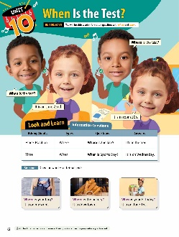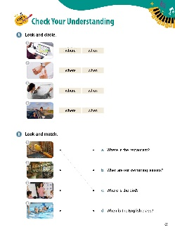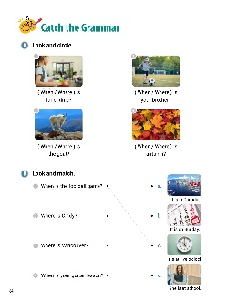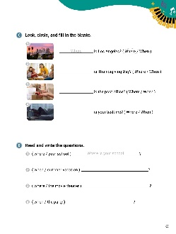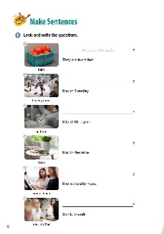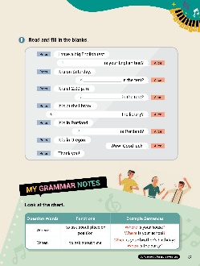

[WARM-UP]
- Have students look at the illustrations and words. Ask students what they see in the picture.

[Look and Learn]
- Have students look at the chart on page 62. Go through the grammar points in the chart.
- Look at the example words and images.
- Read the words together.
- Ask students go back to the cartoon and answer the questions the children in the picture ask. Students should use prepositions.

[Step 1 Check Your Understanding]
  - Have students look at Exercise A ‘Look and circle’. Ask students to look at the pictures and circle the correct words.
  - Answers: 1. where 2. when 3. when 4. where
  - Have students look at Exercise B ‘Look and match’. Tell students look at the pictures. Have students draw lines between the pictures and the questions that match them.
  - Answers: 1. c 2. a 3. d 4. b

[Step 2 Catch the Grammar]
  - Have students look at Exercise A ‘Look and circle’. Tell students to look at the pictures and read the questions. Have students circle the question words that best fit the questions.
  - Answers: 1. When 2. Where 3. Where 4. When
  - Have students look at Exercise B ‘Look and match’. Have students read the questions. Then, have the students look at the pictures and read the sentences. Tell students to draw lines from the questions to the correct answers.
  - Answers: 1. c 2. d 3. a 4. b
  - Have students look at Exercise C ‘Look, circle, and fill in the blanks’. Have students look at the pictures. Ask them to circle the correct words to complete the questions. Then, ask students to fill in the blanks with the words.
  - Answers: 1. Where 2. When 3. Where 4. When
  - Have students look at Exercise D ‘Read and write the questions’. Tell the students to look at the words in the parentheses. Then, ask them to write questions using the words.
  - Answers: 1. Where is your school? 2. When is summer vacation? 3. Where is the movie theater? 4. When is the party?

[Step 3 Make Sentences]
  - Have students look at Exercise A ‘Look and write the questions’. Ask students to look at the pictures and read the words under them. Then, have students read the answers. Tell students to write the questions that match the answers on the lines.
  - Answers: 1. Where are the balls? 2. When is the hockey game? 3. When is bedtime? 4. Where is the book? 5. When is the piano lesson? 6. Where is your mother?
  - Have students look at Exercise B ‘Read and fill in the blanks ’. Tell students to read the conversation between Peter and Alice. Then, have students complete the conversation using the question words from the chapter.
  - Answers: 1. When 2. When 3. Where 4. Where is 5. Where

[My Grammar Notes]
- Have students look at the chart on page 67. Read the chart out loud. Use the chart to make up new, short conversations. (Answers vary. Suggestions appear below.)
Where is your house? My house is in the city.
When is your sister’s party? My sister’s party is at four o’clock.
Where is the library? The library is near the school.
[Extra Unit Test]
  - Have students turn to page 85 for Unit Test 10. Read the test items out loud. Have the students fill in the blanks.
  - In the My Grammar Summary, read each line item. Tell students to write what they thought the grammar point for the unit was.
  - Tell students to write what they think is the most important thing they learned from Unit 10. Have students write two examples of what they learned in Unit 10.

