Unit 1. A Boy

Unit Objective | You will be able to use nouns and articles.

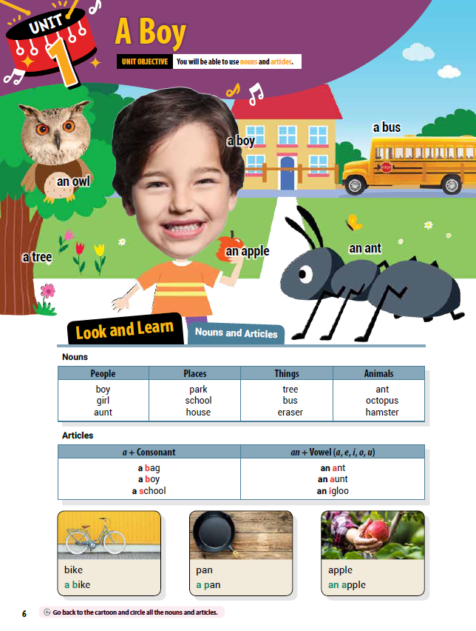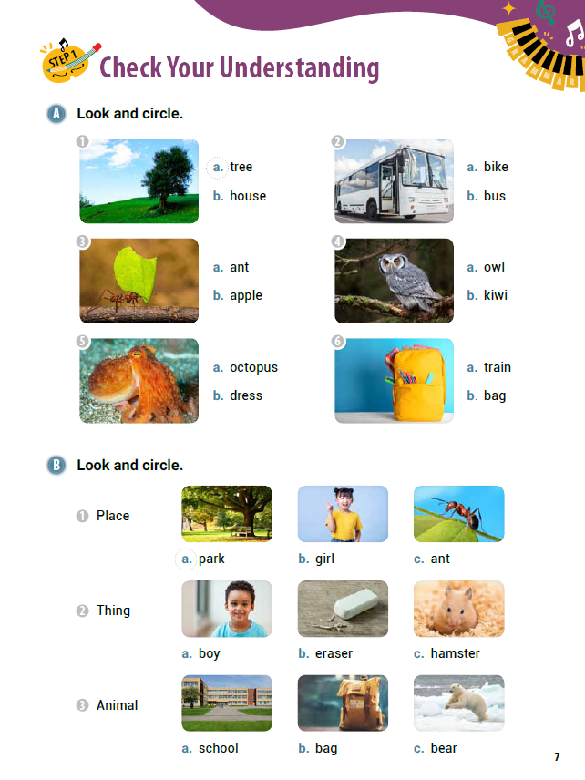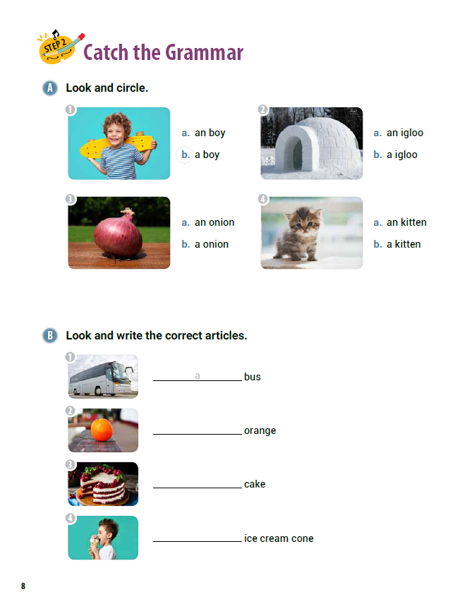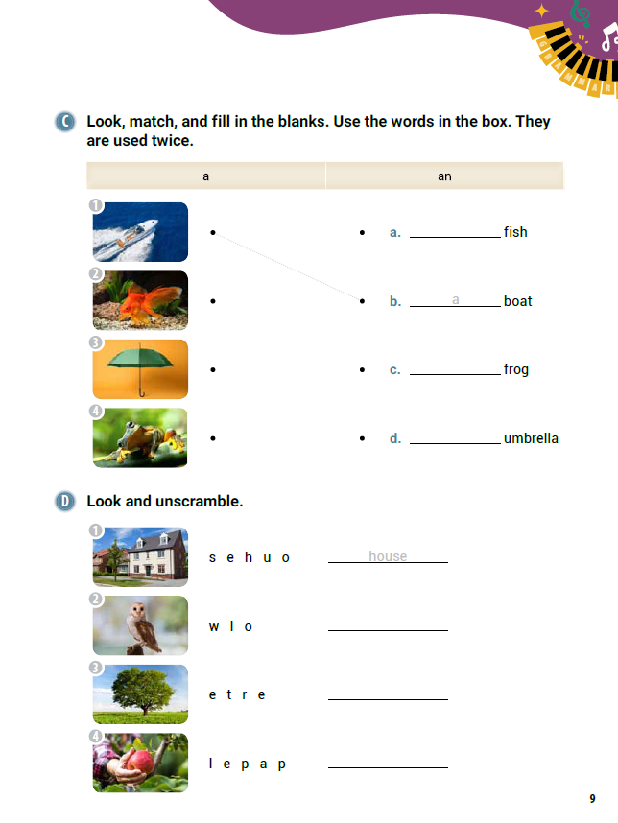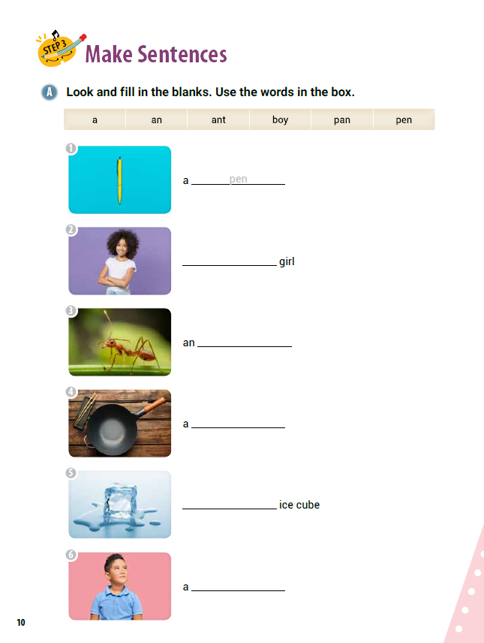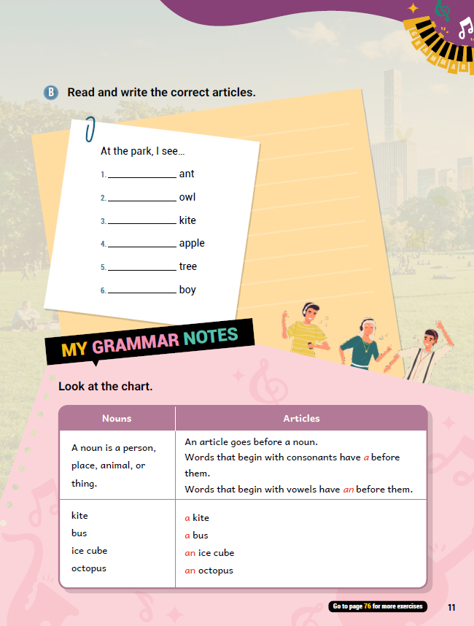

[WARM-UP]
- Greet your students.
- Have students look at the illustrations and words.

[Look and Learn]
- Have students look at the chart on page 6. Go through the grammar points in the chart.
- Look at the example words and images.
- Read the words together.
- Ask students to go back to the cartoon and circle all the nouns and articles.

[Step 1 Check Your Understanding]
- Have students look at Exercise A ‘Look and circle’. Tell students to choose the correct words to go with the pictures.
- Answers: 1. a 2. b 3. a 4. a 5. a 6. b
- Have students look at Exercise B ‘Look and circle’. Ask students choose the correct picture after reading the words on the left (Place, Thing, Animal).
- Answers: 1. a 2. b 3. c
- Check the answers together after students finished.

[Step 2 Catch the Grammar]
- Have students look at Exercise A ‘Look and circle’. Have students choose the answer that shows the correct article and noun.
- Answers: 1.b 2. a 3. a 4. b
- Have students look at Exercise B ‘Look and write the correct articles’. Ask students choose the correct article after saying the names of the pictures on the left.
- Answers: 1. a 2. an 3. a 4. an
- Have students look at Exercise C ‘Look, match, and fill in the blanks.’ Have students say the names of the pictures out loud together. Tell the students to use the words in the box (a and an). Each article is used twice.
- Answers: 1. b; a 2. a; a 3. d; an 4. c; a
- Have students look at Exercise D ‘Look and unscramble’. Tell students to say the names of the pictures out loud together. Have students write the correct words on the lines.
- Answers: 1. house 2. owl 3. tree 4. apple
[Step 3 Make Sentences]
- Have students look at Exercise A ‘Look and fill in the blanks’. Read the words in the chart together on page 10. Tell students to look at the pictures and write the words from the box on the lines next to them.
- Answers: 1. pen 2. a 3. ant 4. pan 5. an 6. boy
- Have students look at Exercise B ‘Read and write the correct articles. Read each word out loud together. Tell students to fill in the blanks with either ‘a’ or ‘an’.
- Answers: 1. an 2. an 3. a 4. an 5. a 6. a

[My Grammar Notes]
- Have students look at the chart on page 11. Read the chart out loud. Ask students some questions about the chart (suggestions below):
Is a cat a noun? (Yes.)
Is a house a noun? (Yes.)
Is running a noun? (No.)
What are two articles? (a and an)
[Extra Unit Test]
- Have students turn to page 76 for Unit Test 1. Read the test items out loud.
- Have the students fill in the blank.
- In the My Grammar Summary, read each line item.
- Tell students to write what they thought the grammar point for the unit was.
- Tell students to write what they think is the most important thing they learned from Unit 1.
- Tell the students to write two examples of what they learned in Unit 1.

Unit 2. Three Owls

Unit Objective | You will be able to use singular nouns and plural nouns.

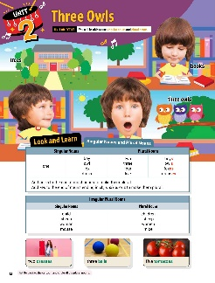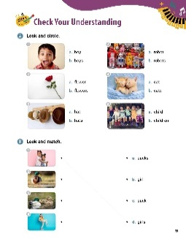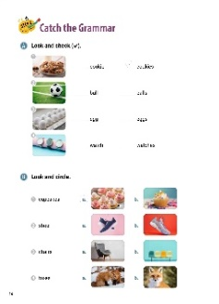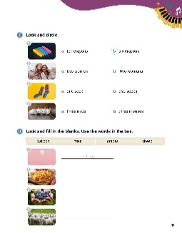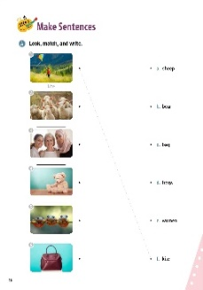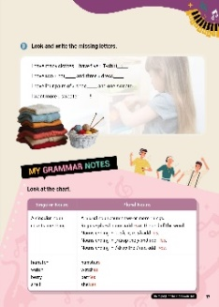

[WARM-UP]
- Have students look at the illustrations and words on page 12. Ask questions about what the students see (suggestions below):
Do you see a house? (Yes.)
Do you see two houses? (No.)
Do you see owls? (Yes.)
How many owls do you see? (Three.)
[Look and Learn]
- Have students look at the chart on page 12. Go through the grammar points in the chart.
- Look at the example words and images.
- Read the words together.
- Ask students to go back to the cartoon and circle all the plural nouns.

[Step 1 Check Your Understanding]
- Have students look at Exercise A ‘Look and circle’. Ask students to choose the correct words that match the pictures.
- Answers: 1. a 2. b 3. a 4. b 5. b 6. B
- Have students look at Exercise B ‘Look and match’. Tell students to draw a line between the correct picture and the correct words.
- Answers: 1. d. girls 2. c. duck 3. a. ducks 4. b. girl
- Call on students to give the correct answers. Have the class say the correct answers together.

[Step 2 Catch the Grammar]
- Have students turn to page 14 for Exercise A ‘Look and check ( )’. Read the words out loud. Ask students to put a check mark by the correct word for the picture. Go over the answers together.
Answers: 1. cookies 2. ball 3. eggs 4. watches
- Have students look at Exercise B ‘Look and circle’. Read each of the words out loud. Tell students to circle the pictures that match the words. Have students share their answers with the class.
- Answers: 1. a 2. b 3. b 4. a
- Have students look at Exercise C ‘Look and circle. Ask the students what the pictures are. Tell students to choose the correct words for the pictures. Go over the answers together.
- Answers: 1. b 2. a 3. b 4. a
- Have students look at Exercise D ‘Look and f ill in the blanks.’ Read the words in the chart on page 15 out loud. Have students fill in the blanks with the correct words. Go over the answers as a class.
- Answers: 1. balloon 2. fries 3. grapes 4. sheep

[Step 3 Make Sentences]
- Have students turn to page 16 for Exercise A ‘Look, match, and write’. Have students draw a line between the pictures and the correct words. Talk about their answers in class.
- Answers: 1. f. kite 2. a. sheep 3. e. women 4. b. bear 5. d. frogs 6. c. bag
- Have students look at page 17 for Exercise B ‘Look and write the missing letters’. Read the sentences out loud. Have students fill in the blanks with the correct letters.
- Answers: 1. T-shirts 2. hats 3. dresses 4. shoes 5. sweaters

[My Grammar Notes]
- Have students look at the chart on page 17. Read the chart out loud. Ask students some questions about the chart (suggestions below):
Name a singular noun. (Answers vary. Cookie. Bed. House. Frog.)
ame a plural noun. (Answers vary. Cookies. Houses. Hats.)
- Practice spelling plural nouns with different endings. Say a word out loud. Ask students to write the word as a plural. Go over the spelling in class. Suggestions:
cherry>>cherries
match>>matches
elf>>elves
dog>>dogs

[Extra Unit Test]
- Have students turn to page 77 for Unit Test 2. Read the test items out loud.
- Have the students fill in the blanks. In the My Grammar Summary, read each line item.
- Tell students to write what they thought the grammar point for the unit was.
- Tell students to write what they think is the most important thing they learned from Unit 2.
- Have students write two examples of what they learned in Unit 2.

Unit 3. We Are Friends

Unit Objective | You will be able to use subject pronouns and the verb be.

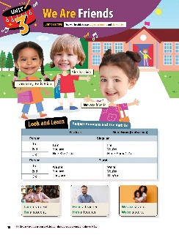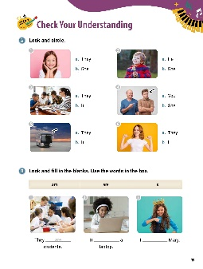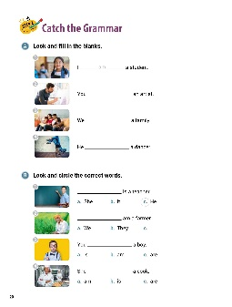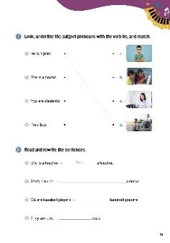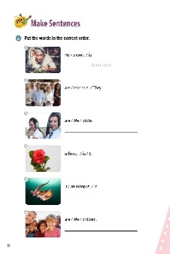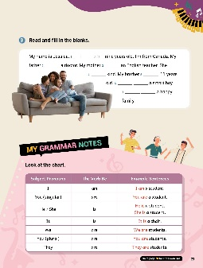

[WARM-UP]
- Have students look at the illustrations and words at the top of page 18.
- Ask students what they see. Have students read the sentences out loud.

[Look and Learn]
- Have students look at the chart on page 18. Go through the grammar points in the chart.
- Look at the example words and images.
- Read the words together.
- Ask students go back to the cartoon. Tell them to circle all the subject pronouns and the verb be.

[Step 1 Check Your Understanding]
- Have students look at Exercise A ‘Look and circle’. Ask students circle the correct letters that match the pictures.
- Go over the answers together.
- Answers: 1. b 2. a 3. a 4. a 5. b 6. b
- Have students look at Exercise B ‘Look and fill in the blanks’. Read the words in the box out loud. Ask students to choose the correct words from the box to match the pictures. Have students read their answers to the class.
- Answers: 1. are 2. is 3. am

[Step 2 Catch the Grammar]
- Have students look at Exercise A ‘Look and fill in the blanks’. Tell students they will fill in the blanks with the ‘be’ verb. Go over the answers together.
- Answers: 1. am 2. are 3. are 4. is
- Have students look at Exercise B ‘Look and circle the correct words’. Ask students what they see in the pictures. Tell them to circle the subject pronouns that match the pictures.
- Answers: 1. c 2. c 3. c 4. b
- Have students look at Exercise C ‘Look, underline the subject pronouns with the verb be, and match.’ On page 21. Read the sentences out loud. Tell students to underline the subject pronouns. Then tell students to match the sentences with the pictures.
- Answers: 1. He is a pilot. d 2. She is a doctor. c 3. You are students. b 4. I’m a boy. a
- Have students look at Exercise D ‘Read and rewrite the sentences’. Tell students they will fill in the blanks with the word or their contractions. Read number 1 out loud together.
- Answers: 1. She’s 2. She is 3. We’re 4. They’re

[Step 3 Make Sentences]
- Have students look at Exercise A ‘Put the words in the correct order’. Tell students they need to unscramble the words to make a sentence. Go over number 1 together.
- Answers: 1. He is a cook. 2. They are teachers. 3. We are pilots. 4. It is a flower. 5. It is an octopus. 6. We are children.
- Have students look at Exercise B ‘Read and fill in the blanks’. Tell them they need to read each sentence carefully and complete it using the ‘be’ verb, the correct pronoun, or a contraction of the verb and pronoun. Have students read the sentences out loud when they are finished.
- Answers: 1. I am 2. is 3. is 4. is 5. is 6. He is 7. We are

[My Grammar Notes]
- Have students look at the chart on page 23. Read the chart together. Ask students some questions about the chart (suggestions below):
Can you make sentences using the words in the chart?
(I am a teacher. He is a cook.)
Can you make the sentences in the chart use the contractions?
(They’re students. We’re students.)

[Extra Unit Test]
- Have students turn to page 78 for Unit Test 3. Read the test items out loud.
- Have the students fill in the blanks.
- In the My Grammar Summary, read each line item. Tell students to write what they thought the grammar point for the unit was.
- Tell students to write what they think is the most important thing they learned from Unit 3.
- Have students write two examples of what they learned in Unit 3.

Unit 4. Are They Friends?

Unit Objective | You will be able to use the verb be in negatives and questions.
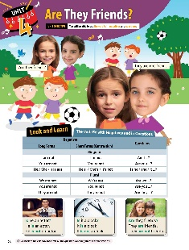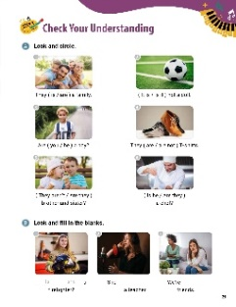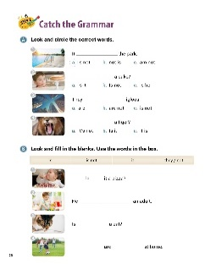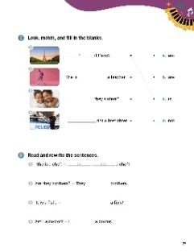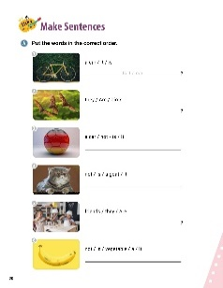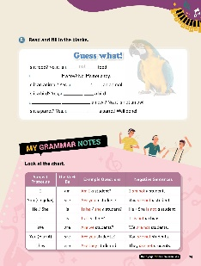

[WARM-UP]
- Have students look at the illustrations and words on page 24.

[Look and Learn]
- Have students look at the chart. Go through the grammar points in the chart.
- Look at the example words and images.
- Read the words and sentences together.
- Ask students go back to the cartoon and circle all the questions and negatives with the verb be.

[Step 1 Check Your Understanding]
- Have students look at Exercise A ‘Look and circle’. Ask students choose the correct words that match the pictures.
- Answers: 1. are 2. It is 3. you 4. are not 5. Are they 6. Is he
- Have students look at Exercise B ‘Look and fill in the blanks’. Ask students to write the correct words in the blanks. Check the answers together after students finish.
- Answers: 1. Is she 2. is not 3. not

[Step 2 Catch the Grammar]
- Have students look at Exercise A ‘Look and circle the correct word’. Have students circle the correct letter for the answer that best fits the sentence. Ask students to read their answers out loud.
- Answers: 1. a 2. a 3. b 4. B
- Have students look at Exercise B ‘Look and fill in the blanks’. Read the words in the box. Tell students to fill in the blanks using the words.
- Answers: 1. Is 2. is not 3. it 4. They, not
- Have students look at Exercise C ‘Look, match, and fill in the blanks’. Tell students to match the sentences with the correct words. Then, have them write the answers correctly in the blanks.
- Answers: 1. c. Is 2. d. not 3. b. Are 4. a. am
- Have students look at Exercise D ‘Read and rewrite the sentences’. Ask students to fill in the blanks with the correct words.
- Answers: 1. Is she 2. are 3. Is it 4. am

[Step 3 Make Sentences]
- Have students look at Exercise A ‘Put the words in the correct order’. Tell students they need to unscramble the words to make a sentence. Go over number 1 together.
- Answers: 1. Is it a car? 2. Are they birds? 3. It is not a car. 4. It is not a goat. 5. Are they friends? 6. It is not a vegetable.
- Have students look at Exercise B ‘Read and fill in the blanks’. Tell students they will fill in the blanks with words from the chapter. Go over the first two sentences with the whole class. Answers: 1. not 2. Is 3. it’s 4. it’s 5. Is it 6. it’s

[My Grammar Notes]
- Have students look at the chart on page 29. Read the chart together. Ask students some questions about the chart (suggestions below):
Can you make negative sentences using the words in the chart?
(I am not a teacher. He is not a cook.)
Can you make questions from the sentences like those shown in the chart?
(Are they teachers? Are you a runner?)

[Extra Unit Test]
- Have students turn to page 79 for Unit Test 4. Read the test items out loud.
- Have the students fill in the blanks.
- In the My Grammar Summary, read each line item.
- Tell students to write what they thought the grammar point for the unit was.
- Tell students to write what they think is the most important thing they learned from Unit 4. Have students write two examples of what they learned in Unit 4.

Unit 5. This Is a Pineapple

Unit Objective | You will be able to use demonstrative pronouns in positives, negatives, and questions.

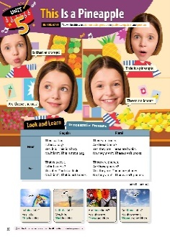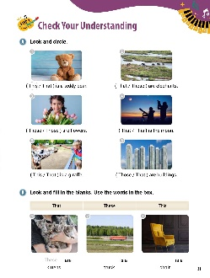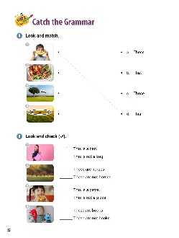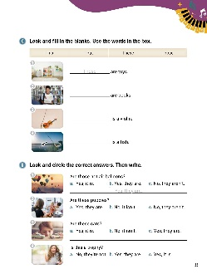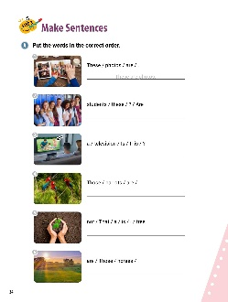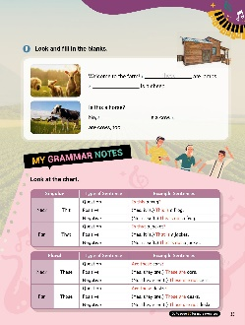

[WARM-UP]
- Have students look at the illustrations and words. Ask them to read the questions and answers out loud.

[Look and Learn]
- Have students look at the chart on page 30. Go through the grammar points in the chart.
- Look at the example words and images.
- Read the words together.
- Ask students go back to the illustration and circle all the demonstrative pronouns.

[Step 1 Check Your Understanding]
- Have students look at Exercise A ‘Look and circle’. Ask students choose the correct words for the pictures.
- Answers: 1. This 2. Those 3. These 4. That 5. This 6. Those
- Have students look at Exercise B ‘Look and fill in the blanks’. Read the words in the box. Tell students to complete the sentences using the words from the box.
- Answers: 1. These 2. That 3. This
- Go over the answers together.

[Step 2 Catch the Grammar]
- Have students look at Exercise A ‘Look and match’. Have students draw lines between the correct words and the pictures.
- Answers: 1. d. This 2. a. These 3. b. That 4. c. Those
- Have students look at Exercise B ‘Look and check ( )’. Tell students to place a check mark next to the sentence with the correct demonstrative pronoun.
- Answers: 1. This is a bag. 2. Those are horses. 3. This is not a pizza. 4. These are not books.
- Have students look at Exercise C ‘Look and fill in the blanks’. Tell students to use the words in the box to complete the sentences.
- Answers: 1. Those 2. These 3. This 4. That
- Have students look at Exercise D ‘Look and circle the correct answers’. Tell students to read the questions and circle the correct answers. Students should then write the answers on the lines provided.
- Answers: 1. b. Yes, they are. 2. c. No, they aren’t. 3. c. Yes, they are. 4. c. Yes, it is.
[Step 3 Make Sentences]
- Have students look at Exercise A ‘Put the words in the correct order’ on page 34. Tell students they need to unscramble the words to make a sentence. Go over number 1 together.
- Answers: 1. These are photos. 2. Are these students? 3. Is this a television? 4. Those are parrots. 5. That is not a tree. 6. Those are horses.
- Have students look at Exercise B ‘Look and fill in the blanks’. Ask students to write the correct words in the blanks. Check the answers together after students finish.
- Answers: 1. These 2. That 3. this 4. Those

[My Grammar Notes]
- Have students look at the chart on page 35. Read the chart together. Ask students some questions about the charts (suggestions below):
Give me one question with a positive answer like that shown in the chart.
(Is this a ring? Yes, this is a ring.// Are those cookies? Yes, those are cookies.)
Answer these questions negatively:
“Are those frogs?” (No, they aren’t.) “Are they swimming?” (No, they aren’t.)
“Is that a hat?” (No, it isn’t.) “Is that a shirt?” (No, it isn’t.)

[Extra Unit Test]
- Have students turn to page 80 for Unit Test 5. Read the test items out loud.
- Have the students fill in the blanks.
- In the My Grammar Summary, read each line item.
- Tell students to write what they thought the grammar point for the unit was.
- Tell students to write what they think is the most important thing they learned from Unit 5. Have students write two examples of what they learned in Unit 5.

Unit 6. It’s Sally’s Hat

Unit Objective | You will be able to use possessives.

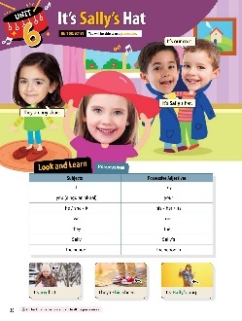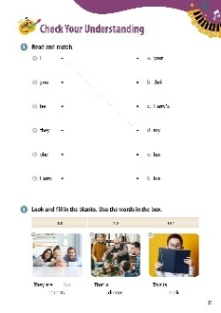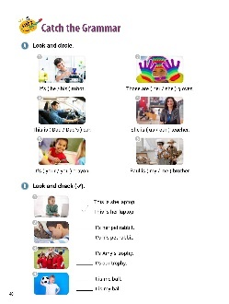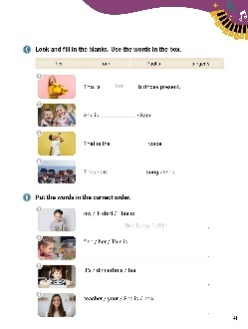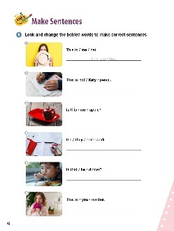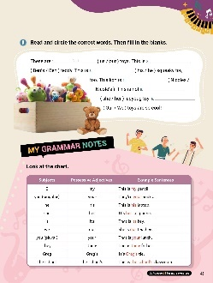

[WARM-UP]
- Have students look at the illustrations and words.
- Ask students what they see.

[Look and Learn]
- Have students look at the chart on page 38. Go through the grammar points in the chart.
- Look at the example words and images.
- Read the words together.
- Ask students go back to the cartoon and circle all the possessives.

[Step 1 Check Your Understanding]
- Have students look at Exercise A ‘Read and match’. Ask students to draw a line between the subject and the correct possessive. Go over number 1 as an example.
- Answers: 1. d. my 2. a. your 3. f. his 4. b. their 5. e. her 6. c. Harry’s
- Have students look at Exercise B ‘Look and fill in the blanks.’. Read the words in the box. Tell students to complete the sentences with the correct possessives.
- Answers: 1 her 2. our 3. his

[Step 2 Catch the Grammar]
- Have students look at Exercise A ‘Look and circle’. Tell students to circle the correct possessives for the pictures.
- Answers: 1. his 2. her 3. Dad’s 4. our 5. your 6. my
- Have students look at Exercise B ‘Look and check ( )’. Tell students to read each sentence pair. Put a check mark by the sentence that shows the correct possessive.
- Answers: 1. This is her laptop. 2. It’s his pet rabbit. 3. It’s our trophy. 4. It is my ball.
- Have students look at Exercise C ‘Look and fill in the blanks’. Read the words in the box. Tell students to chose the correct possessives to complete the sentences. Go over number 1 as an example.
- Answers: 1. her 2. Paul’s 3. singer’s 4. our
- Have students look at Exercise D ‘Put the words in the correct order’. Tell students unscramble the words to make sentences. Students should write the new sentences on the lines. Go over number 1 as an example.

- Answers: 1. This is my T-shirt. 2. This is her fish. 3. It’s his dinnertime. 4. She is your new teacher.

[Step 3 Make Sentences]
- Have students look at Exercise A ‘Look and change the bolded words to make correct sentences’. Tell the students to change the words in bold to the correct possessives. Then, write the sentences with the possessives. Go over number 1 as an example.
- Answers: 1. This is my hat. 2. That is not Katy’s pencil. 3. Is this my apple? 4. It’s their homework. 5. Is that his dinner? 6. That is your mother.
- Have students look at Exercise B ‘Read and circle the correct words’. Tell students to write the correct words from the parentheses on the lines. Go over number 1 as an example.
- Answers: 1. our 2. Ben’s 3. his 4. Nicole’s 5. her 6. Our

[My Grammar Notes]
- Have students look at the chart on page 43. Read the chart out loud. Ask students some questions about the chart (suggestions below):
Can you make a sentence using ‘my’? (This is my book. This is my class.)
Can you make a question using ‘our’? (Is this our class? Is this our homework?)
Point at an object in the room and ask “What is this?” This is Song’s ….)
Point at an object far away from you and ask “What is that?”
That is our ….)

[Extra Unit Test]
- Have students turn to page 81 for Unit Test 6. Read the test items out loud.
- Have the students fill in the blanks.
- In the My Grammar Summary, read each line item.
- Tell students to write what they thought the grammar point for the unit was.
- Tell students to write what they think is the most important thing they learned from Unit 6. Have students write two examples of what they learned in Unit 6.

Unit 7. He Is Tall

Unit Objective | You will be able to use adjectives.

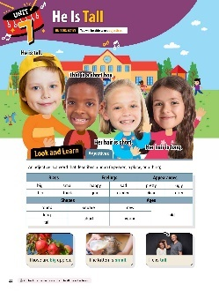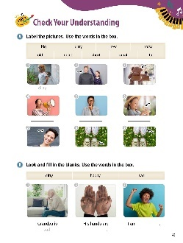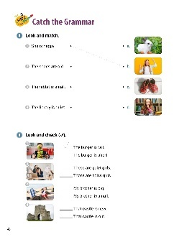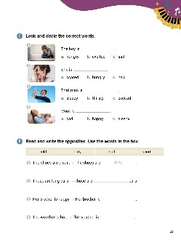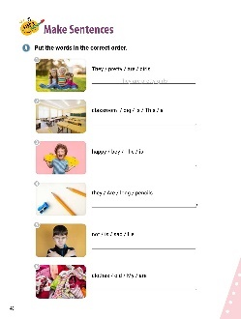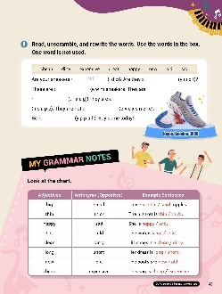

[WARM-UP]
- Have students look at the illustrations and words. Ask them what they see.

[Look and Learn]
- Have students look at the chart on page 44. Go through the grammar points in the chart.
- Look at the example words and images.
- Read the words together.
- Ask students go back to the cartoon and circle all the adjectives.

[Step 1 Check Your Understanding]
- Have students look at Exercise A ‘Label the pictures’. Read the words in the box. Ask students to choose the correct adjectives to match the pictures. Go over number 1 together.
- Answers: 1. dirty 2. tall 3. big 4. noisy 5. quiet 6. small 7. short 8. old 9. new
- Have students look at Exercise B ‘Look and fill in the blanks.’ Read the words in the box. Ask students choose the correct adjectives that match the pictures.
- Answers: 1. sad 2. dirty 3. happy

[Step 2 Catch the Grammar]
- Have students look at Exercise A ‘Look and match’. Tell students to draw a line between the correct pictures and the sentences describing them.
- Answers: 1. b 2. c 3. a 4. d
- Have students look at Exercise B ‘Look and check ( )’. Tell students to read each pair of sentences. They should put a checkmark on the sentences that show the adjectives that best match the pictures.
- Answers: 1. The burger is tall. 2. Those are noisy girls. 3. My brother is small. 4. That castle is old.
- Have students look at Exercise C ‘Look and circle the correct words’. Tell students to choose the adjectives that best complete the sentences.
- Answers: 1. c. sad 2. a. scared 3. b. thirsty 4. c. sleepy
- Have students look at Exercise D ‘Read and write the opposites’. Read the words in the box. Tell students to choose the adjectives from the box to complete the sentences.
- Answers: 1. dirty 2. short 3. sad 4. cold

[Step 3 Make Sentences]
- Have students look at Exercise A ‘Put the words in the correct order’. Tell students to unscramble the words. Then they should write the sentences on the lines.
- Answers: 1. They are pretty girls. 2. This is a big classroom. 3. The boy is happy. 4. Are they long pencils? 5. He is not sad. 6. My clothes are old.
- Have students look at Exercise B ‘Read, unscramble, and rewrite the words’. Read the words in the box. Tell students to use the adjectives from the box to help unscramble the words for the blanks. Have students write the words on the lines.
- Answers: 1. old 2. dirty 3. new 4. great 5. cheap 6. expensive 7. happy

[My Grammar Notes]
- Have students look at the chart on page 49. Read the chart out loud. Ask students some questions about the chart (suggestions below):
What is the opposite of cold? (Hot.)
What is the antonym of hot? (Cold.)
Can you use ‘cold’ and ‘hot’ in a sentence?
(The water is cold and the food is hot.)

[Extra Unit Test]
- Have students turn to page 82 for Unit Test 7. Read the test items out loud.
- Have the students fill in the blanks.
- In the My Grammar Summary, read each line item.
- Tell students to write what they thought the grammar point for the unit was.
- Tell students to write what they think is the most important thing they learned from Unit 7. Have students write two examples of what they learned in Unit 7.

Unit 8. Who Is He?

Unit Objective | You will be able to use information questions.

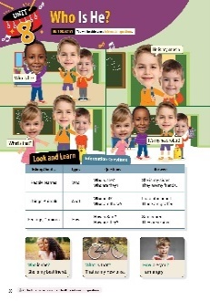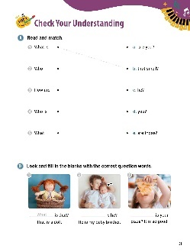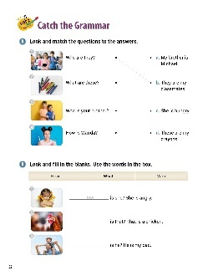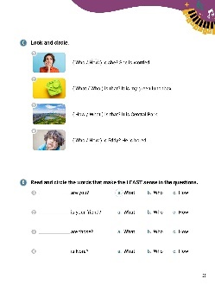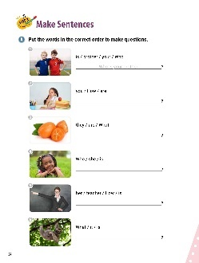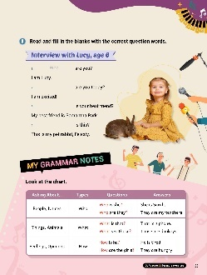

[WARM-UP]
- Have students look at the illustrations and words.

[Look and Learn]
- Have students look at the chart on page 50. Go through the grammar points in the chart.
- Look at the example words and images.
- Read the words together.
- Ask students go back to the cartoon and circle all the information questions.

[Step 1 Check Your Understanding]
- Have students look at Exercise A ‘Read and match’. Ask students to draw lines between the beginning of the sentences and the ends.
- Answers: 1. b 2. a 3. d 4. c 5. e
- Have students look at Exercise B ‘Look and fill in the blanks with the correct question words’. Go over the first example. Have students fill in the blanks.
- Answers: 1. What 2. Who 3. How

[Step 2 Catch the Grammar]
- Have students look at Exercise A ‘Look and match the questions to the answers’. Tell students to draw lines between the correct question and the information it is asking for. Go over number 1 together.
- Answers: 1. b 2. d 3. a 4. c
- Have students look at Exercise B ‘Look and fill in the blanks’. Read the words in the box. Tell students to use the question words in the box to fill in the blanks. Go over number 1 together.
- Answers: 1. How 2. What 3. Who
- Have students look at Exercise C ‘Look and circle’. Have students look at the pictures. Tell them to circle the correct question words to go with the sentences. Go over number 1 together.
- Answers: 1. How 2. What 3. What 4. How
- Have students look at Exercise D ‘Read and circle the words that make the LEAST sense in the questions. Tell students to read each answer for the blanks. Tell them to cross out the right answer. Tell them to circle the wrong answers. Go over number 1 together.
- Answers: 1. a 2. a 3. b 4. a
[Step 3 Make Sentences]
- Have students look at Exercise A ‘Put the words in the correct order to make questions’. Tell the students to unscramble the words. They should write the new questions on the lines.
- Answers: 1. Who is your brother? 2. How are you? 3. What are they? 4. Who is she? 5. How is her teacher? 6. What is it?
- Have students look at Exercise B ‘Read and fill in the blanks with the correct question words’. Tell students to use the question words from the chapter to fill in the blanks. Go over number 1 together.
- Answers: 1. Who 2. How 3. Who 4. What

[My Grammar Notes]
- Have students look at the chart on page 55. Read the chart out loud. Tell students they will use the chart for the activity. In this activity, you will say a sentence. The students need to ask the question that matches the sentence. Suggestions below:
This is Min. (Who is he?) That is a cellphone. (What is that?)
She is sad. (How is she?)

[Extra Unit Test]
- Have students turn to page 83 for Unit Test 8. Read the test items out loud.
- Have the students fill in the blanks.
- In the My Grammar Summary, read each line item.
- Tell students to write what they thought the grammar point for the unit was.
- Tell students to write what they think is the most important thing they learned from Unit 8. Have students write two examples of what they learned in Unit 8.

Unit 9. I Have a Yellow Banana

Unit Objective | You will be able to use the present simple tenses.

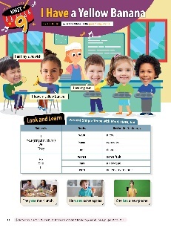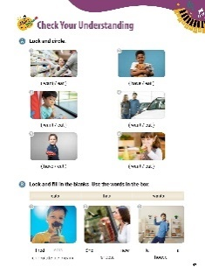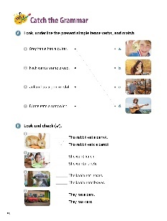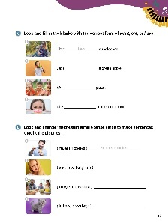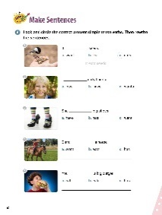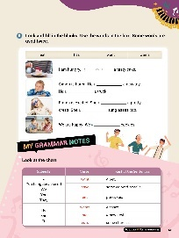

[WARM-UP]
- Have students look at the illustrations and words. Ask what they see in the picture.

[Look and Learn]
- Have students look at the chart on page 56. Go through the grammar points in the chart.
- Look at the example words and images.
- Read the words together.
- Remind students that to use -es after s, ch, and sh, -ies if there is a consonant before the y, and do - does, go - goes, have – has.

[Step 1 Check Your Understanding]
- Have students look at Exercise A ‘Look and circle’. Ask students choose the correct verbs with the pictures.
- Answers: 1. want 2. have 3. eat 4. want 5. have 6. eat
- Have students look at Exercise B ‘Look and fill in the blanks’. Read the words in the box. Ask students to write the correct verbs on the lines.
- Answers: 1. eats 2. wants 3. has

[Step 2 Catch the Grammar]
- Have students look at Exercise A ‘Look, underline the present simple tense verbs, and match’. Tell students to read the sentences. Have them underline the verbs in the sentences. Then, have students draw lines to the correct pictures.
- Answers: 1. has; d 2. wants; c 3. has; a 4. eats; b
- Have students look at Exercise B ‘Look and check ( )’. Tell students to place check marks next to the sentences with the correct present tense verbs. Go over number 1 as a class.
- Answers: 1. This rabbit eats a carrot. 2. She wants lunch. 3. The koala eats leaves. 4. They have cars.

- Have students look at Exercise C ‘Look and f ill in the blanks with the correct form of want, eat, or have’. Tell students to look at the pictures. Students should write the present tense verbs on the lines to complete the sentences. Go over number 1 as a class.
- Answers: 1. have 2. eats 3. eat 4. wants

- Have students look at Exercise D ‘Look and change the present simple tense verbs to make sentences that fit the pictures’. Have students use the words to write sentences. Remind them to start sentences with a capital letter. Go over number 1 as a class.
- Answers: 1. He eats noodles. 2. She has long hair. 3. They eat breakfast. 4. It has short legs.

[Step 3 Make Sentences]
- Have students look at Exercise A ‘Look and circle the correct present simple tense verbs’. Tell students to look at the pictures. Have them circle the correct verb. Then, students should write the sentences on the lines. Go over number 1 as a class.
- Answers: 1. c; It eats seeds. 2. b; I have dirty hands. 3. b; She has big shoes. 4. c; Clara has a horse. 5. a; You eat a big burger.
- Have students look at Exercise B ‘Look and fill in the blanks’. Read the words in the box. Tell students to use these words to complete the sentences. Go over number 1 as a class.
- Answers: 1. want 2. wants 3. wants 4. has 5. has 6. eat

[My Grammar Notes]
- Have students look at the chart on page 61. Read the chart out loud. Ask students to make new sentences using the chart (suggestions below):
I want some colored pencils.
He wants a pet.
She eats pancakes.

[Extra Unit Test]
- Have students turn to page 84 for Unit Test 9. Read the test items out loud.
- Have the students fill in the blanks.
- In the My Grammar Summary, read each line item.
- Tell students to write what they thought the grammar point for the unit was.
- Tell students to write what they think is the most important thing they learned from Unit 9. Have students write two examples of what they learned in Unit 9.

Unit 10. I Don’t Have Dessert

Unit Objective | You will be able to use the present simple tense in negatives and questions.

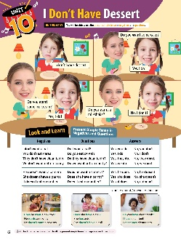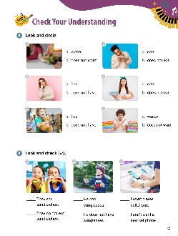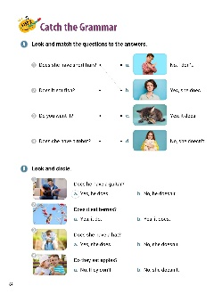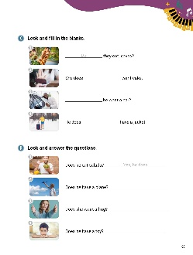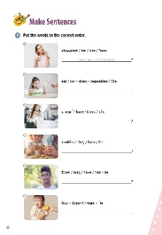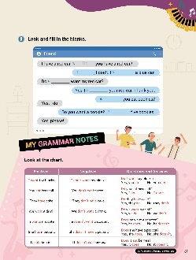

[WARM-UP]
- Have students look at the illustrations and words.

[Look and Learn]
- Have students look at the chart on page 62. Go through the grammar points in the chart.
- Look at the example words and images.
- Read the words together.
- Ask students go back to the cartoon and circle all the present simple tense for negatives and questions.

[Step 1 Check Your Understanding]
  - Have students look at Exercise A ‘Look and circle’. Ask students to look at the pictures and circle the letters of the correct answers.
  - Answers: 1. b 2. a 3. b 4. b 5. a 6. b
  - Have students look at Exercise B ‘Look and check ( )’. Tell students to place check marks next to the sentences with the correct sentences. Go over number 1 as a class.
  - Answers: 1. They eat sandwiches. 2. He does not have sunglasses. 3. I want a new cellphone.

[Step 2 Catch the Grammar]
  - Have students look at Exercise A ‘Look and match the questions to the answers’. Tell the students to read the questions and look at the pictures. Have students draw lines between the questions and their correct answers. Go over number 1 as a class.
  - Answers: 1. b 2. c 3. a 4. d
  - Have students look at Exercise B ‘Look and circle’. Have students look at the pictures. Circle the correct answers. Go over number 1 as a class.
  - Answers: 1. a 2. b 3. b 4. a
  - Have students look at Exercise C ‘Look and fill in the blanks’. Have students fill in the blanks with do, not, or does. Go over number 1 as a class.
  - Answers: 1. Do 2. not 3. Does 4. not
  - Have students look at Exercise D ‘Look and answer the questions’. Read the questions. Look at the pictures. Write answers to the questions using the pictures. Go over number 1 as a class.
  - Answers: 1. Yes, he does. 2. Yes, he does. 3. Yes, she does. 4. No, he does not. / No, he doesn’t.

[Step 3 Make Sentences]

  - Have students look at Exercise A ‘Put the words in the correct order’. Ask students to look at the pictures. Tell students to unscramble the words to make sentences or questions. Have students write their answers on the lines. Go over number 1 as a class.
  - Answers: 1. Does she eat chocolate? 2. She does not eat vegetables. 3. Does she have a scarf? 4. Do they have cookies? 5. Does he have long hair? 6. He doesn’t want fruit.
  - Have students look at Exercise B ‘Look and f ill in the blanks’. Tell students to use words from the unit to fill in the blanks. Go over number 1 as a class.
  - Answers: 1. Do 2. No 3. have 4. you 5. want 6. Do 7. have

[My Grammar Notes]
- Have students look at the chart on page 67. Read the chart out loud. Use the chart to play the ‘opposite game’.
- Say “Let’s play a game using the chart. I will say a sentence or question.
You make it the opposite. For example, I say ‘I want toy blocks.’ You say, ‘I don’t want toy blocks.’ Let’s begin.”
Suggestions: You eat broccoli. (You don’t eat broccoli.)
They have cake. (They don’t have cake.)
It doesn’t eat berries. (It does eat berries.)

[Extra Unit Test]
- Have students turn to page 85 for Unit Test 10. Read the test items out loud.
- Have the students fill in the blanks.
- In the My Grammar Summary, read each line item.
- Tell students to write what they thought the grammar point for the unit was.
- Tell students to write what they think is the most important thing they learned from Unit 10. Have students write two examples of what they learned in Unit 10.

